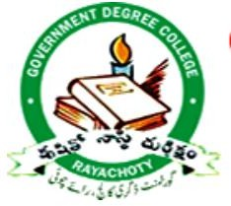
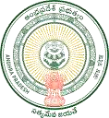
RAYACHOTY—516269
(Accredited by NAAC with C Grade Affiliated to YV University, Kadapa




2018-19

3.4.2: Number of awards and recognitions received for extension activities from government /government recognized bodies during the last five years (05)

SL  NO | Academic Year | Number of Awards
1 | 2018-2019 | 05
2 | 2019-2020 | 58
3 | 2020-2021 | 00
4 | 2021-2022 | 51
5 | 2022-2023 | 14

GOVERNMENT OF ANDHRA PRADESH URDU ACADEMT
AWARD WINNING AUTHOR (Published Books)
Dr. Syed Vasiulla Bakhtiary, Lecturer in Urdu received the Literary Award from the Andhra Pradesh State Urdu Academy, Vijayawada, an Autonomous Body of Government of Andhra Pradesh on 11-11-2018.
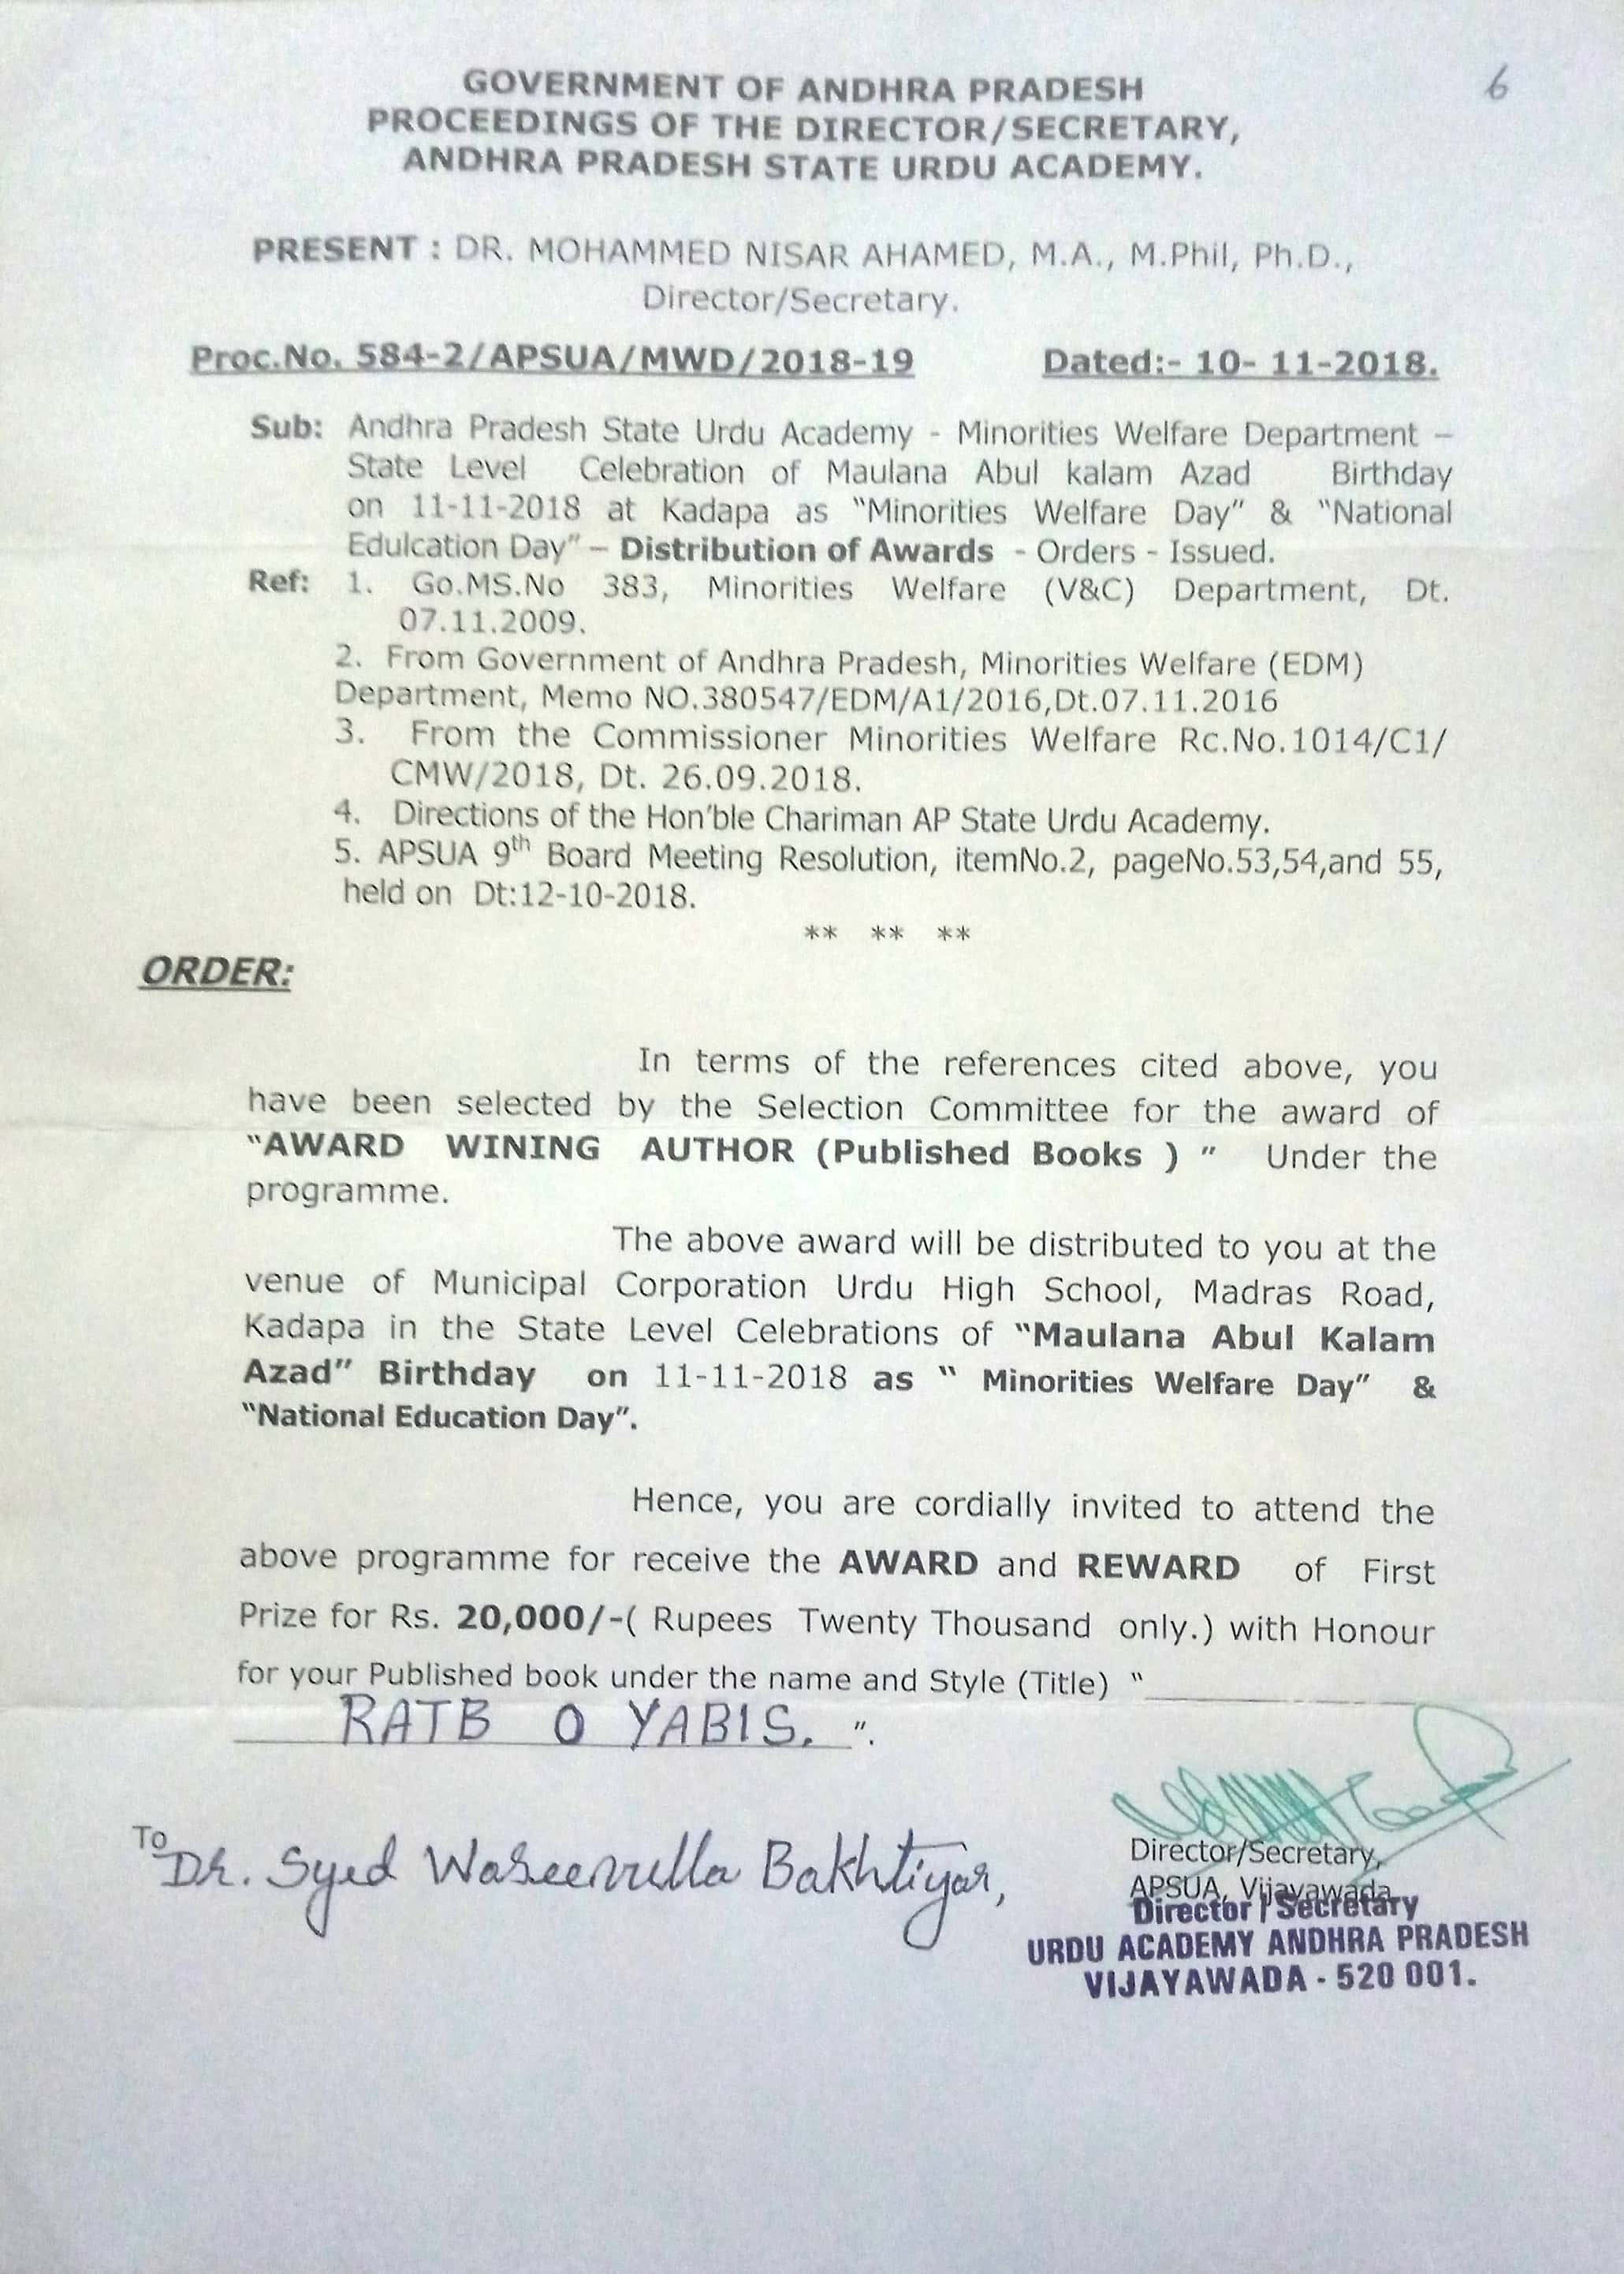

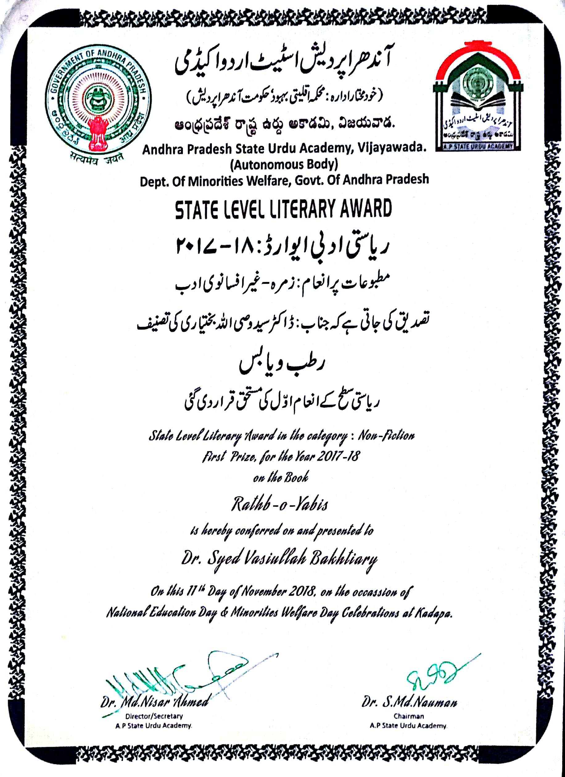

Dr. Syed Vasiulla Bakhtiary, Lecturer in Urdu received the Literary Award from the Andhra Pradesh State Urdu Academy, Vijayawada, an Autonomous Body of Government of Andhra Pradesh on 11-11-2018.

Dr. Syed Vasiulla Bakhtiary, Lecturer in Urdu received the Literary Award from the Andhra Pradesh State Urdu Academy, Vijayawada, an Autonomous Body of Government of Andhra Pradesh on 11-11-2018.

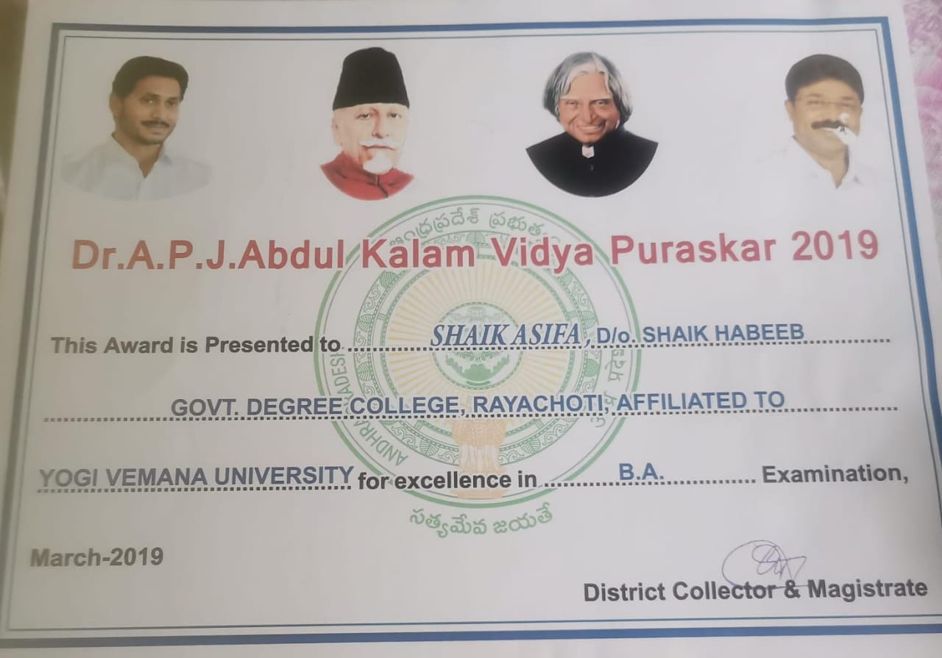

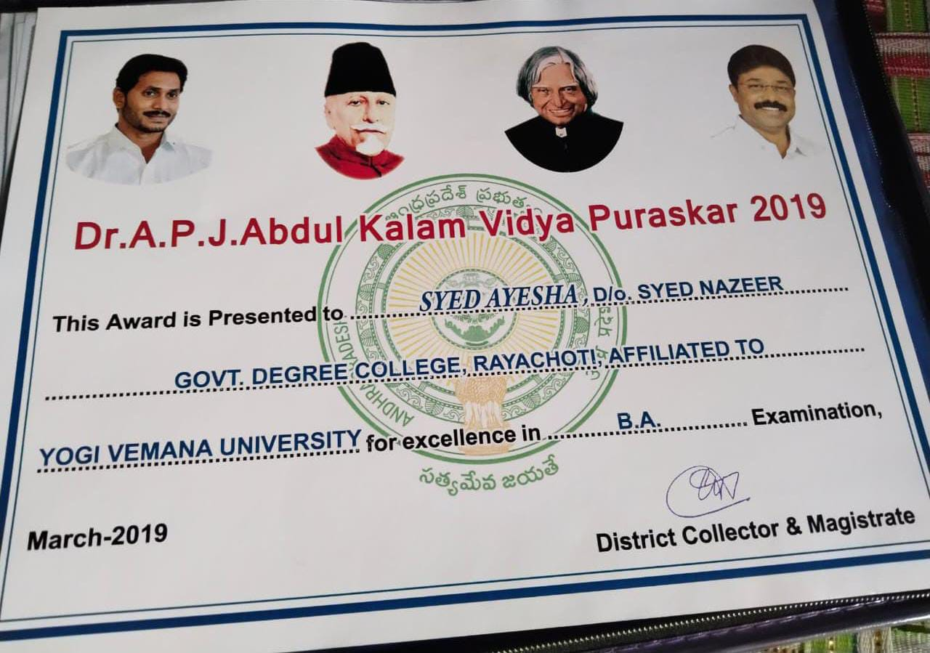

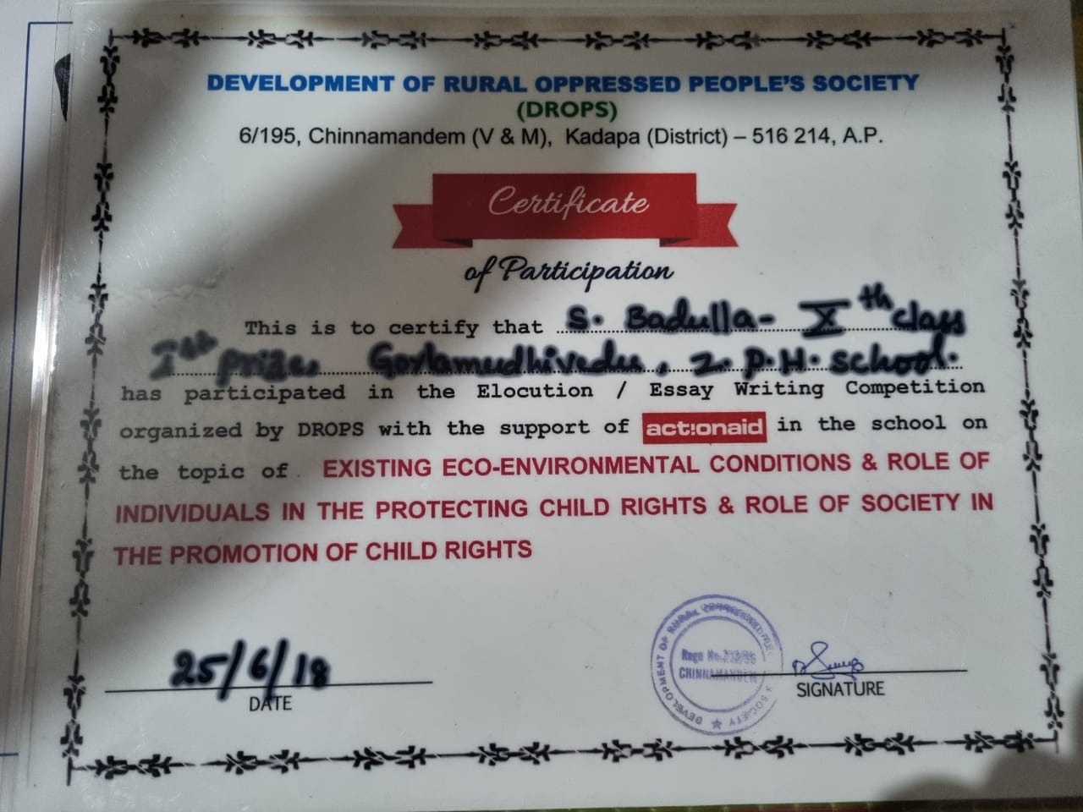

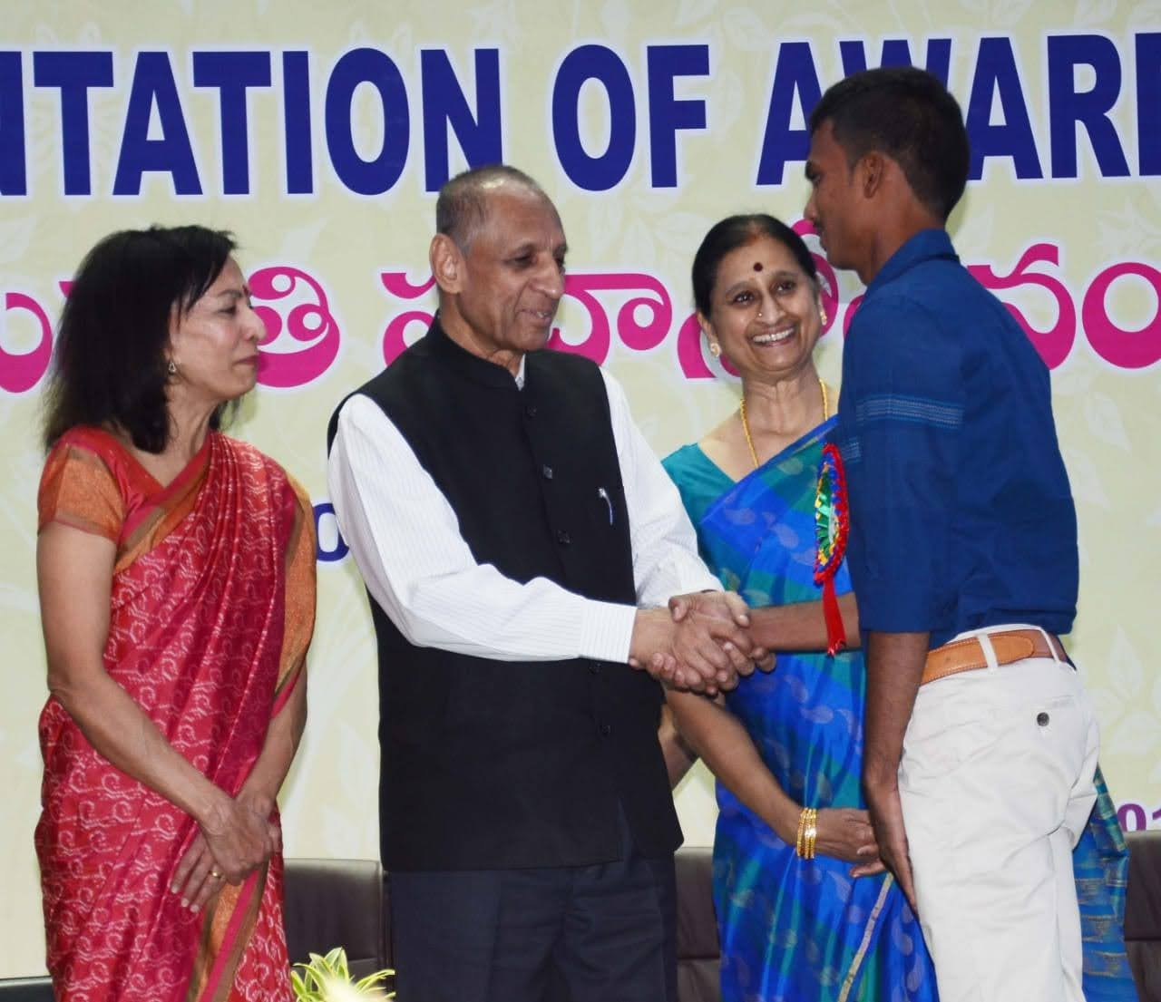

Name of the Activity: Praja Prana Rakshak Award

09.01.2019

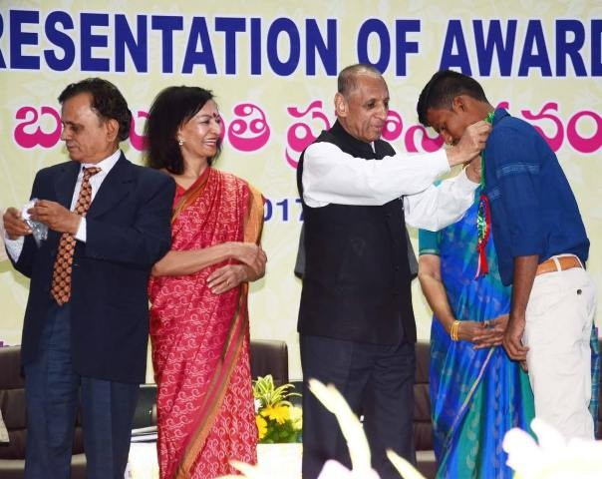
Praja Prana Rakshak Award is for ‘Saving others life’ like Meritorious act of human Nature in saving the Life. This program comes under the “Indian Red Cross Society”. Our college student K. Annamaiah, MPCs has also got this prestigious award of Praja Prana Rakshak in 2019 for saving people from corona pandemic. The event has been organized by the Government of Andhra Pradesh and awards given by Hon’ble State Governor Sri E. S. L. Narasimhan at Vijayawada on 09.01.2019.
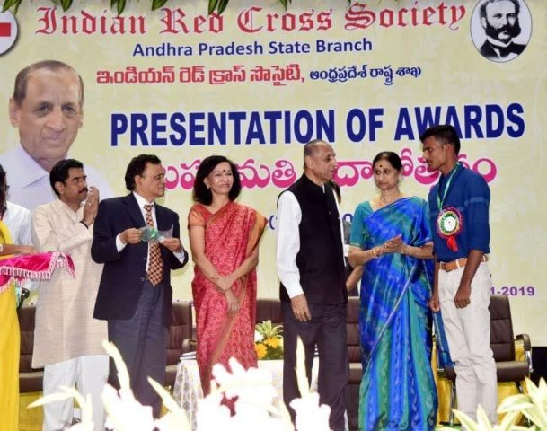

RAYACHOTY—516269
(Accredited by NAAC with C Grade Affiliated to YV University, Kadapa

RAYACHOTY—516269
(Accredited by NAAC with C Grade Affiliated to YV University, Kadapa

2019-20

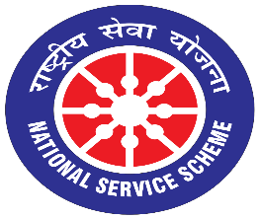
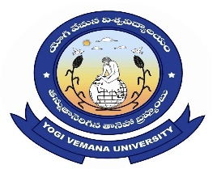
National Service Scheme
Special Champ

THE OPENING CEREMON:
For inauguration programme of Special camp at Rayachoty Near villages, we called renowned persons from village. Inauguration programme started with lighting of the lamps and welcoming of the guests. It was followed by introduction of the chief guests and their felicitation. The vision, mission and the main purpose of the NSS camp was put forth by Mr. N. Rajasekhar Reddy, Program Officer for NSS Unit of AISSMS. The programme proceeded with different speeches given by the guests present for the ceremony. The opening ceremony was concluded by recital of Vande Mataram.
The primary objectives of the special camping programs are: ¬
- Making education more relevant to the present situation, to meet the felt needs of the communities and supplement the education of university/college/school students by bringing them face to face with the prevailing situation of the community

- To provide opportunities for students to play their due roles in the implementation of various development programs by planning and executing development projects, which not only help in creating durable community assets in rural areas and slums but also result in the improvement of the condition of weaker sections of the communities.

- Encouraging the students and non-student to work along with the adults in rural areas, thereby developing their character, social consciousness and commitment, discipline and healthy and helpful attitudes towards the community.

- Building potential youth leaders by exploring the latent potential among the campers, both students as well as local youth (rural and urban), with a view to involve them more intimately in development projects for longer periods. The local leadership generated during the camps would also be useful in ensuring proper maintenance of the assets created as a result of the camps.

- Emphasizing the dignity of labor and self-help and the need for combining physical work with intellectual pursuits, and encouraging youth to participate enthusiastically in the process of national development, and promote national integration through democratic living and cooperative action.

List of Participated Students in the NSS Special Camp

SL NO | Name of the Students | Group
1 | Syed Mansoor Basha | BA HPU
2 | Shaik Fahmida | BA HPU
3 | Shaik Vajiha | BA HPU
4 | Shaik Nameera | BA HPU
5 | Shaik Afzal | BA HPU
6 | Shaik Baba Fakruddin | BA HPU
7 | Shaik Sofiya Begum | BA HPU
8 | Shaik Ruksana | BA HPU
9 | Shaik Darbar | BA HPU
10 | Shaik Mohammed Ghouse | BA HPU
11 | Bommisetti Sai Kumar | B.COM CA
12 | Veeraballi Shambu Prasad | B.COM CA
13 | Shaik Masood Basha | B.COM CA
14 | Syed Mohammed ALI | B.COM CA
15 | Chella Bhaskar | B.COM CA
16 | Shaik Habib | B.COM CA
17 | Mayana Zaid Basha | B.COM CA
18 | Shaik Mohammed Waseem | B.COM CA
19 | Pachipala Devendra | B.COM CA
20 | Shaik Arif Basha | B.COM CA
21 | B.Santhosh Naik | BA HEP
22 | B. Chenna karjuna | BA HEP
23 | O Pavan Kumar | BA HEP
24 | S. Naveen Naidu | BA HEP
25 | S. Masthan Vali | BA HEP
26 | S. Althaf | BA HEP
27 | R. Sagar | BA HEP
28 | P. Kiran Deepak | BA HEP
29 | K. Ganga Raju | BA HEP
30 | K. Guru Siva Kumar | BA HEP
31 | M. Raj Kumar Reddy | MCPC’S
32 | G. Hari Priya | MCPC’S
33 | G. Supriya | MCPC’S
34 | R. Sri Hari | MCPC’S
35 | D. Chenna Keshava | MCPC’S
36 | D. Venkata Sivamma | MCPC’S
37 | D. Venkateswarlu | MCPC’S
38 | B. Karthik | MCPC’S
39 | K. Ghouse Lazam | MCPC’S
40 | K. Suresh Kumar | MCPC’S
41 | B. Rajesh Kumar | BSC BZC
42 | D. Venkatappa | BSC BZC
43 | D. Kanaka Durgaiah | BSC BZC
44 | P. Rama Mohan | BSC BZC
45 | T. Venkatesh | BSC BZC
46 | S. Mohammed Suhel | BSC BZC
47 | S. Irfan Basha | BSC BZC
48 | S. Akbar Basha | BSC BZC
49 | G. Hajira | BSC BZC
50 | S. Yasar | BSC BZC
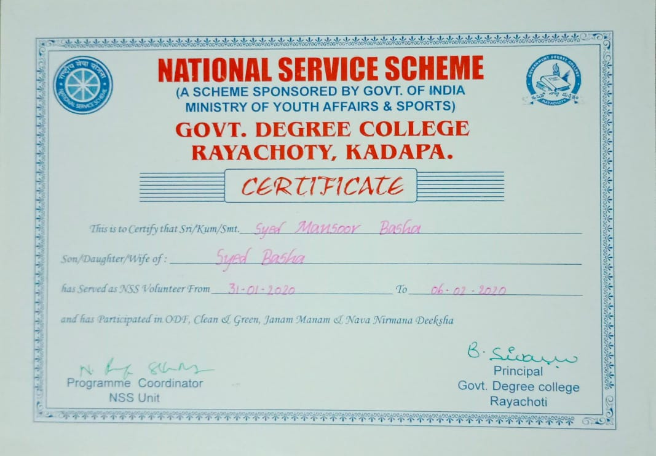

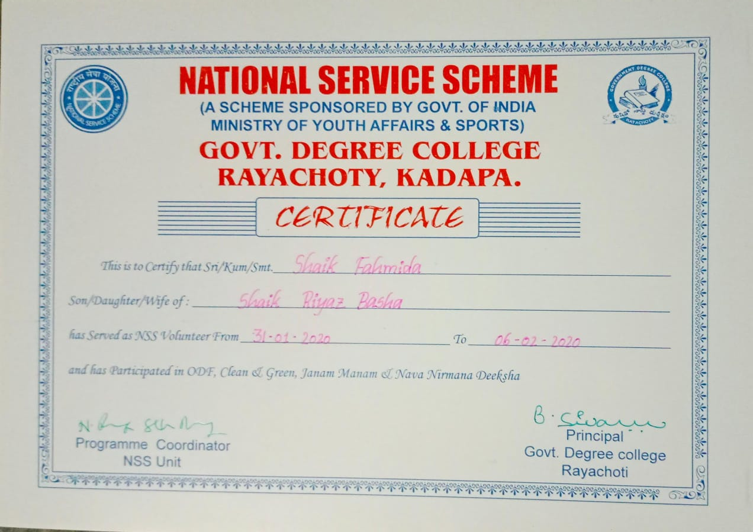

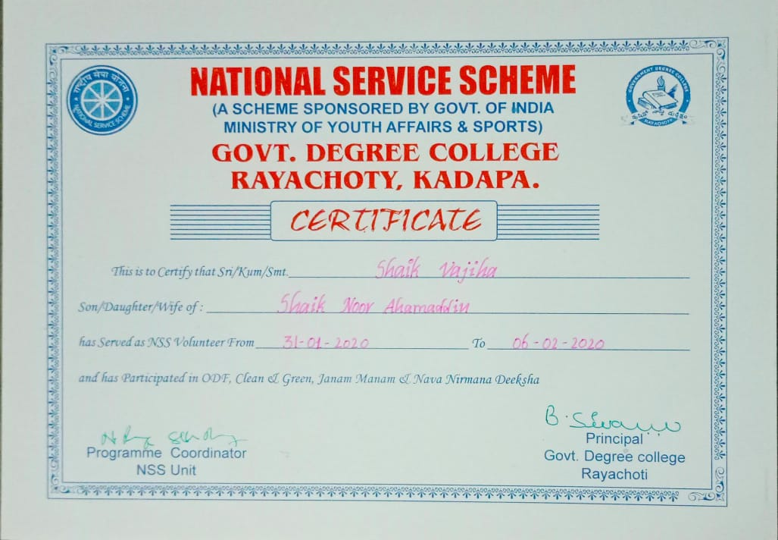

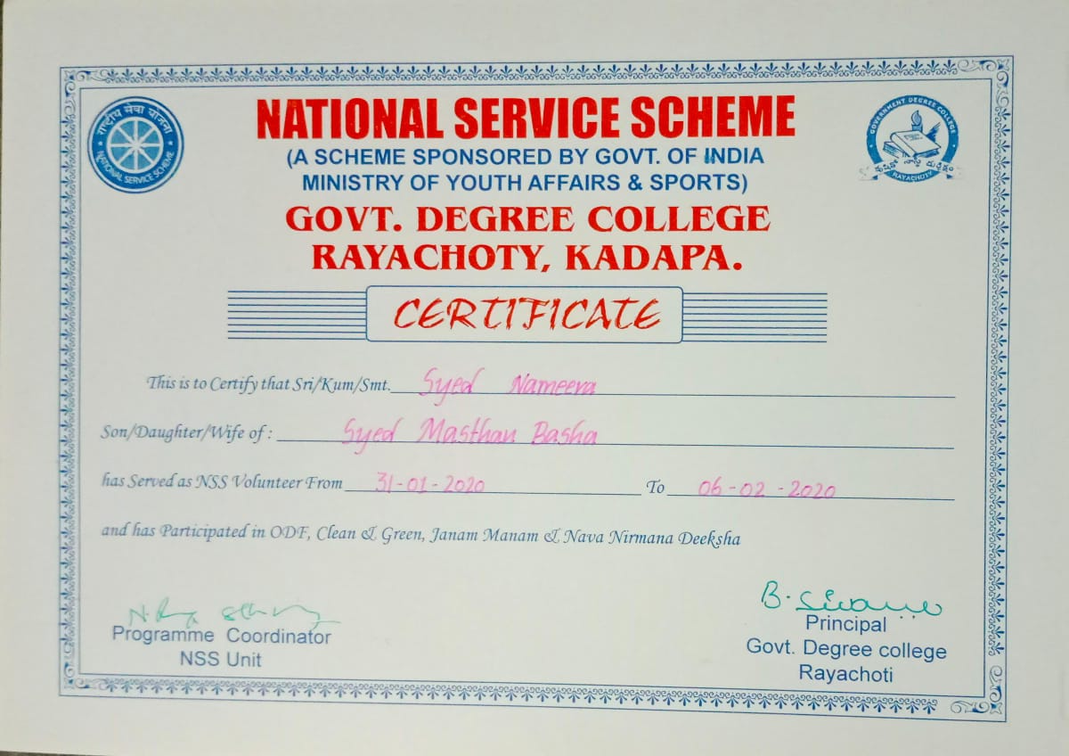

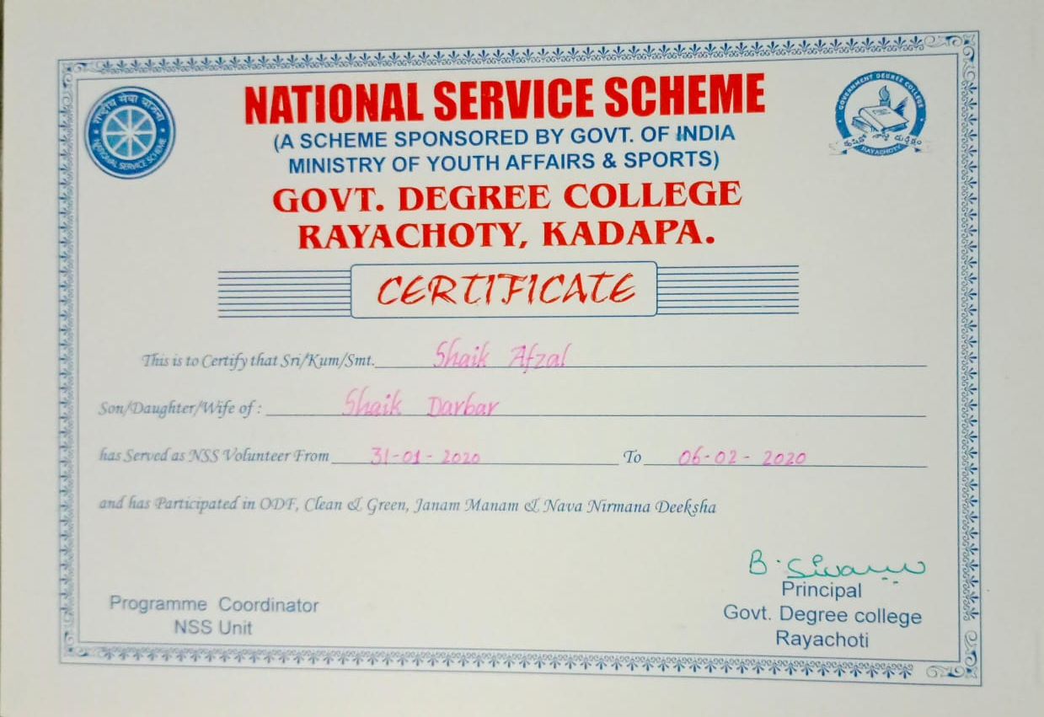

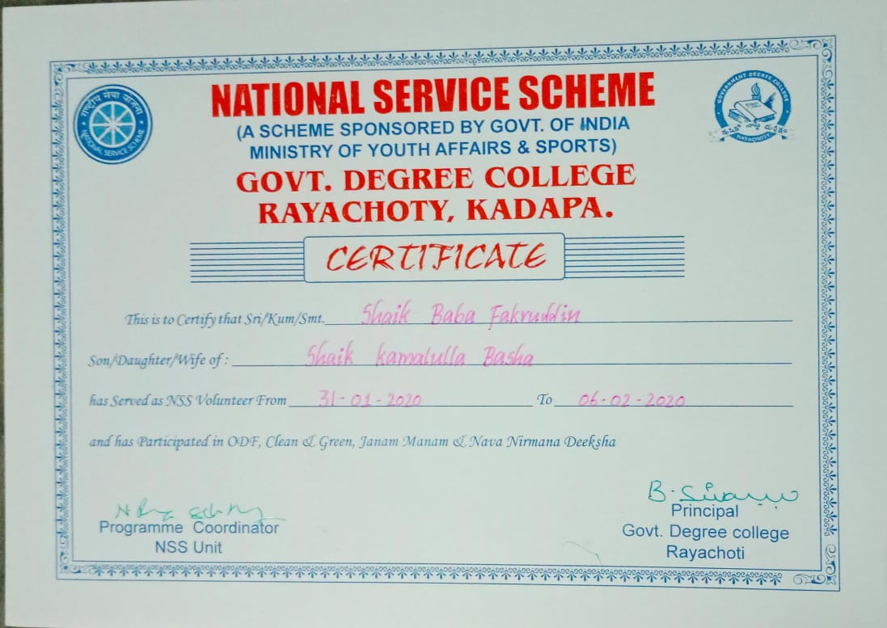

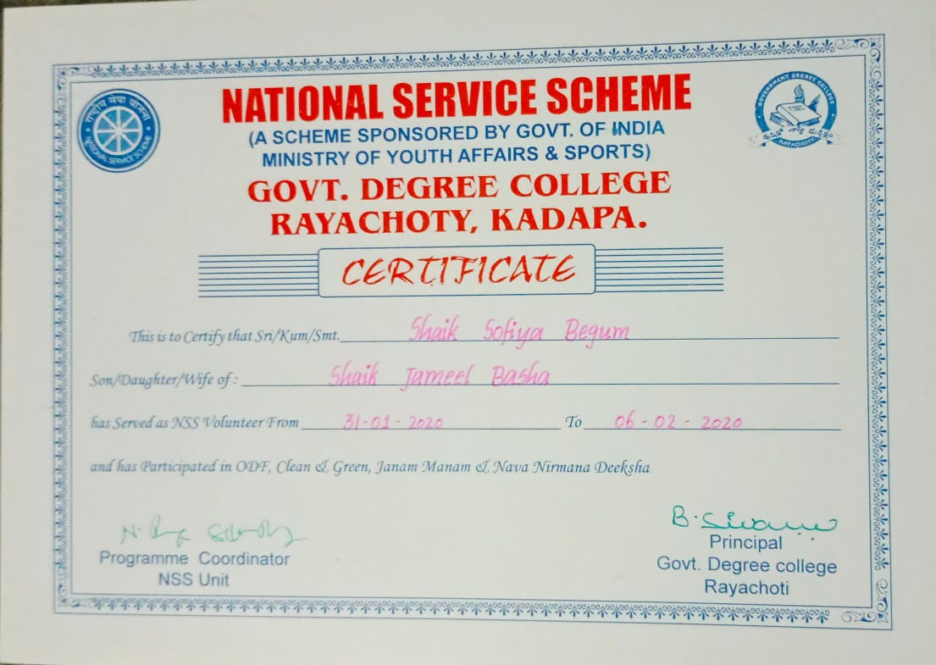

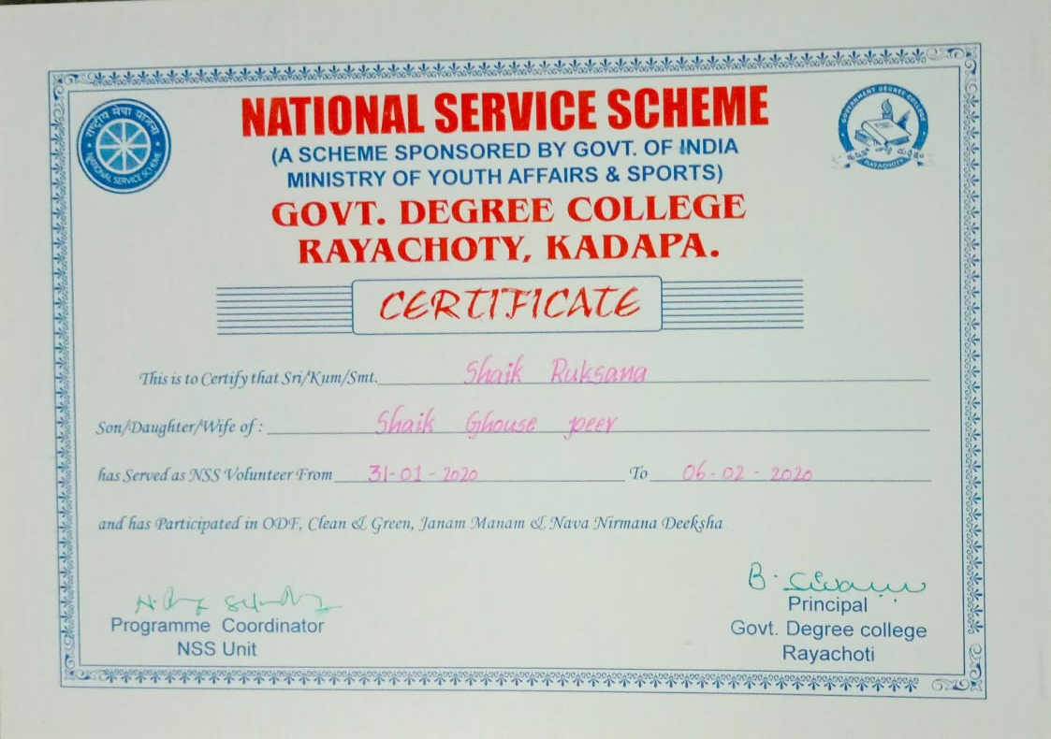

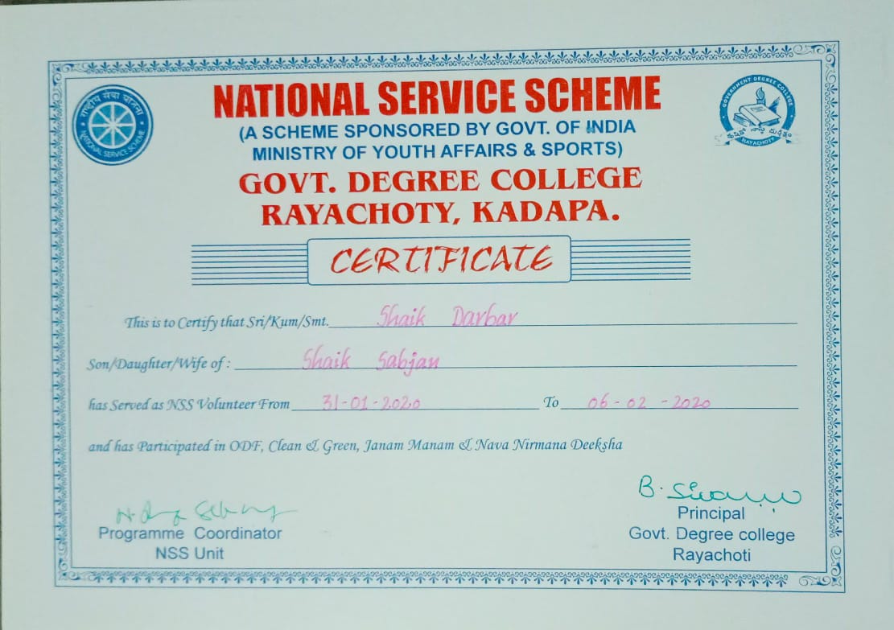

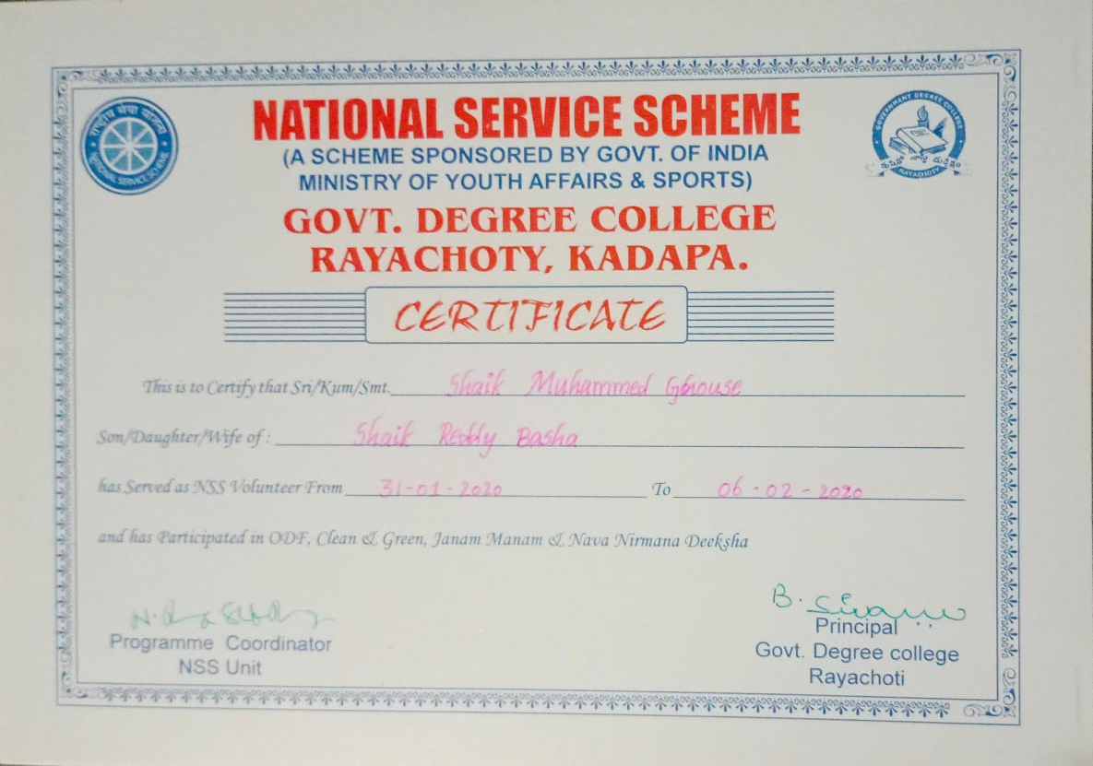

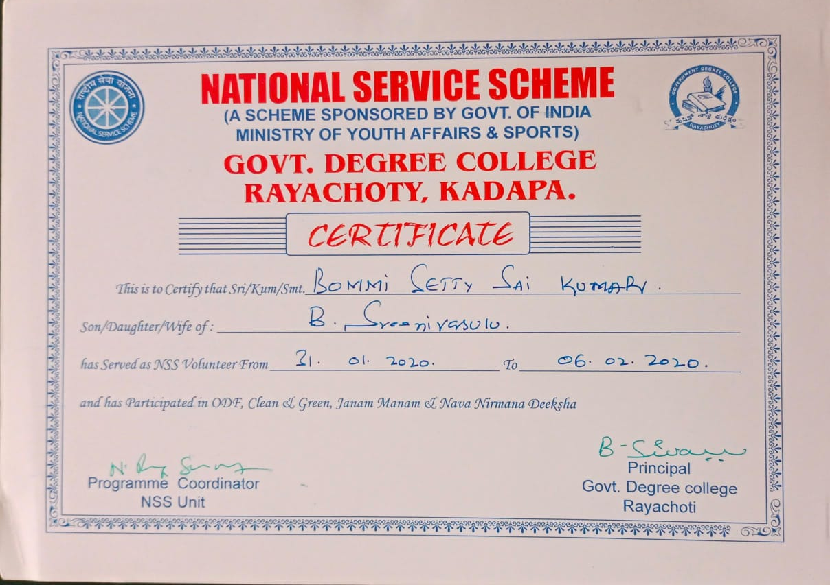

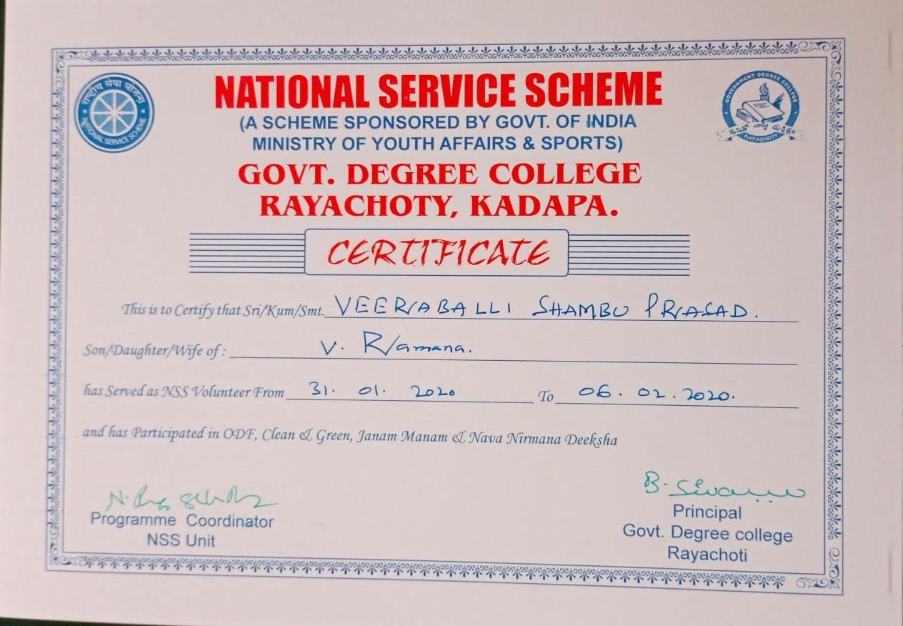

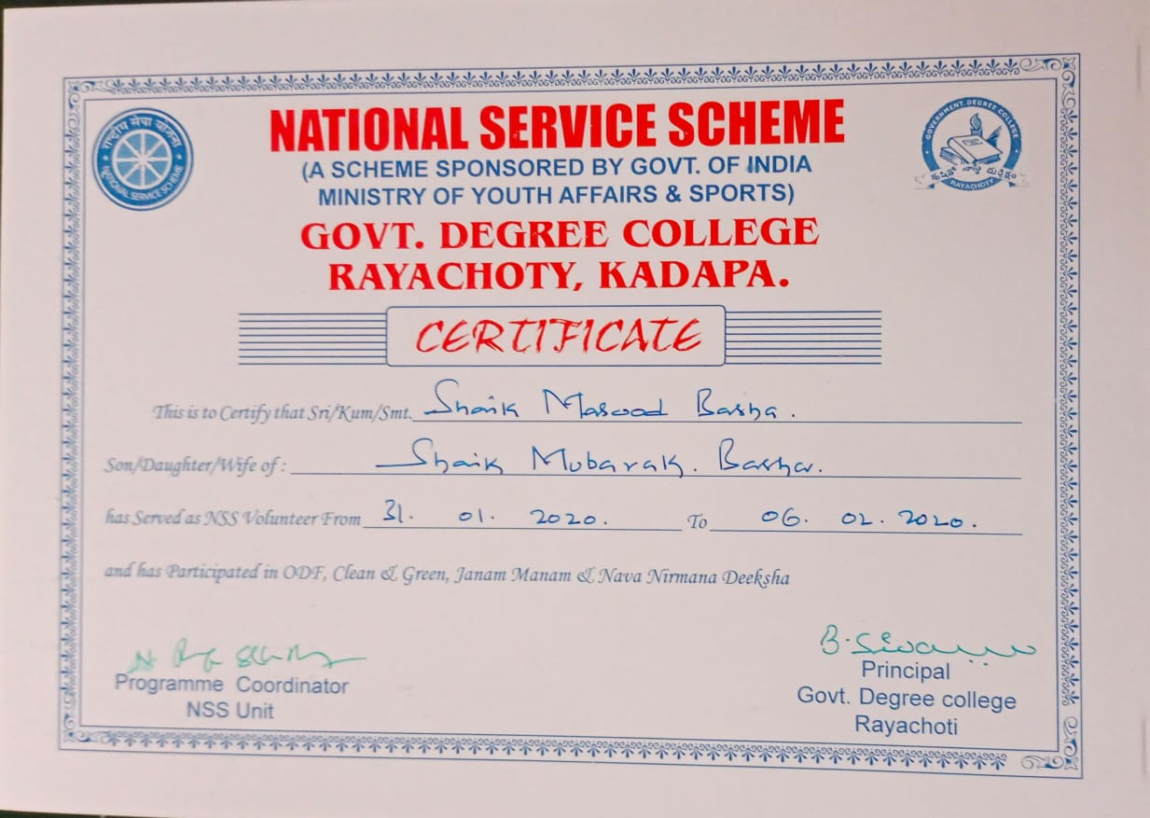

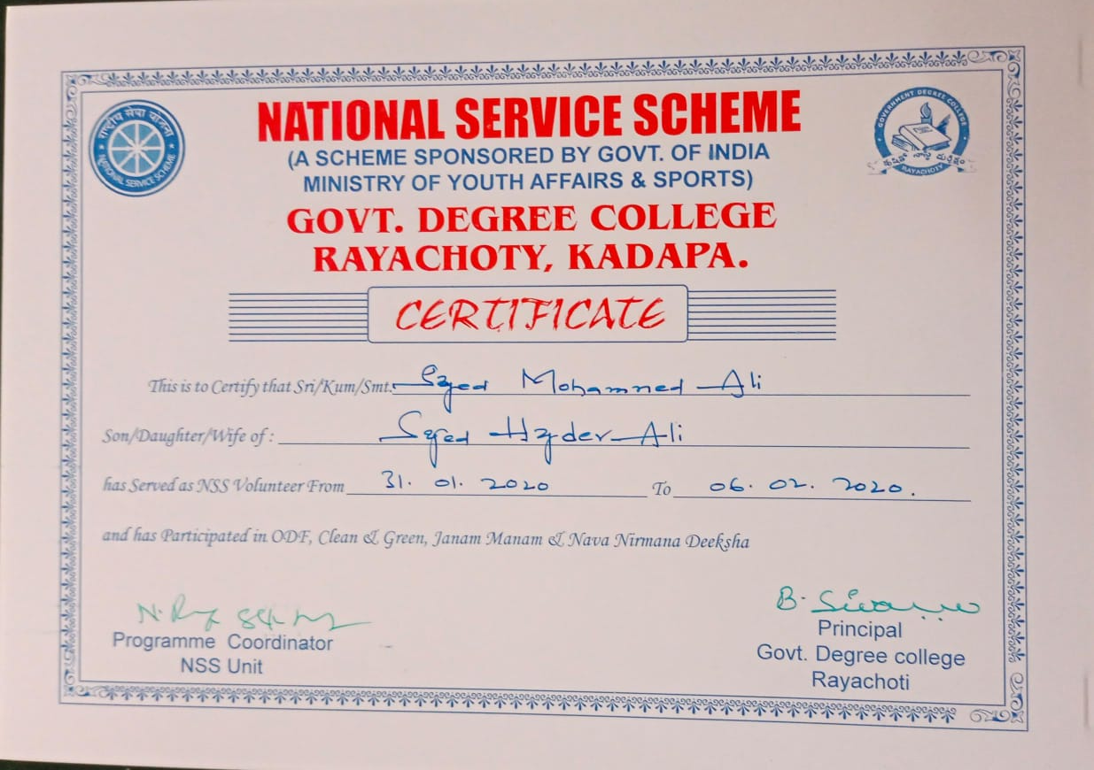

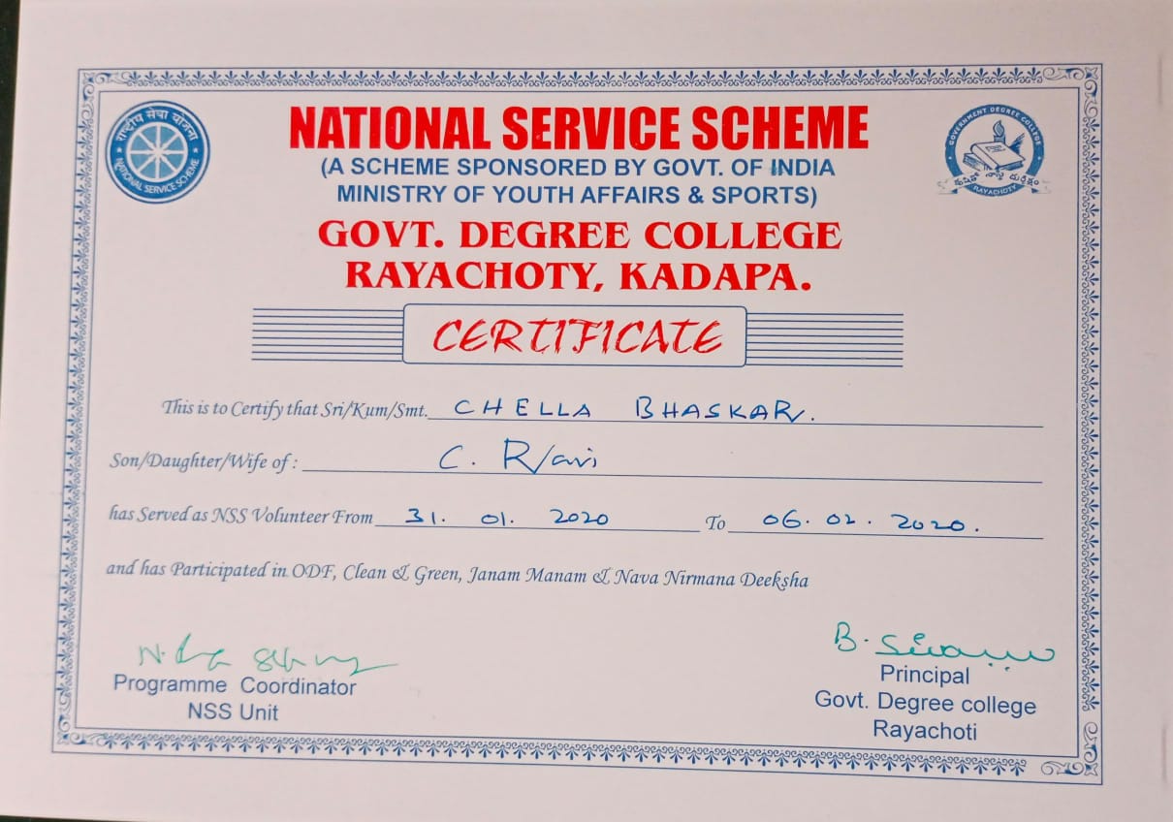

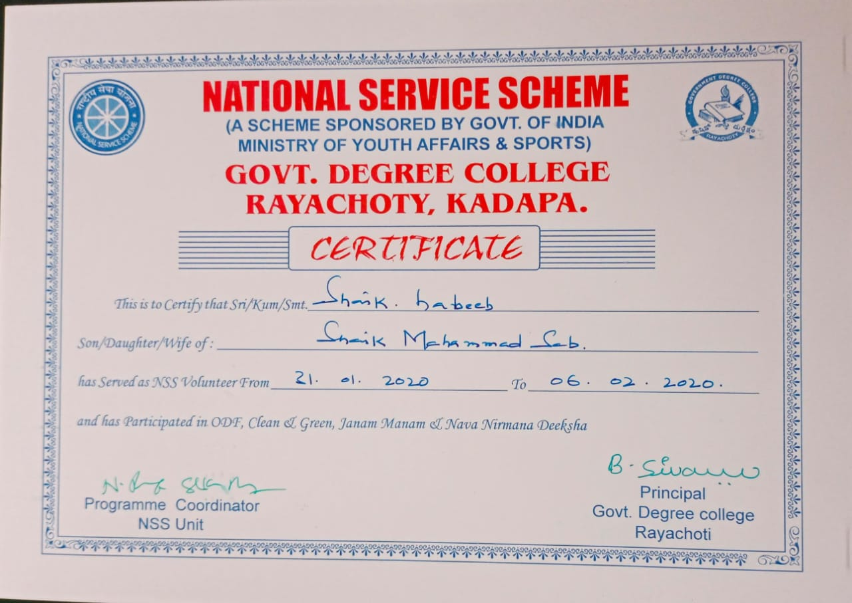

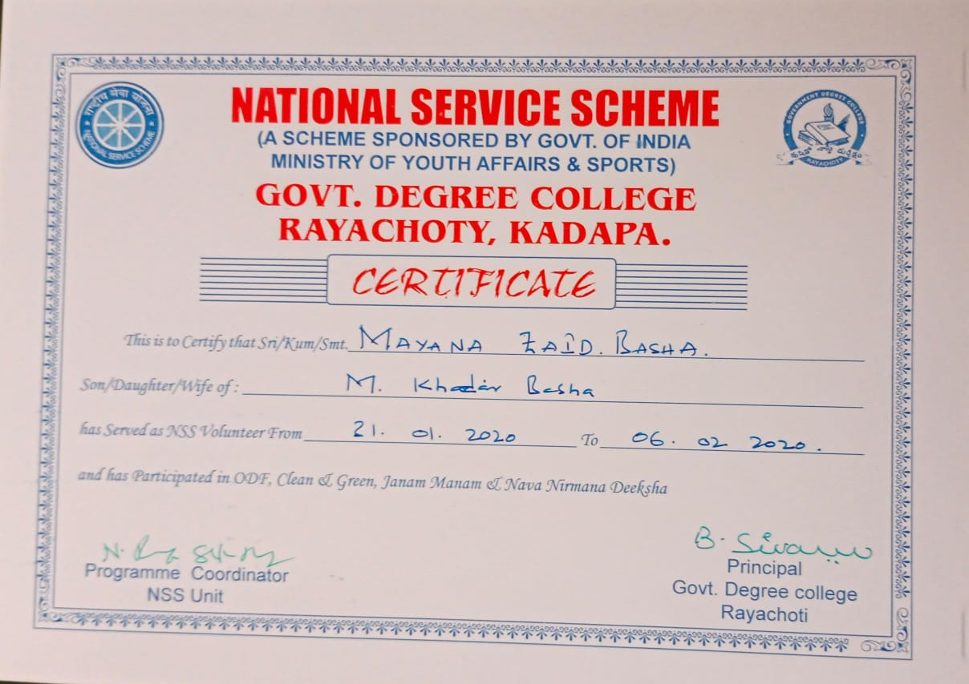

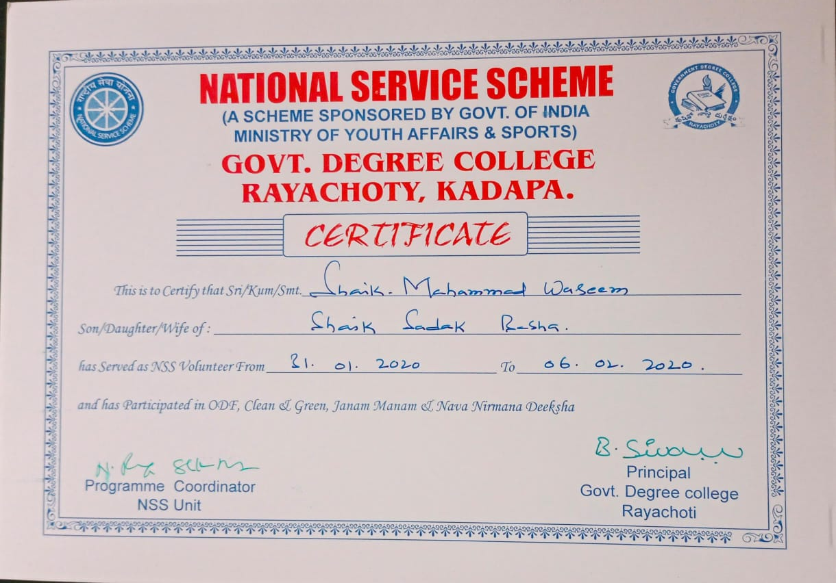

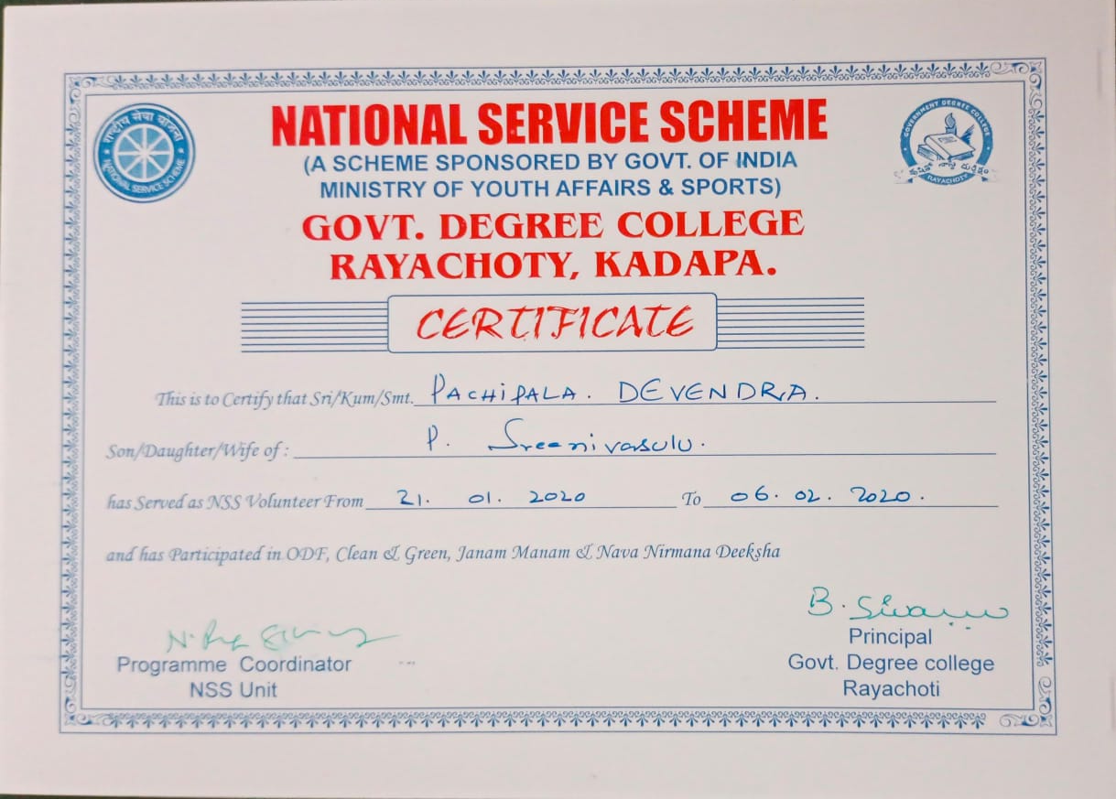

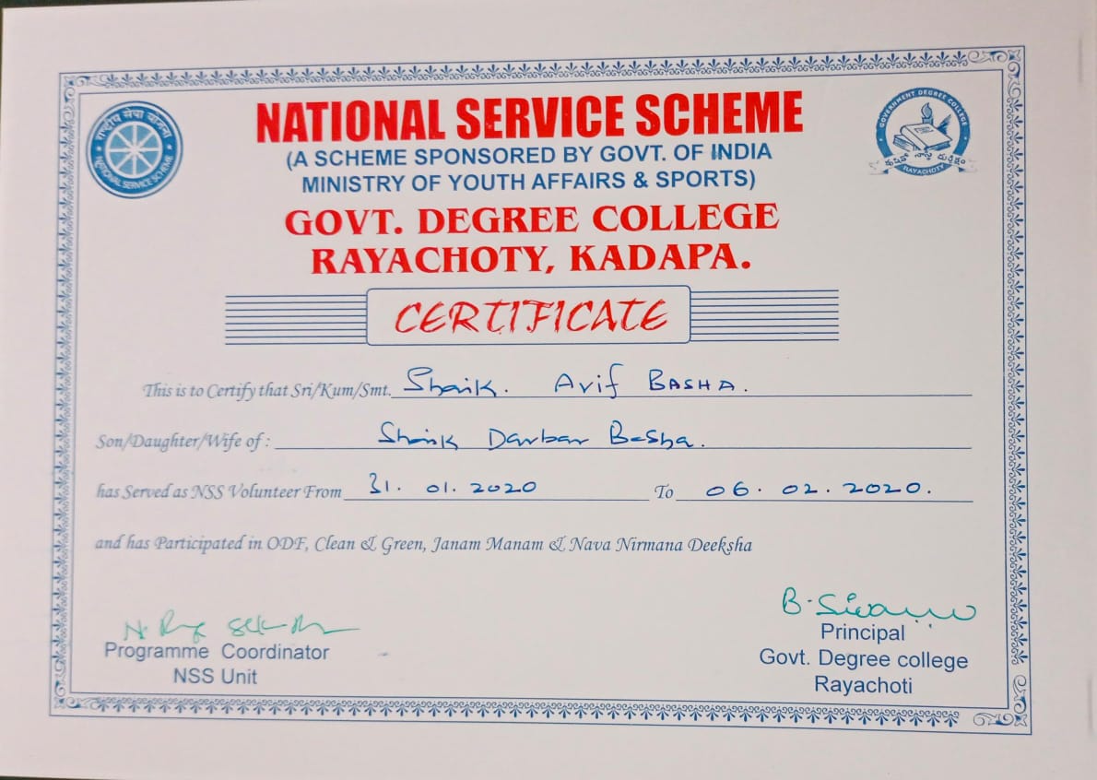

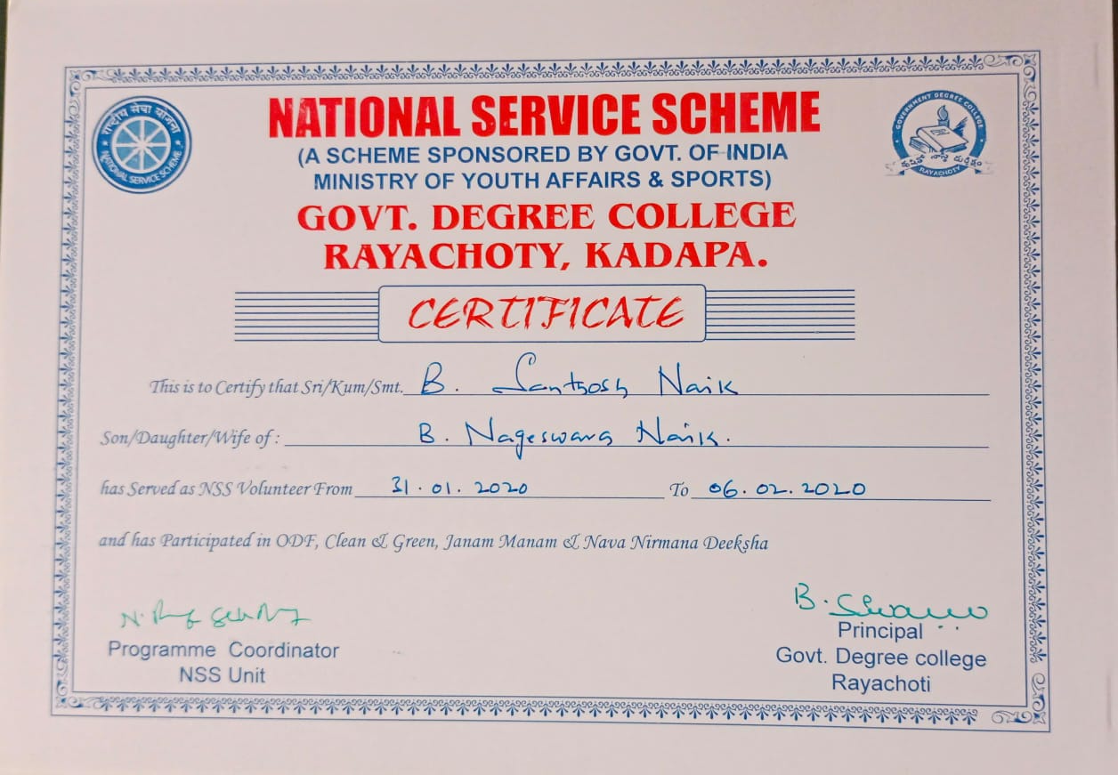

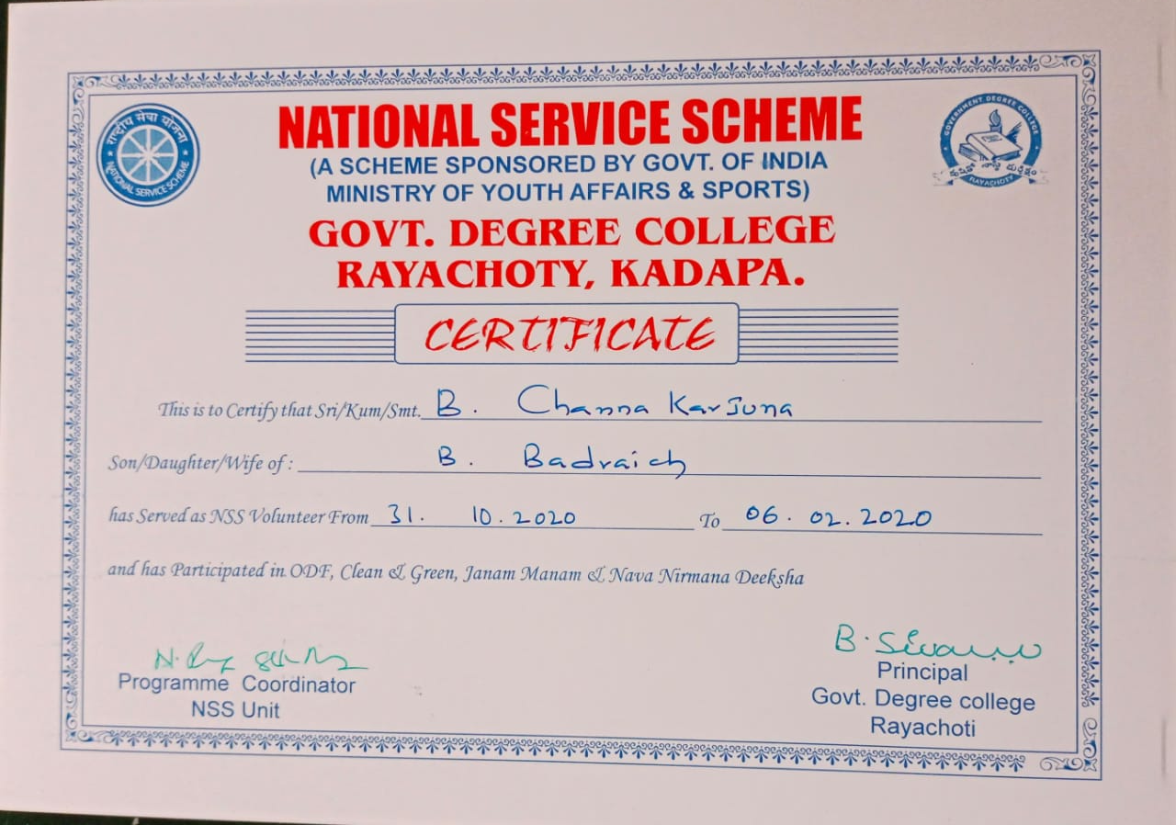

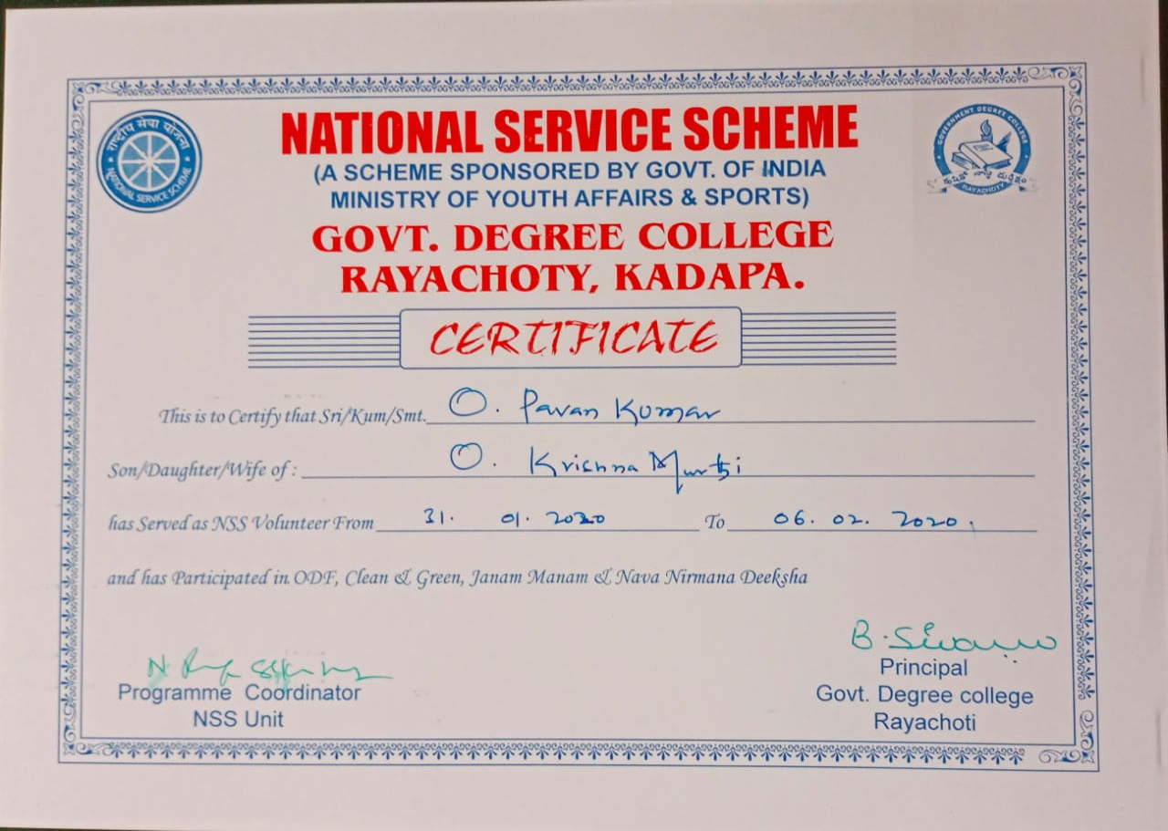

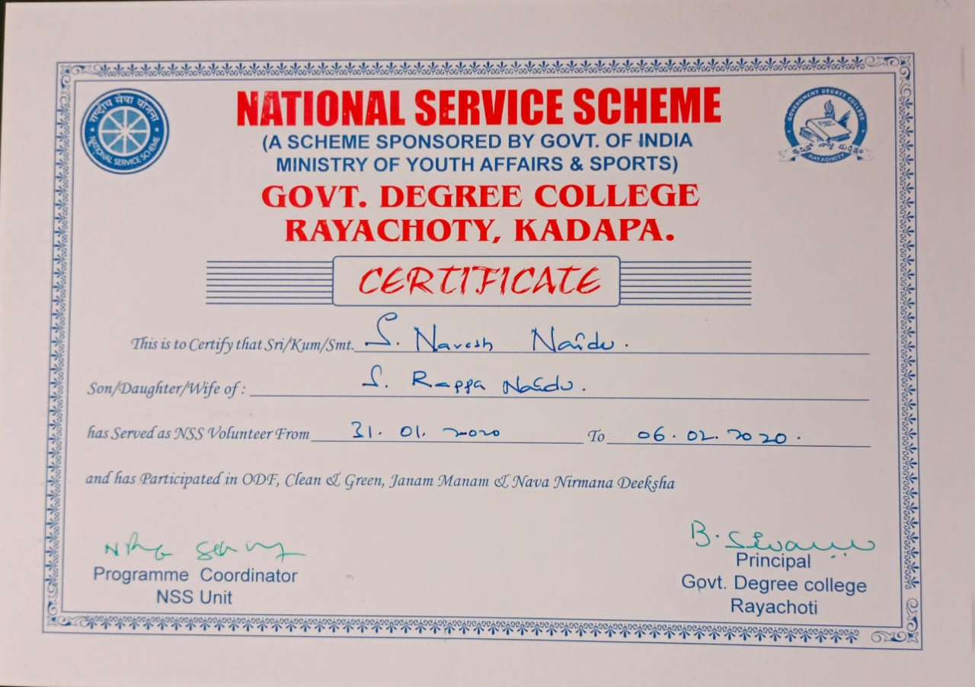

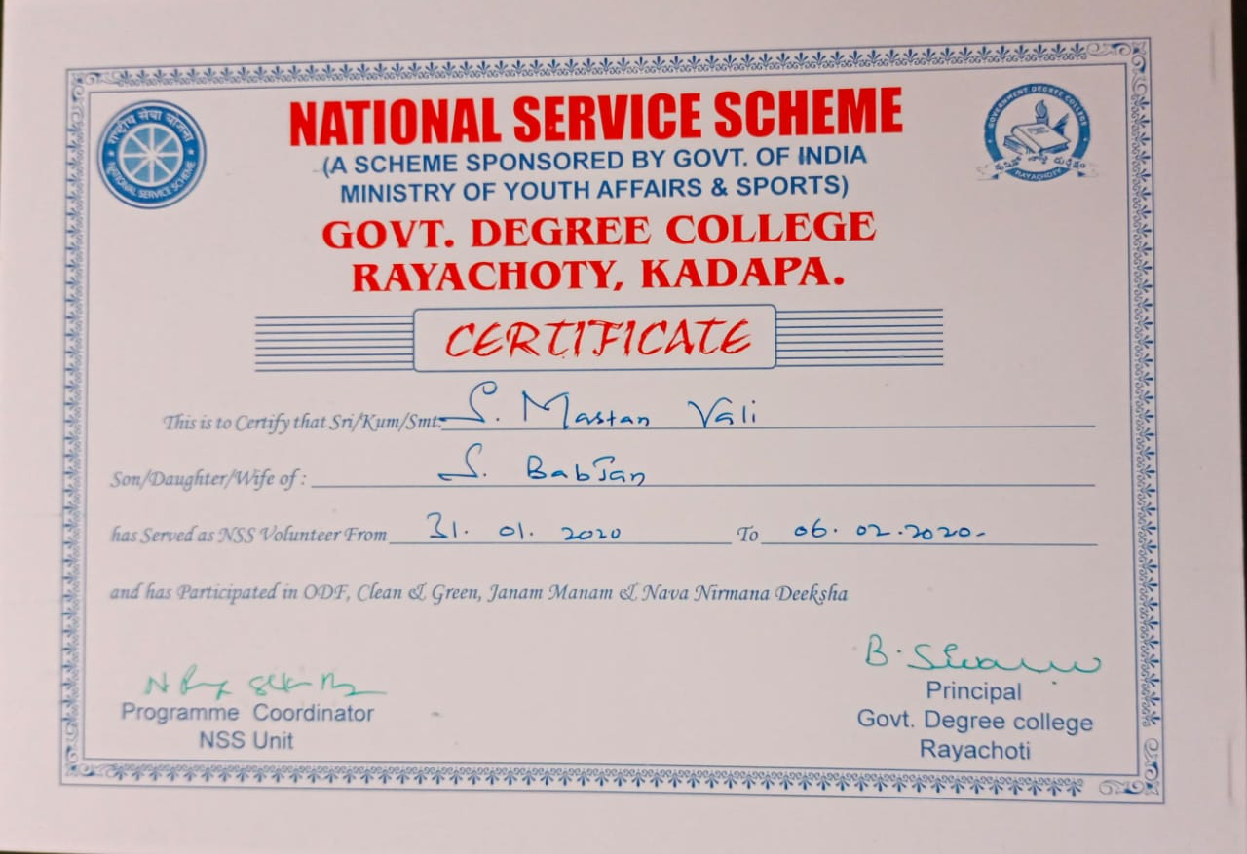

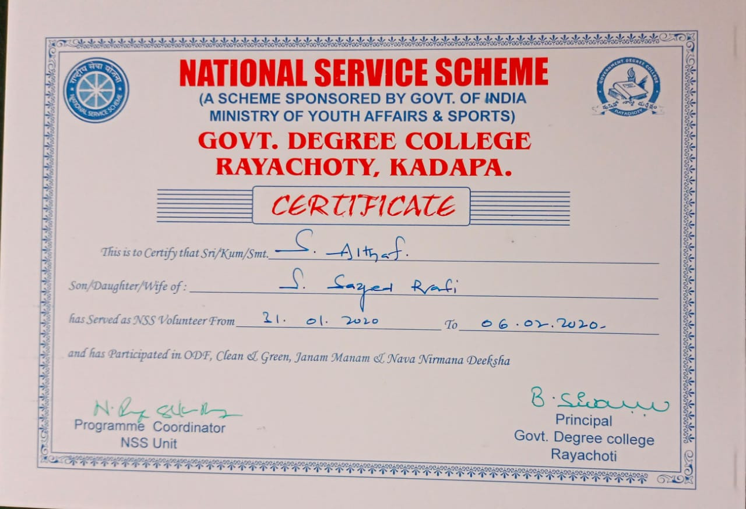

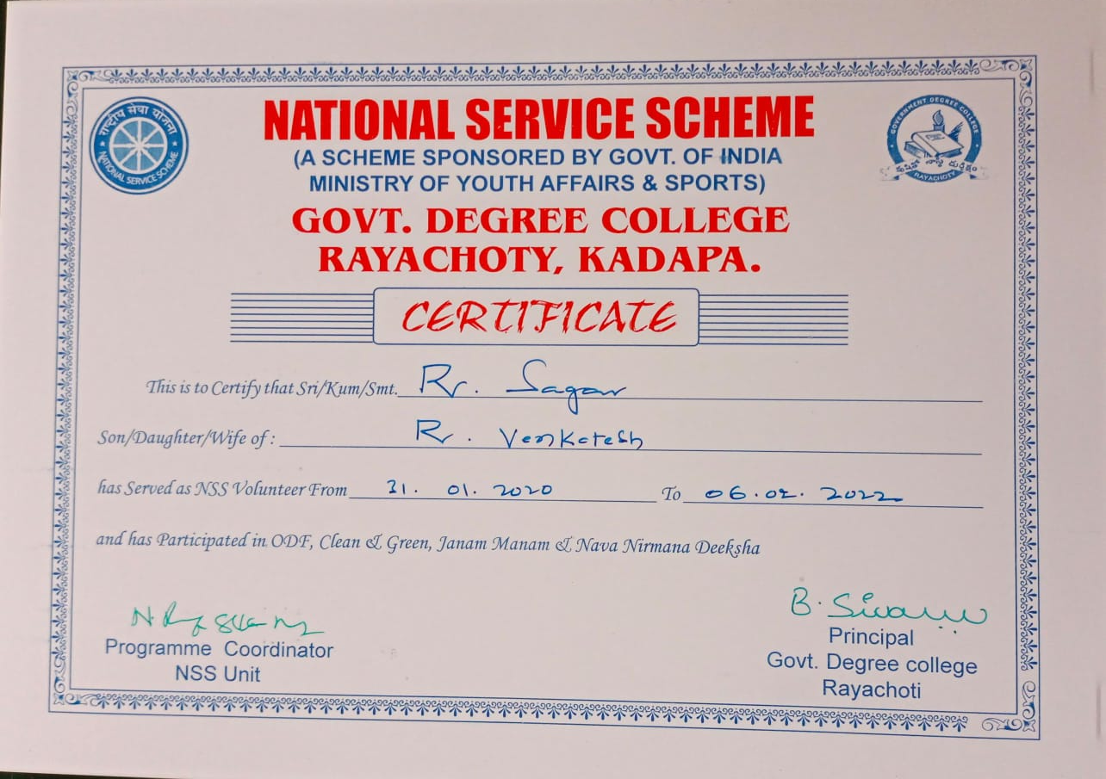

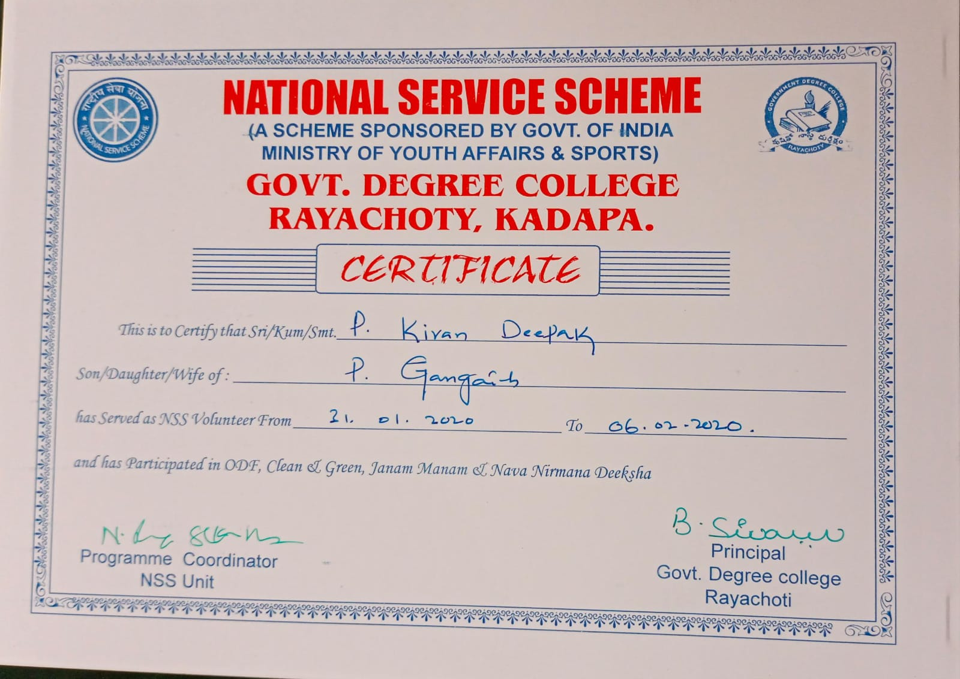

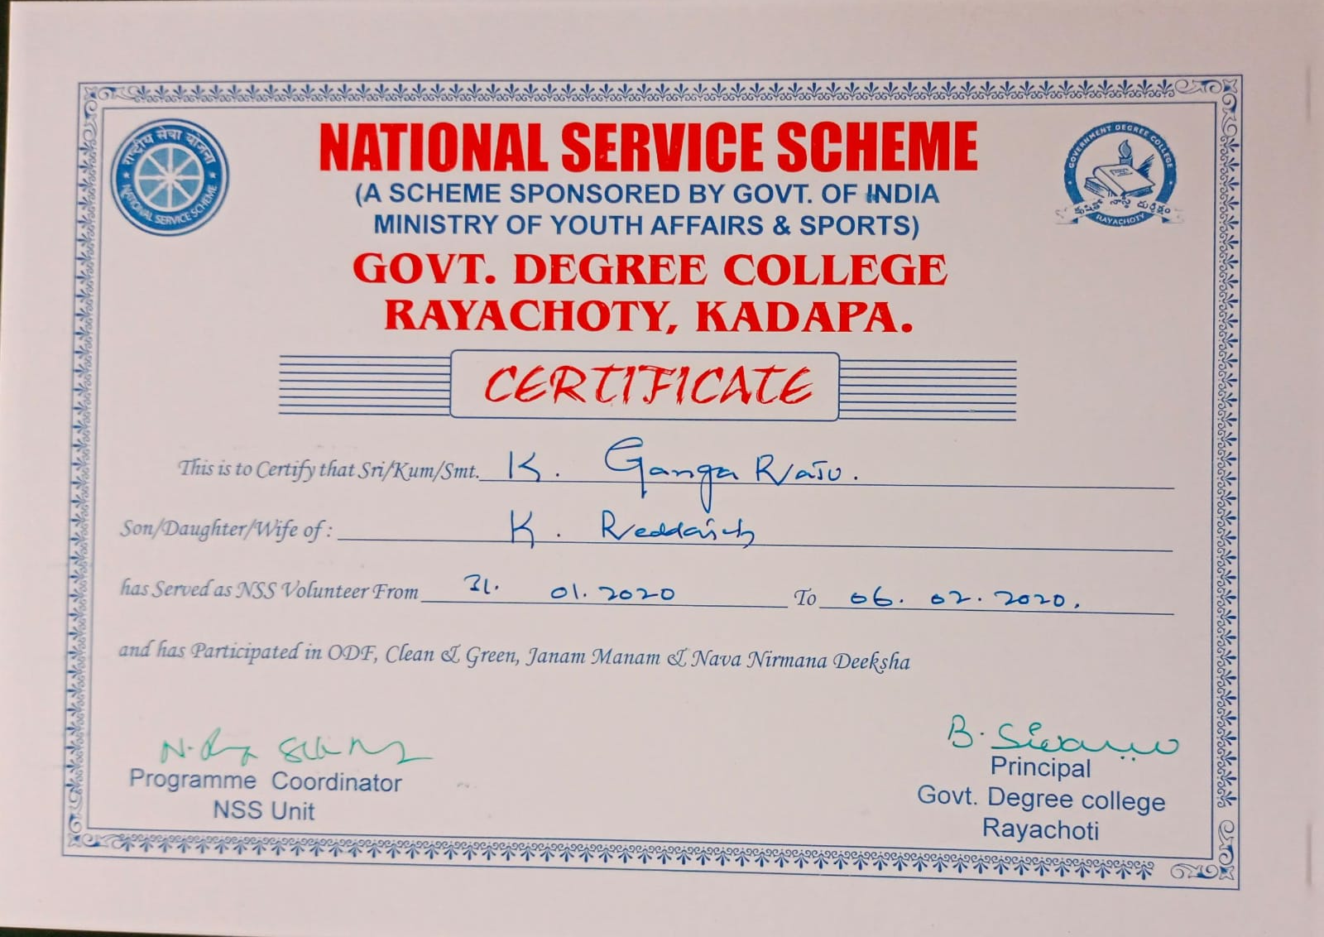

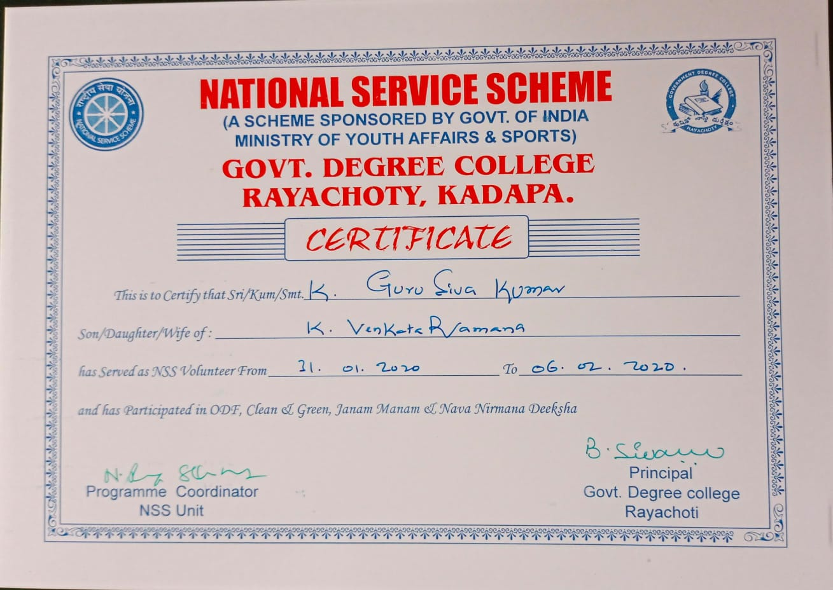

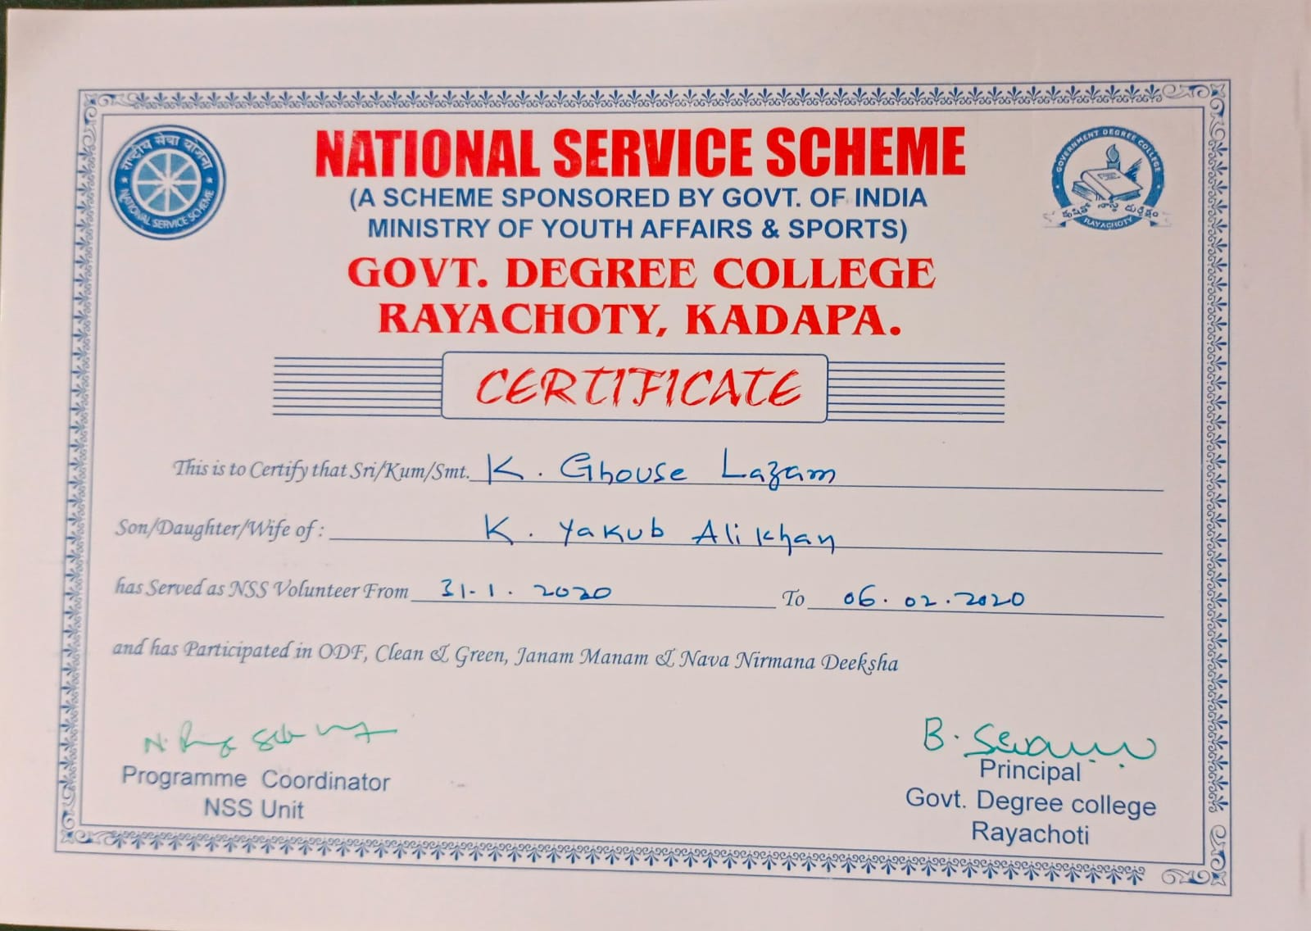

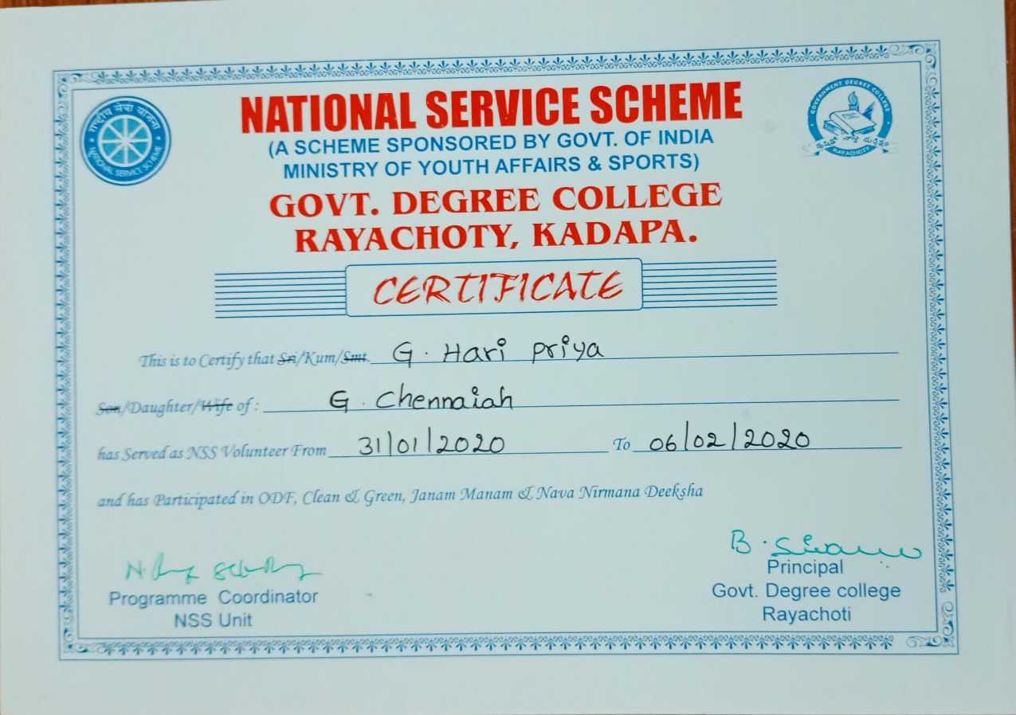

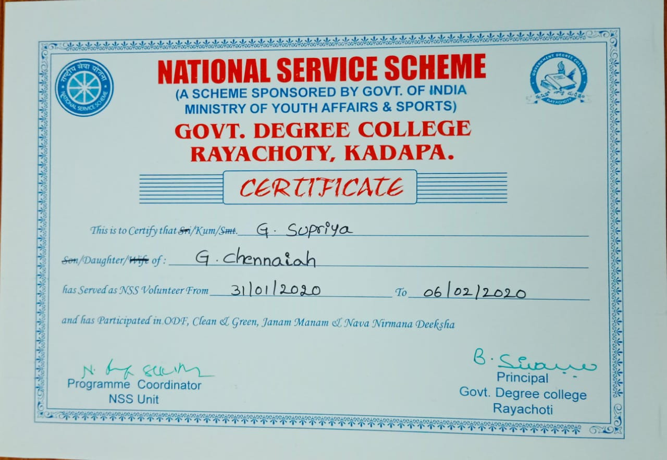

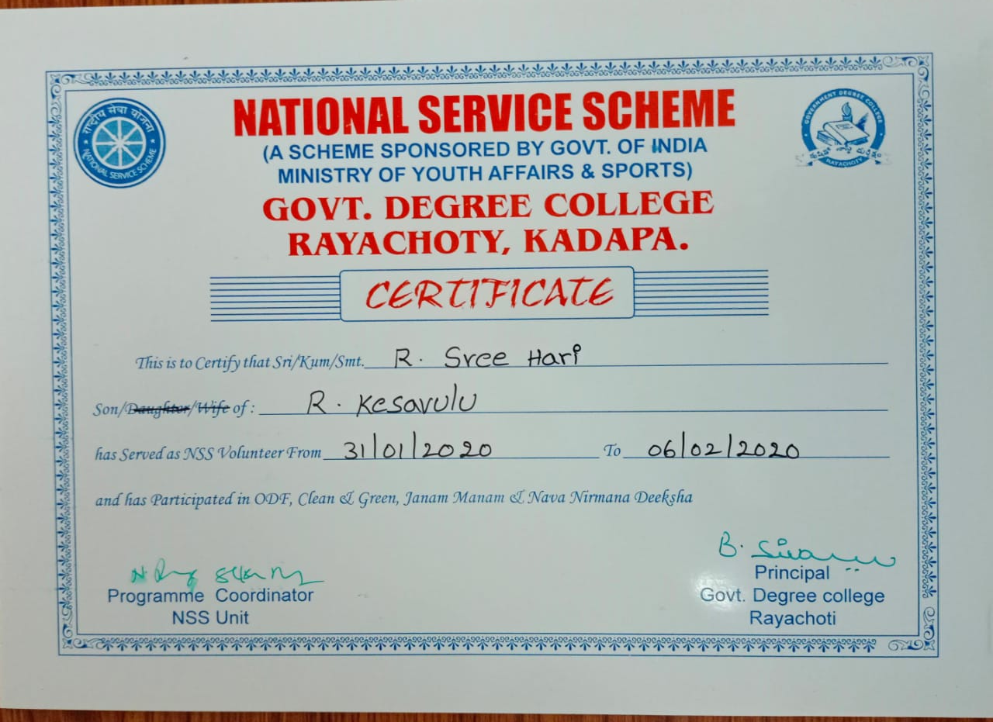

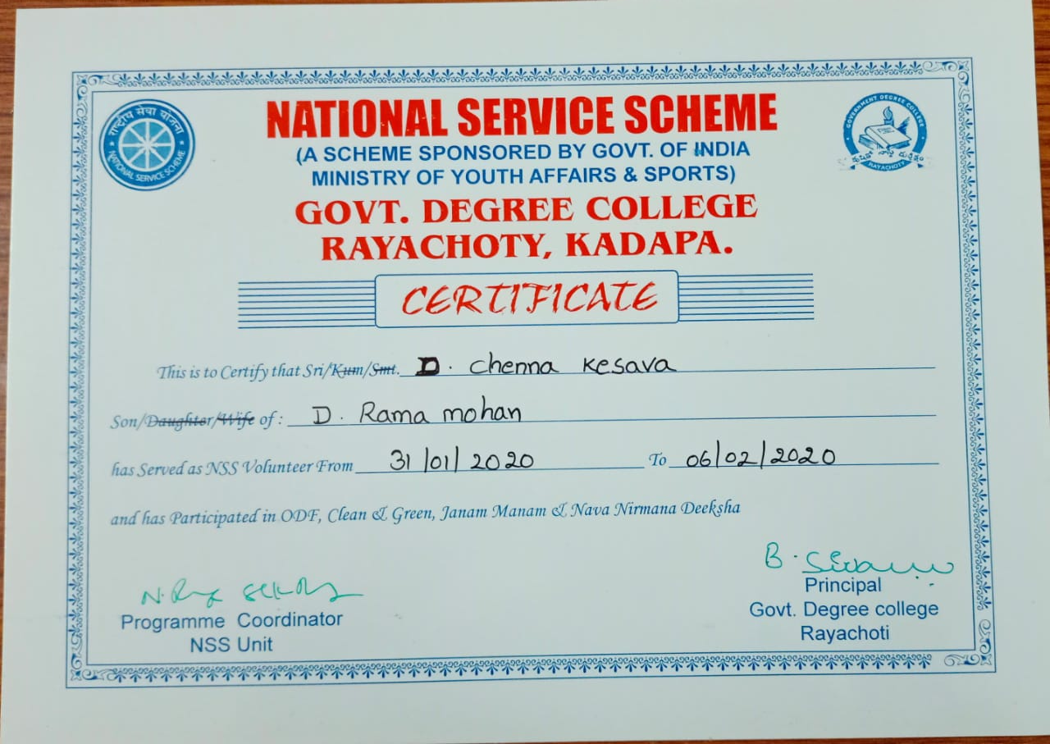

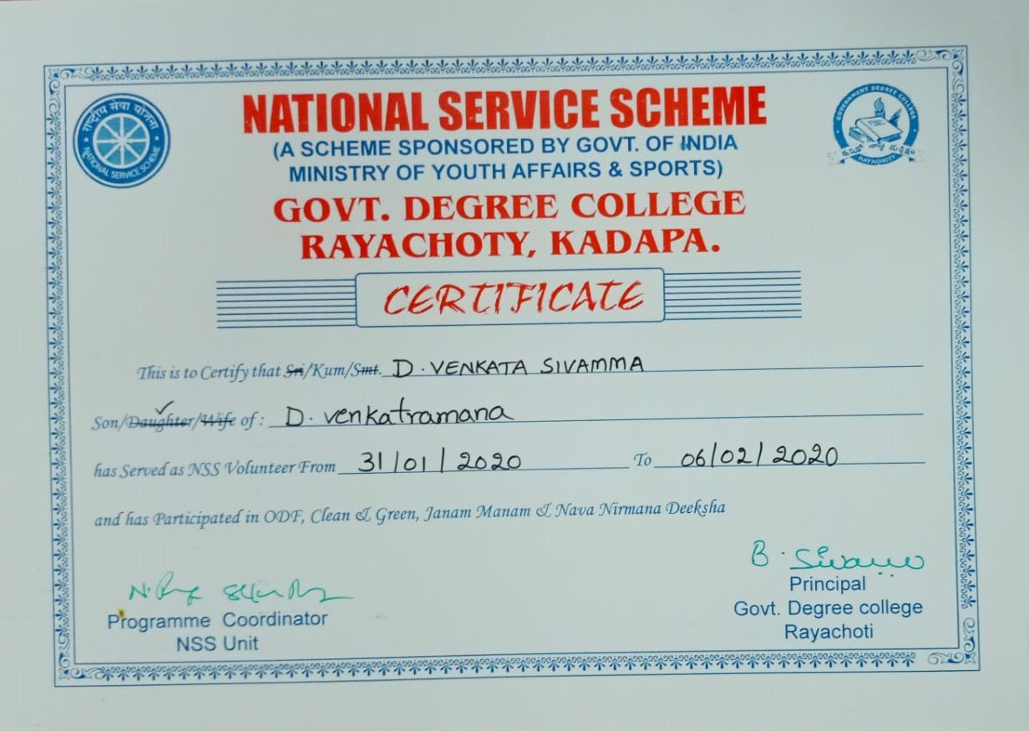

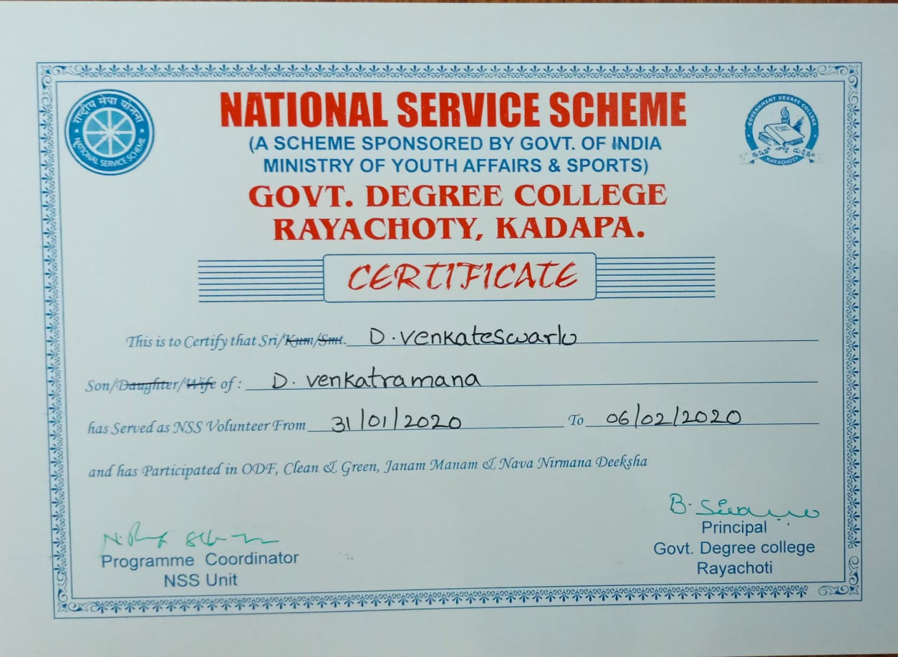

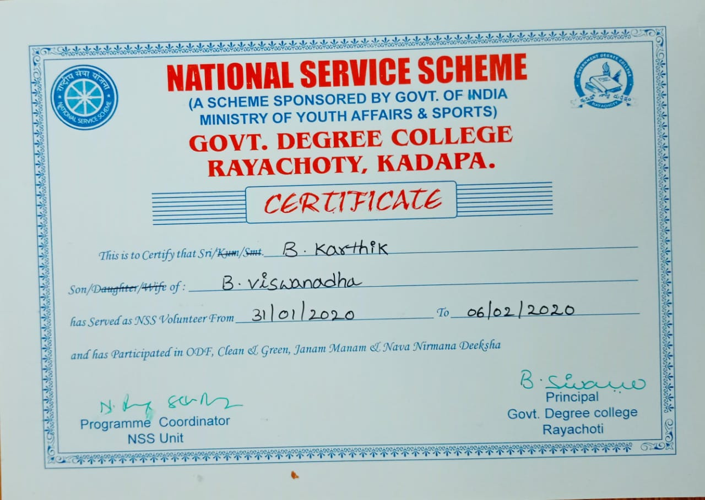

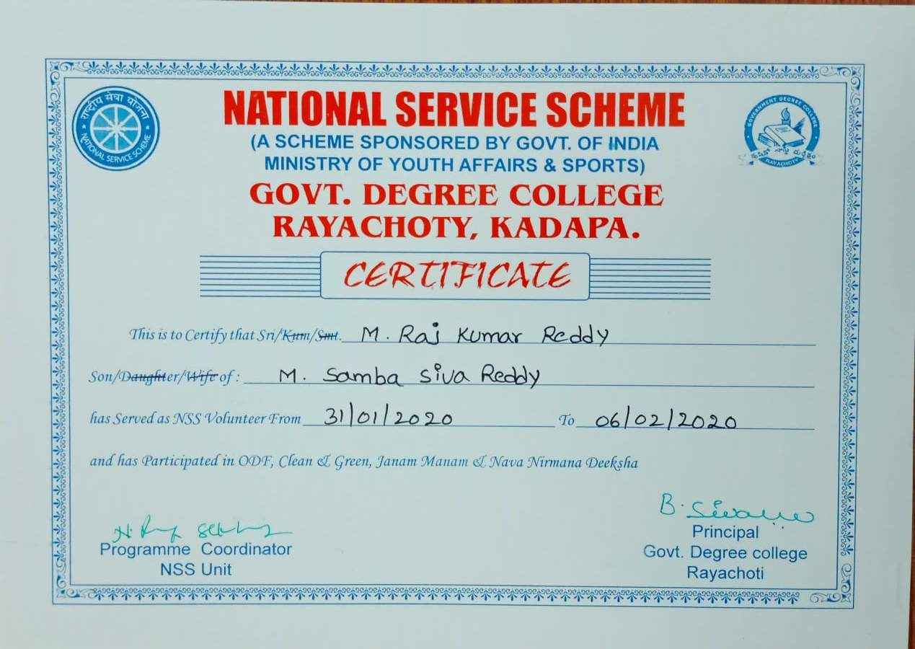

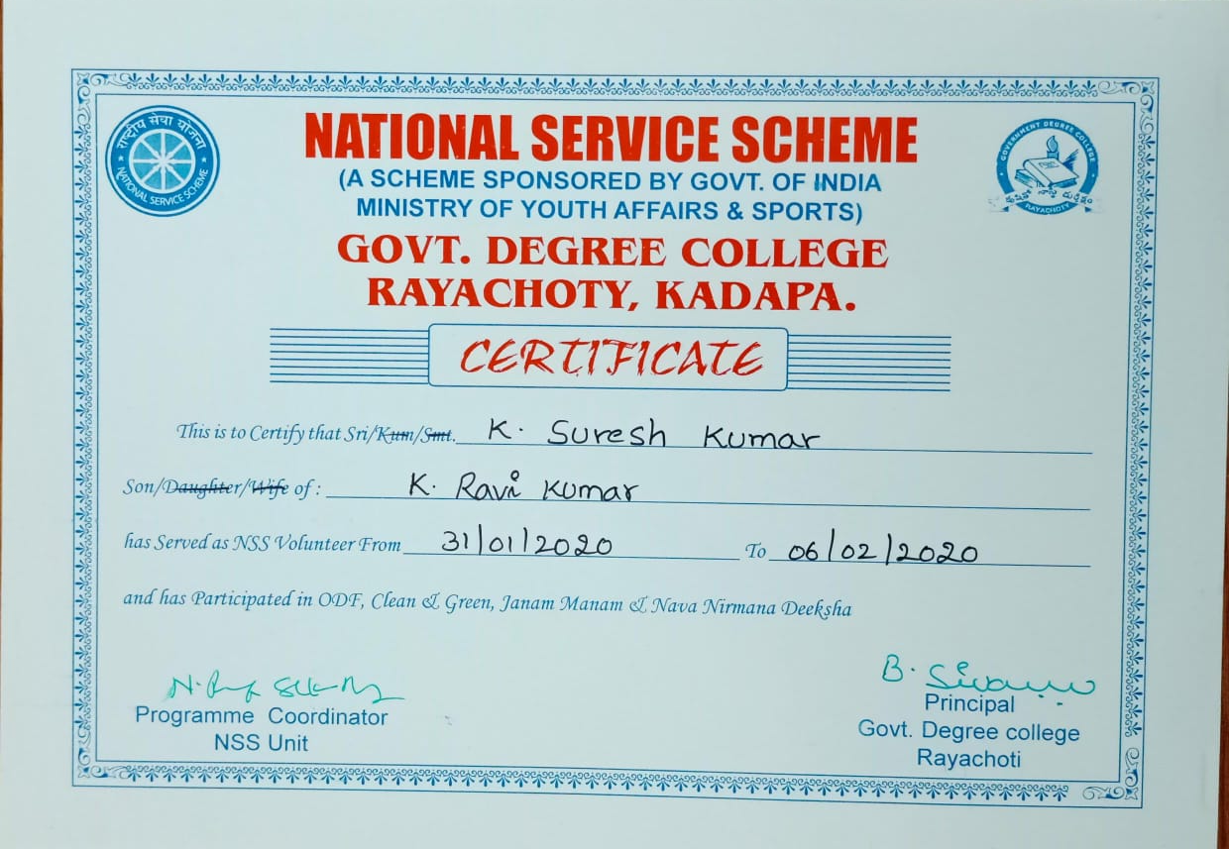

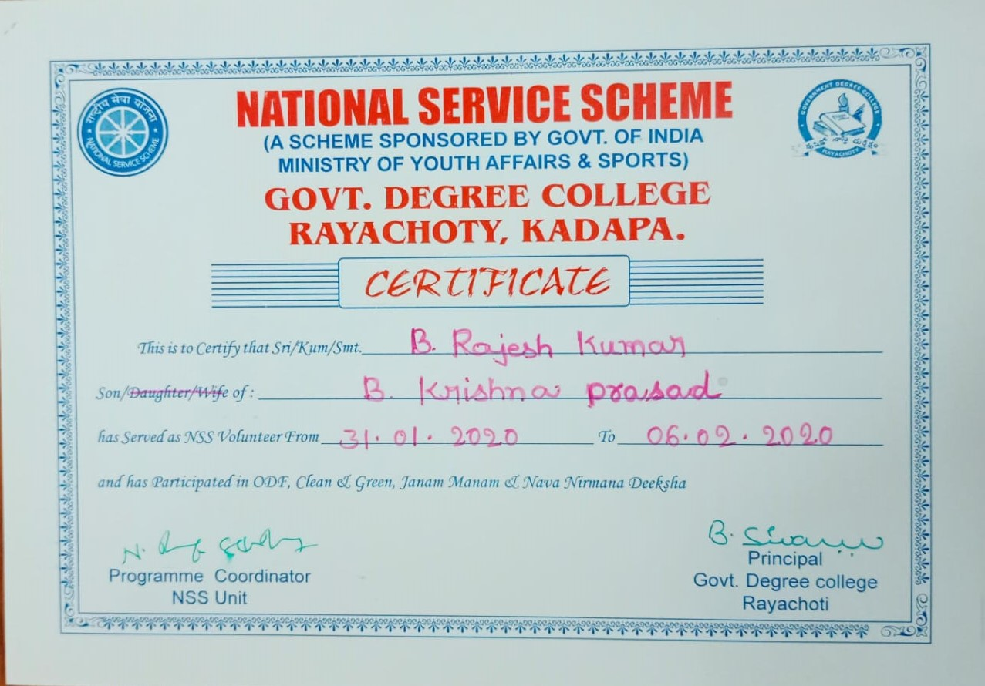

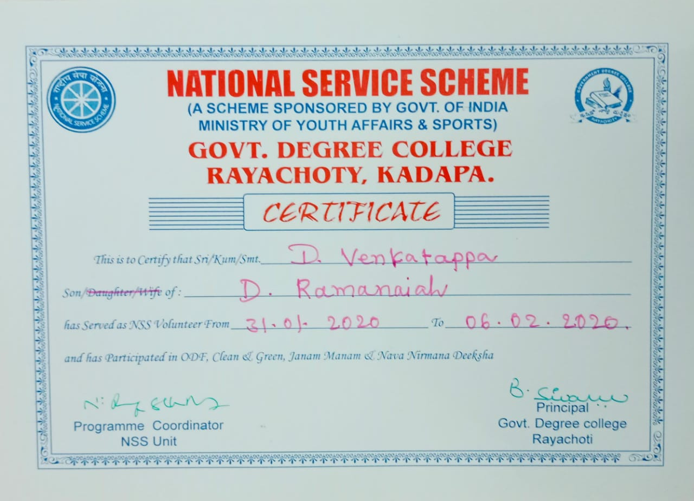

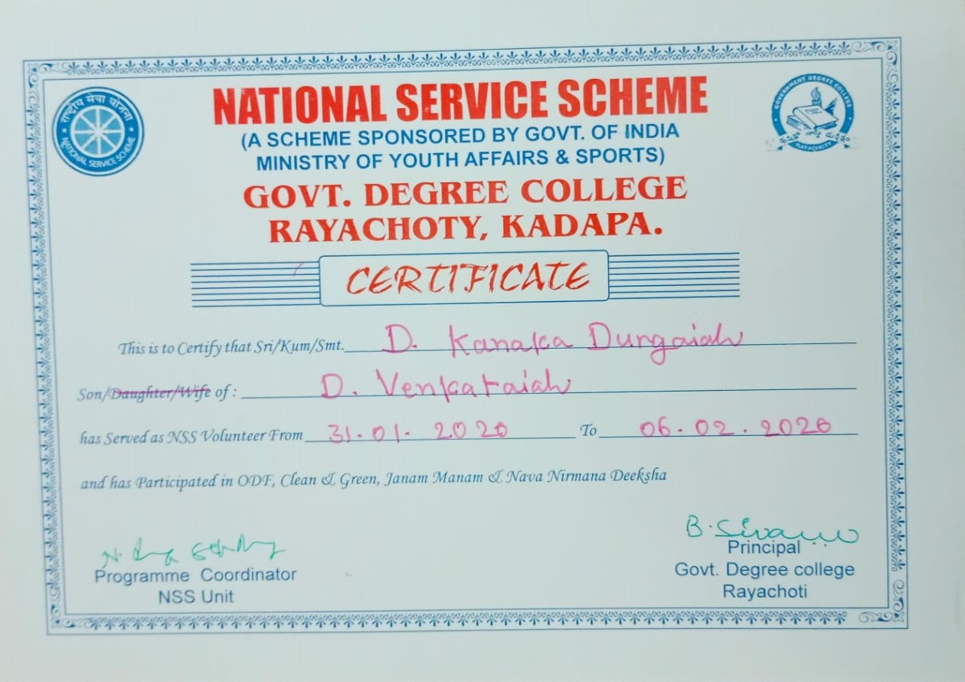

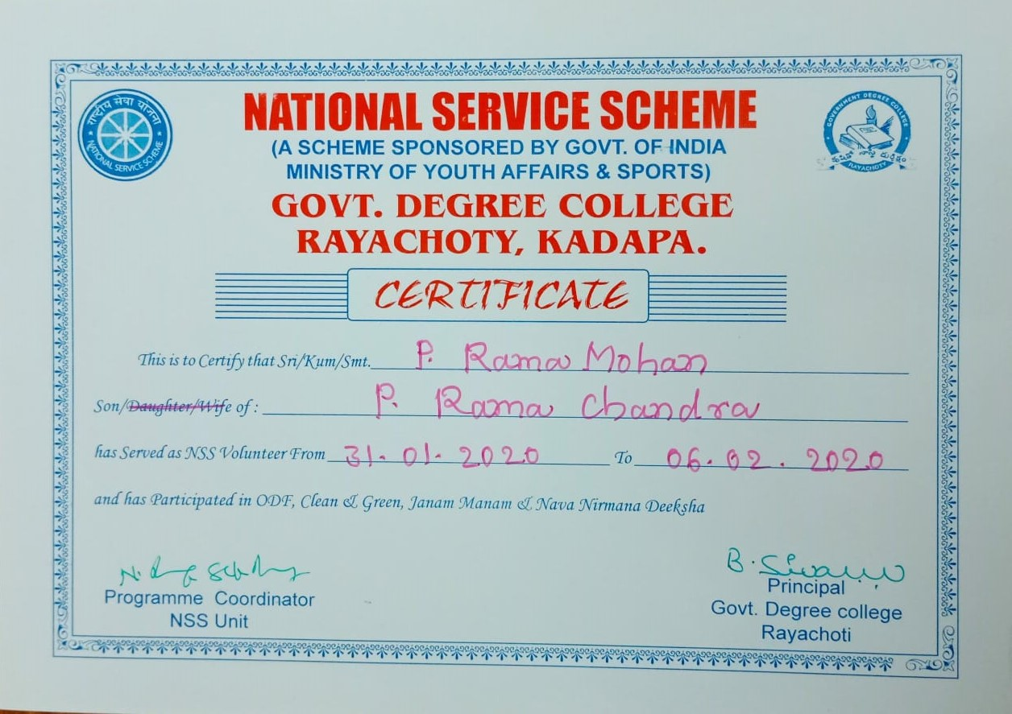

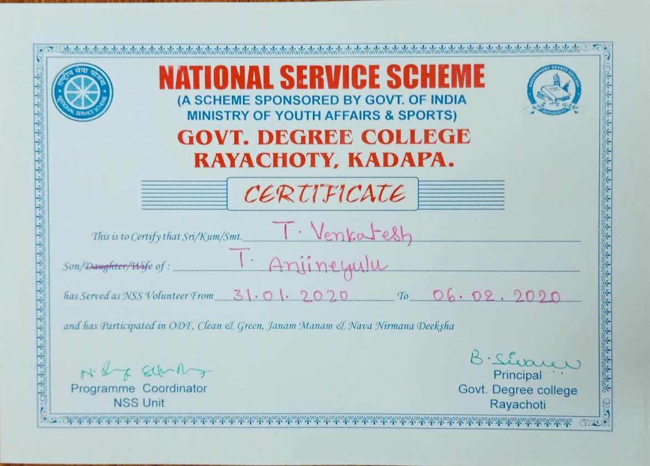

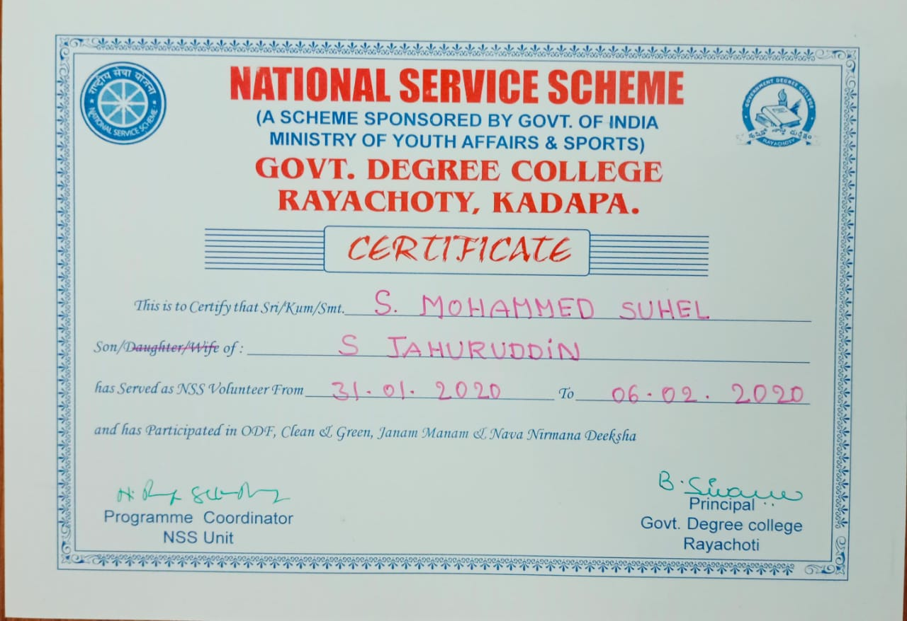

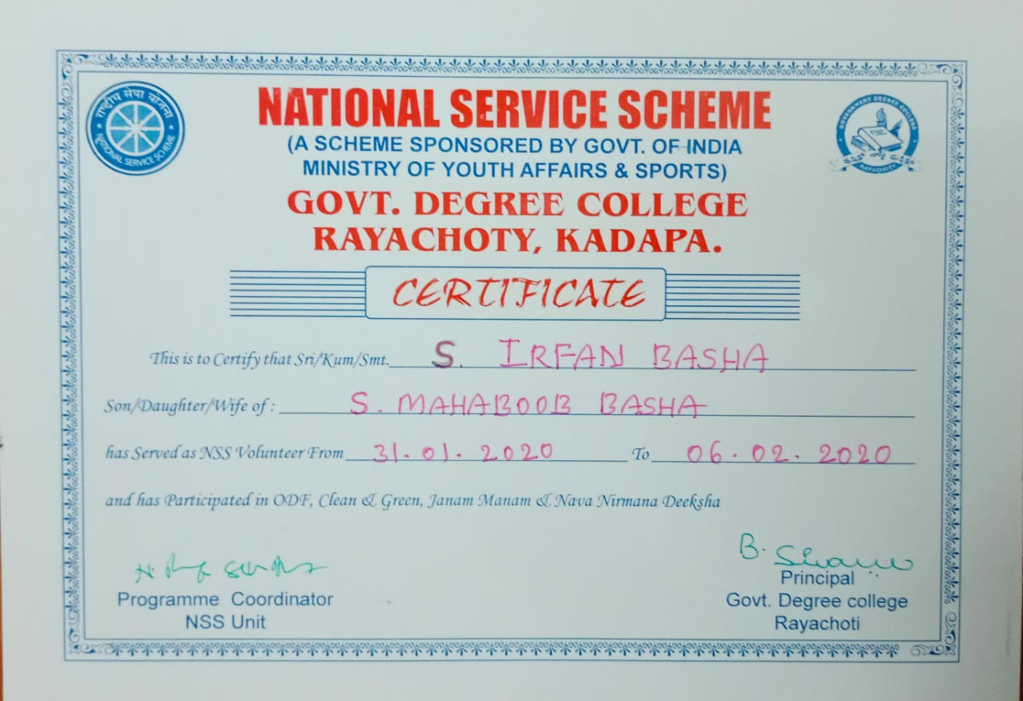

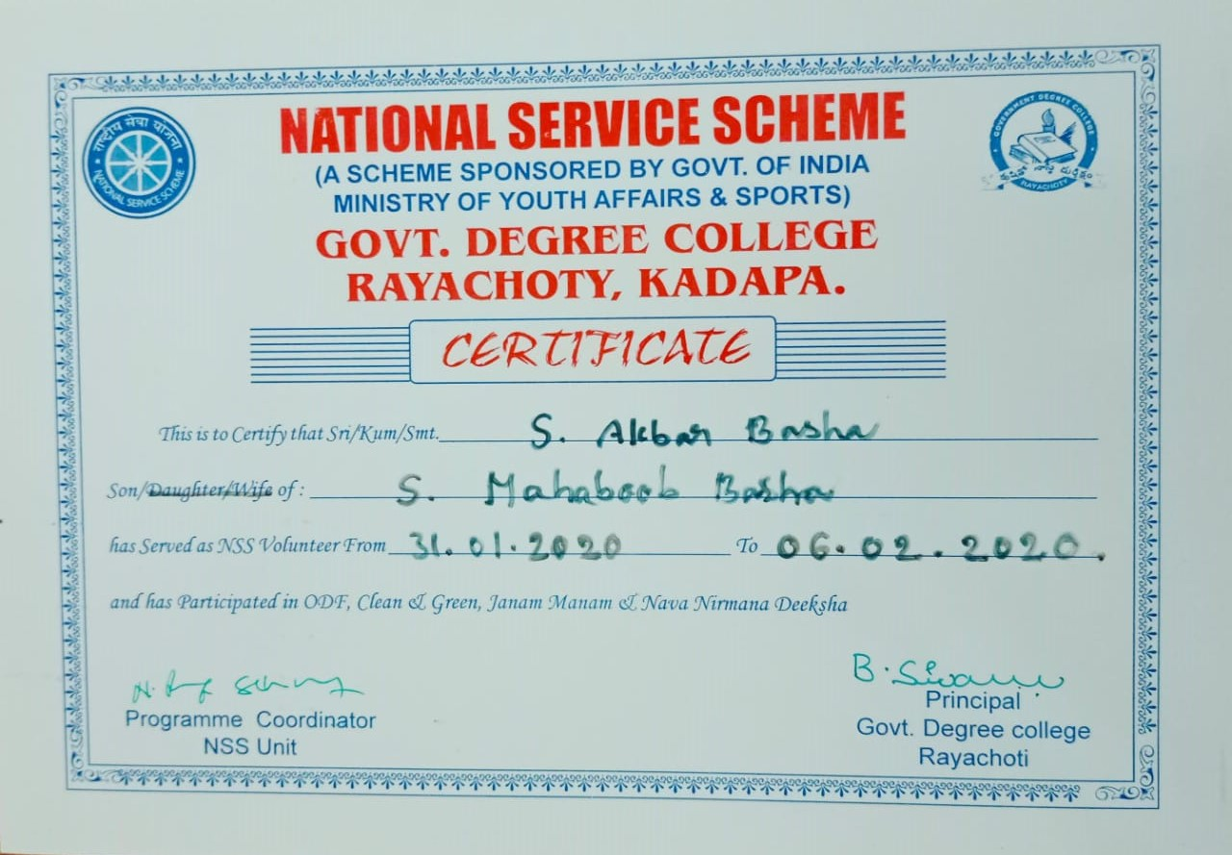

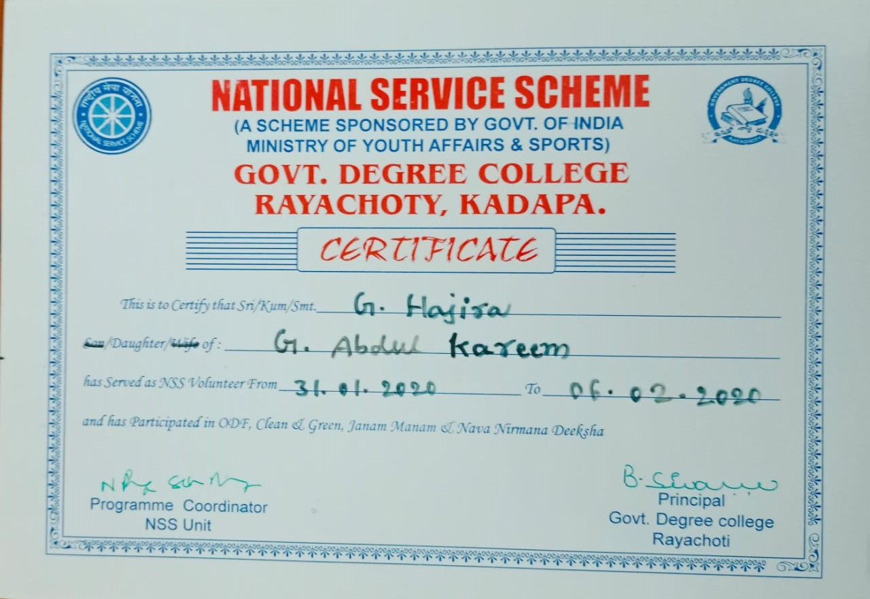

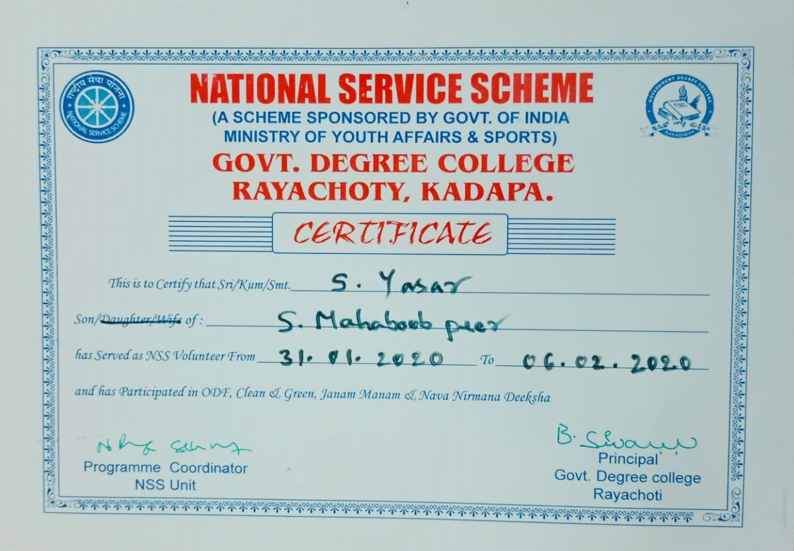

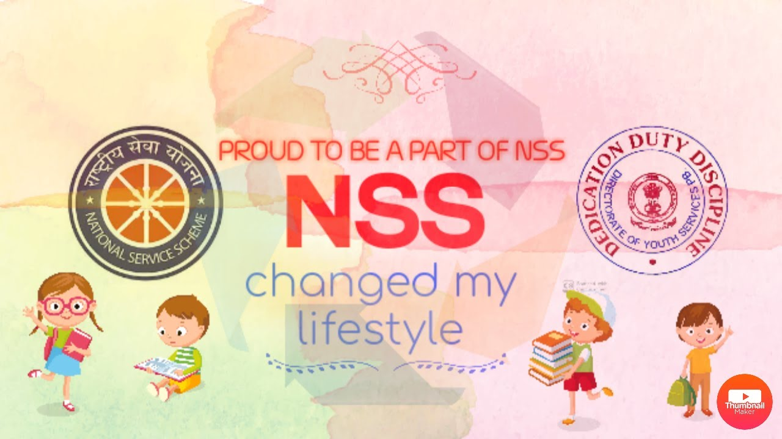
INDIAN RED CROSS SOCIEY
The Indian Red Cross Blood Bank is part of the larger Indian Red Cross Society, which is a humanitarian organization dedicated to providing emergency assistance, disaster relief, and education in communities affected by crises. The Blood Bank specifically focuses on the collection, processing, and distribution of blood and blood products to meet the medical needs of patients in hospitals and healthcare facilities.
- Blood Donation Drives: They organize regular blood donation camps and drives to encourage voluntary blood donation. These drives are often conducted in collaboration with schools, colleges, corporate organizations, and community groups.
- Blood Collection and Testing: Once blood is donated, it is collected in sterile conditions and undergoes rigorous testing for various infections and diseases to ensure it is safe for transfusion.
- Blood Processing: The collected blood is separated into its components, such as red blood cells, plasma, and platelets, allowing for multiple patients to benefit from a single donation.
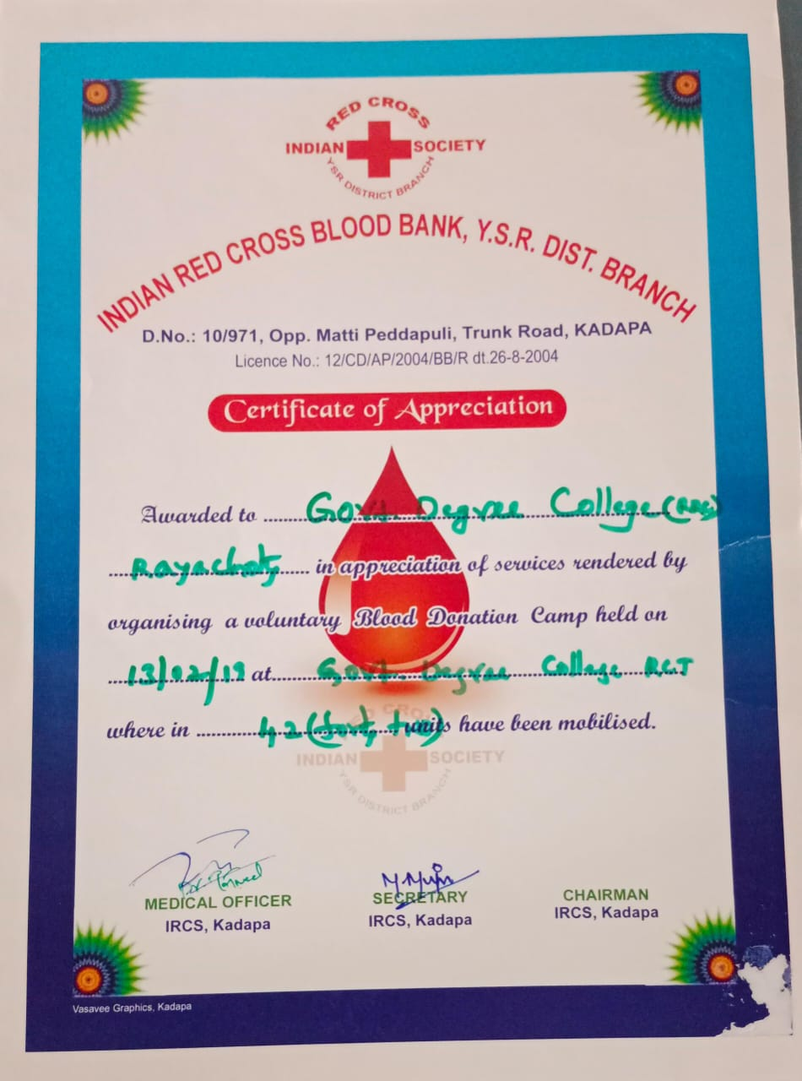

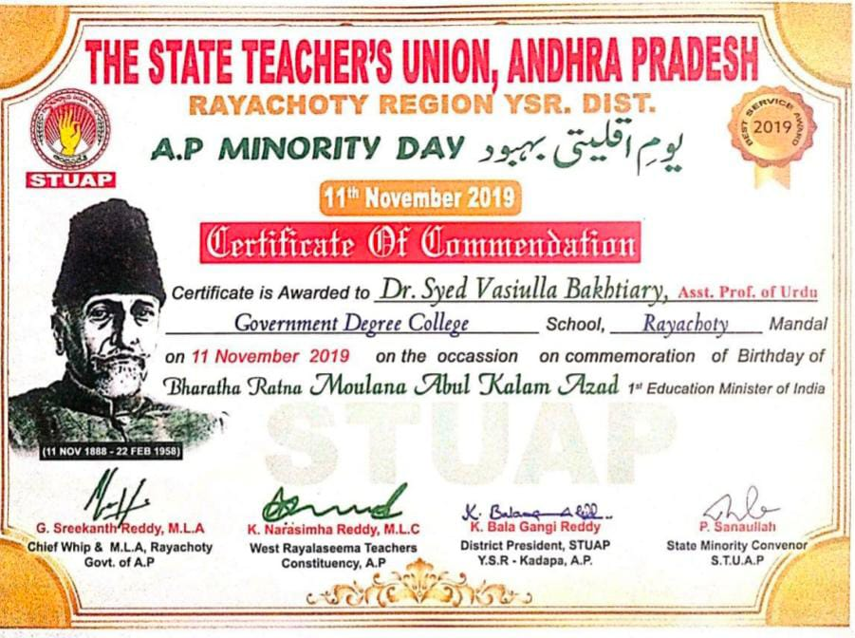

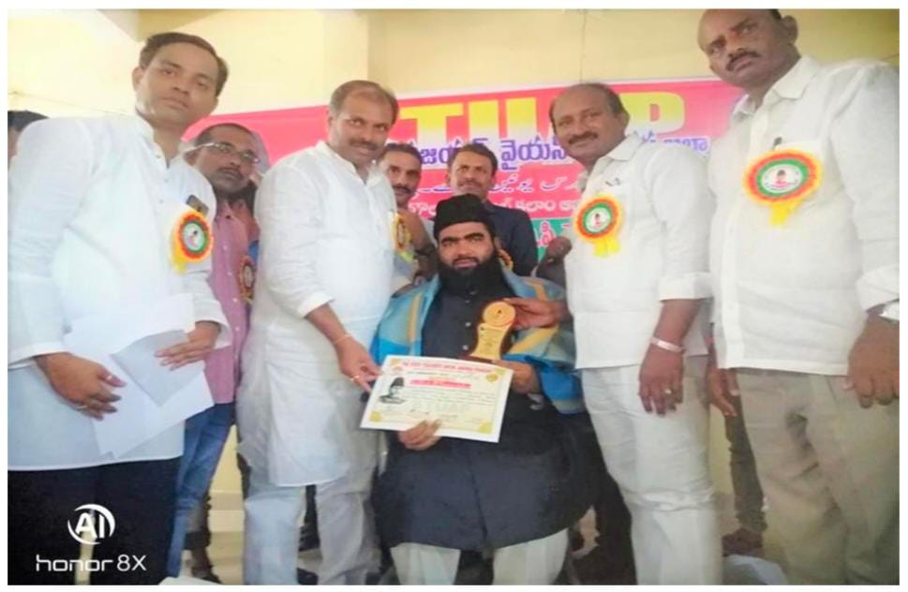
Dr. Syed Vasiulla Bakhtiary, Lecturer in Urdu received Certificate of Commendation from State Teachers Union, Rayachoti on the occasion of the National Education Day 01-11-2019.

Dr. Syed Vasiulla Bakhtiary, Lecturer in Urdu received Certificate of Commendation from State Teachers Union, Rayachoti Region Unit, from the Teacher MLC Rayalaseema Mr. Katti Narasimha Reddy and the MLA of Rayachoti Assembly Constituency Mr. Gadi Kota Srikant Reddy on 11-11-2019.
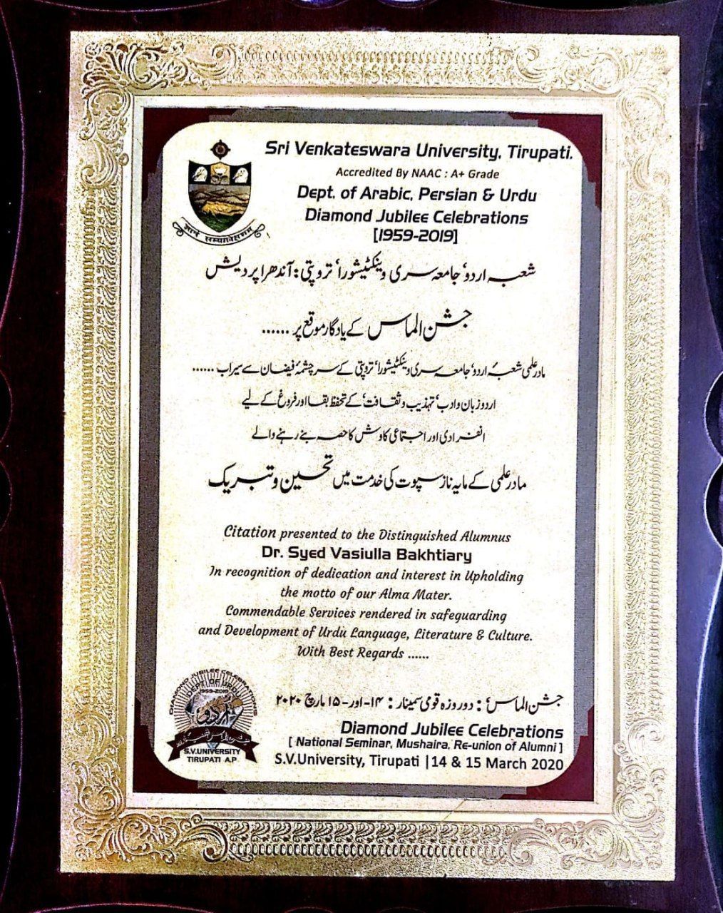

Dr. Syed Vasiulla Bakhtiary, Lecturer in Urdu felicitated and received the Citation Award & Felicitation Certificate from the Department of Urdu, Sri Venkateswara University, Tirupati in

Dr. Syed Vasiulla Bakhtiary, Lecturer in Urdu felicitated and received the citation award & facilitation certificate from the Department of Urdu. SVU Tirupati in the connection with the Diamond Jubilee Celebrations, Jashn-e- Almas on 14th & 15th March, 2020.
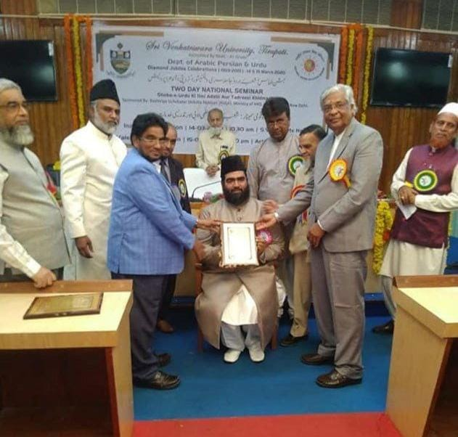

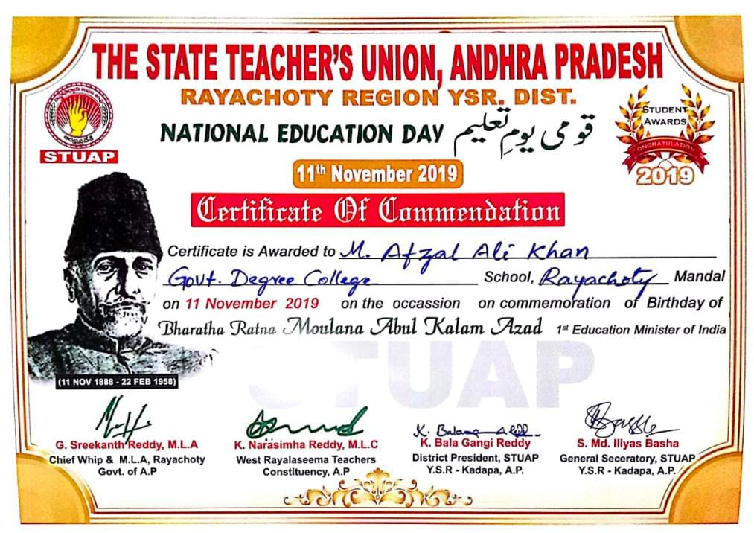
Dr Syed Vasiulla Bakhtiyari Felicitated by Sri Venkateswara University Staff and Urdu Teachers

Mayana Afzal Ali Khan BA HPU Urdu Medium Student received Certificate of Commendation from State Teachers Union, Rayachoti on the occasion of the National Education Day 01-11-2019.
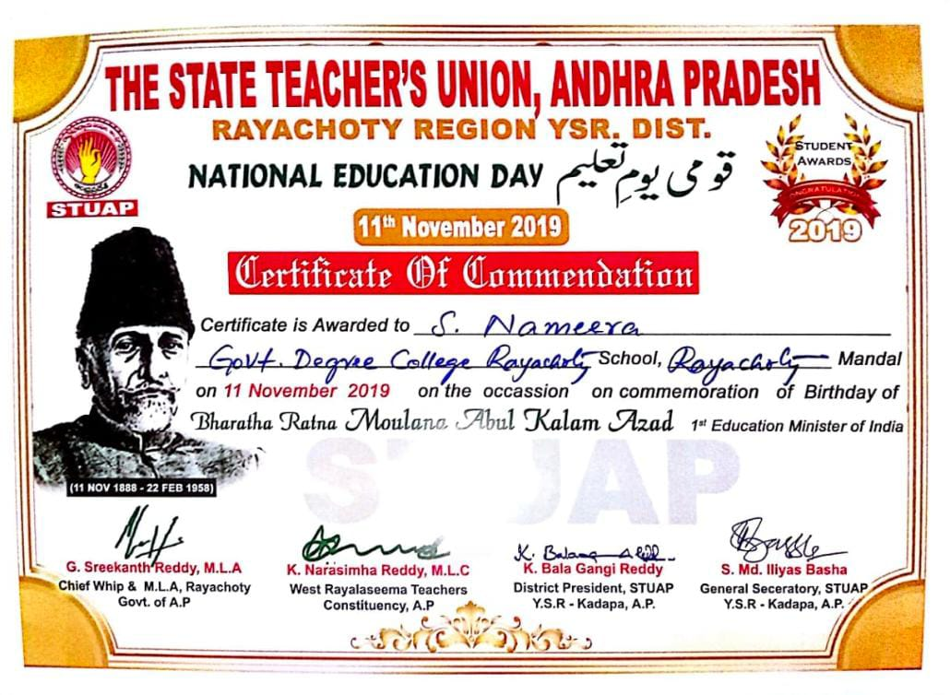

Syed Nameera BA HPU Urdu Medium Student received Certificate of Commendation from State Teachers Union, Rayachoti on the occasion of the National Education Day 01-11-2019.
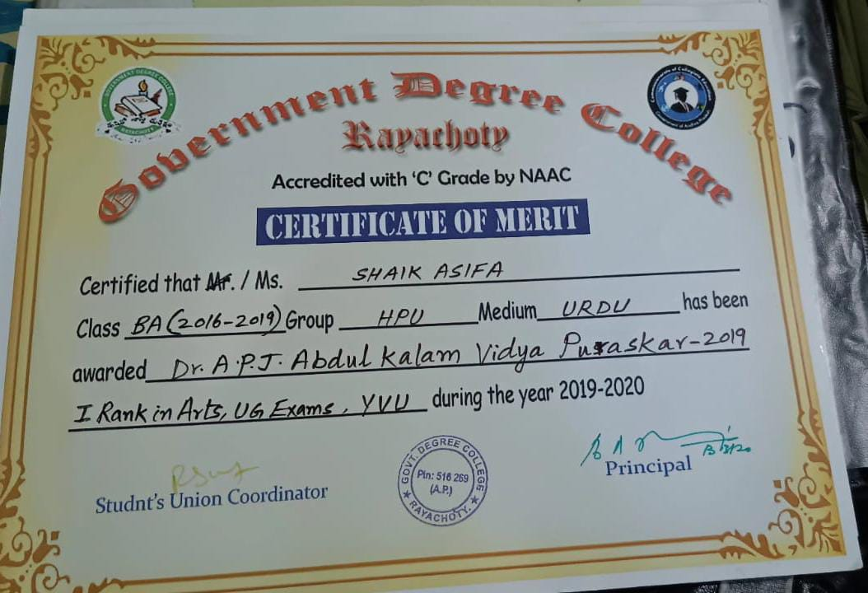

Shaik Asifa BA HPU Urdu Medium Student received a merit certificate on the eve of Dr APJ Abdul Kalam Puraskar – 2019. Shaik Asifa got Ist Rank in Arts UM Exams YVU Kadapa.
ANDHRA PRADESH STATE URDU ACADEMY
Dept. of Minorities Welfare, Government of Andhra Pradesh
MINORITIES WELFARE DAY CELEBRATIONS
Maulana Abul Kalam Azad National Award is a prestigious honor given in India to individuals or organizations for their outstanding contributions to education. Named after Maulana Abul Kalam Azad, an influential scholar and the first Minister of Education in independent India, this award celebrates those who have made significant advancements in the field of education and promoted its development.
MD ISMAIL Lecturer in History Urdu Medium received this award on Education Day, it signifies a high level of recognition for his Urdu Calligraphy achievements in education, following in the footsteps of Maulana Abul Kalam Azad’s legacy of promoting educational excellence. The award highlights his dedication and impactful work in the educational sector.
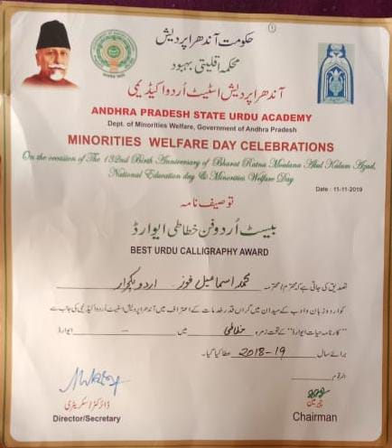

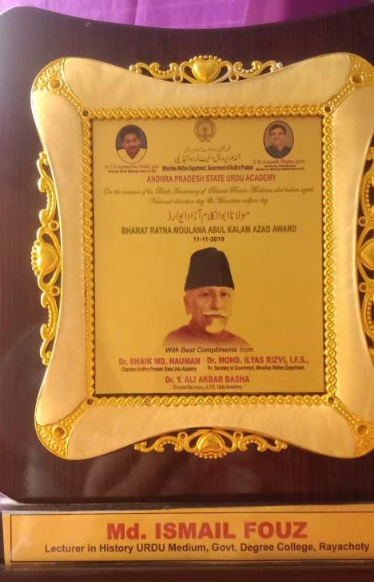

MD ISMAIL Lecturer in History Urdu Medium received Best Urdu Calligraphy Bharata Ratna Moulana Abul Kalam Azad Award 11-11-2019 from Andhra Pradesh Chief Minister YS Jagan Mohan Reddy. Andhra Pradesh State Urdu Academy Conducted a Programmed on the eve of National Educational Day at 11-11-2019.
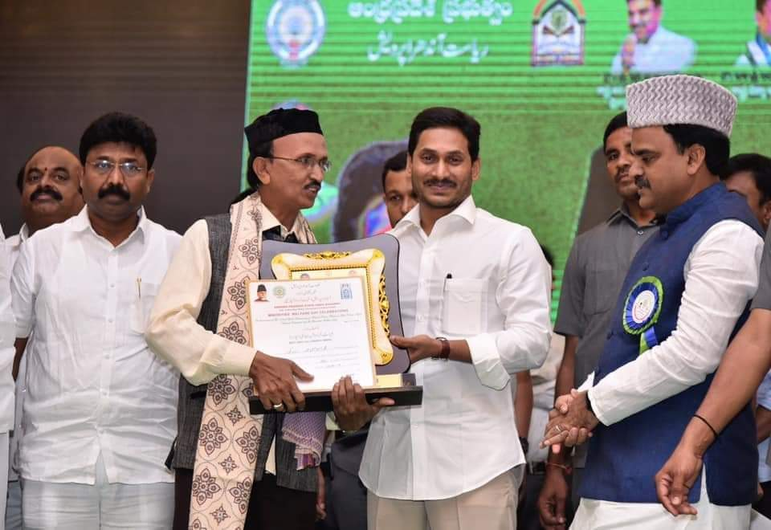

The Urdu Academy Awards are given to recognize and honour contributions to Urdu literature, language, and culture. These awards are typically presented by Urdu academies or cultural organizations to individuals who have made significant achievements in various fields, including literature, poetry, journalism, and education, all in the Urdu language.
The awards aim to celebrate and promote the rich heritage of Urdu and encourage the continued growth and appreciation of Urdu culture. Recipients of these awards are often distinguished scholars, writers, poets, and educators who have contributed to the advancement and preservation of Urdu literature and language.
Calligraphy awards presented by a Chief Minister (CM) YS Jagan Mohan Reddy usually recognize exceptional talent and contributions to the art of calligraphy. These awards are often part of cultural events or initiatives aimed at preserving and promoting traditional art forms, including calligraphy, which is highly valued in various cultures, including in the context of Urdu and Islamic art.
MD Ismail Lecturer in History Urdu Medium received an Urdu Academy Award, it would be a significant acknowledgment of his work in the field of Urdu, whether it’s through writing, teaching, or another form of cultural contribution.

RAYACHOTY—516269
(Accredited by NAAC with C Grade Affiliated to YV University, Kadapa

2021-22

National Service Scheme
Special Champ

THE OPENING CEREMON:
For inauguration programme of Special camp at Mootukatla village, we called renowned persons from village. Inauguration programme started with lighting of the lamps and welcoming of the guests. It was followed by introduction of the chief guests and their felicitation. The vision, mission and the main purpose of the NSS camp was put forth by Mr. K Gurrappa, Program Officer for NSS Unit of AISSMS. The programme proceeded with different speeches given by the guests present for the ceremony. The opening ceremony was concluded by recital of Vande Mataram.
The primary objectives of the special camping programs are: ¬
- Making education more relevant to the present situation, to meet the felt needs of the communities and supplement the education of university/college/school students by bringing them face to face with the prevailing situation of the community

- To provide opportunities for students to play their due roles in the implementation of various development programs by planning and executing development projects, which not only help in creating durable community assets in rural areas and slums but also result in the improvement of the condition of weaker sections of the communities.

- Encouraging the students and non-student to work along with the adults in rural areas, thereby developing their character, social consciousness and commitment, discipline and healthy and helpful attitudes towards the community.

- Building potential youth leaders by exploring the latent potential among the campers, both students as well as local youth (rural and urban), with a view to involve them more intimately in development projects for longer periods. The local leadership generated during the camps would also be useful in ensuring proper maintenance of the assets created as a result of the camps.

- Emphasizing the dignity of labor and self-help and the need for combining physical work with intellectual pursuits, and encouraging youth to participate enthusiastically in the process of national development, and promote national integration through democratic living and cooperative action.

List of Participated Students in the NSS Special Camp

SL NO | Name of the Students | Group
1 | T. Hari Prasad | B. Com General
2 | V.Suresh | B. Com General
3 | V. Sai Kumar | B. Com CA
4 | D. Sireesha | B. Com CA
5 | S. Yasar | B.Sc. BZC
6 | S. Venu Gopal | B.Sc. BZC
7 | S.MD Suhail | B.Sc. BZC
8 | S. Shabeena | B.Sc. BZC
9 | S. Nageswari | B.Sc. BZC
10 | B. Siddeswar | B.Sc. BZC
11 | P. Vanitha | B.Sc. BZC
12 | G. Praveen Kumar | B.Sc. BZC
13 | S. Syed Vali | B.Sc. MCPc’s
14 | T. Thirumalesh | B.Sc. MCPc’s
15 | M.Damodhra | B.Sc. MCPc’s
16 | D. Prasanna Jyothi | B.Sc. MCPc’s
17 | M. SAI | B.Sc. MCPc’s
18 | - Sravani | B.Sc. MCPc’s
19 | T. Sree Vidya | B.Sc. MCPc’s
20 | G. Reddy Lokesh | B.Sc. MCPc’s
21 | V. Siva Sankar | B.Sc. MCPc’s
22 | Shaik Sofiya Begum | BA HPU
23 | Shaik Baba Fakruddin | BA HPU
24 | Shaik Vajiha | BA HPU
25 | Shaik Noor Asif | BA HPU
26 | Syed Neelofer | BA HPU
27 | Shaik Mohammed Badulla | BA HEP
28 | M. Mahesh | BA HEP
29 | P. Venkateswarlu | BA HEP
30 | Shaik Rukhsana | BA HPU
31 | R. Ranganayakulu | BA HEP
32 | Deevapatla Sreekanth | BA HEP
33 | G. Ramesh | BA HEP
34 | Shaik Zainab | BA HPU
35 | Shaik Sadiq | BA HPU
36 | Shaik Sameera | BA HPU
37 | P. Chandu | B. Com General
38 | S. Arif Basha | B. Com CA
39 | D. Sahadeva | B. Com CA
40 | - Bhagyamma | B. Com CA
41 | N. Krishna Babu | B. Com CA
42 | G. Hazeera | B.Sc BZC
43 | U. Sai Nath | B. Com CA
44 | K. Lakshmi Reddy | B. Com General
45 | M. Ramya | BA HEP
46 | D. Kavitha | BA HEP
47 | G. Ramesh | BA HEP
48 | K. Siva Mani | BA HEP
49 | Shaik Sharmila | BA HPU
50 | Shaik Mohammed | BA HPU
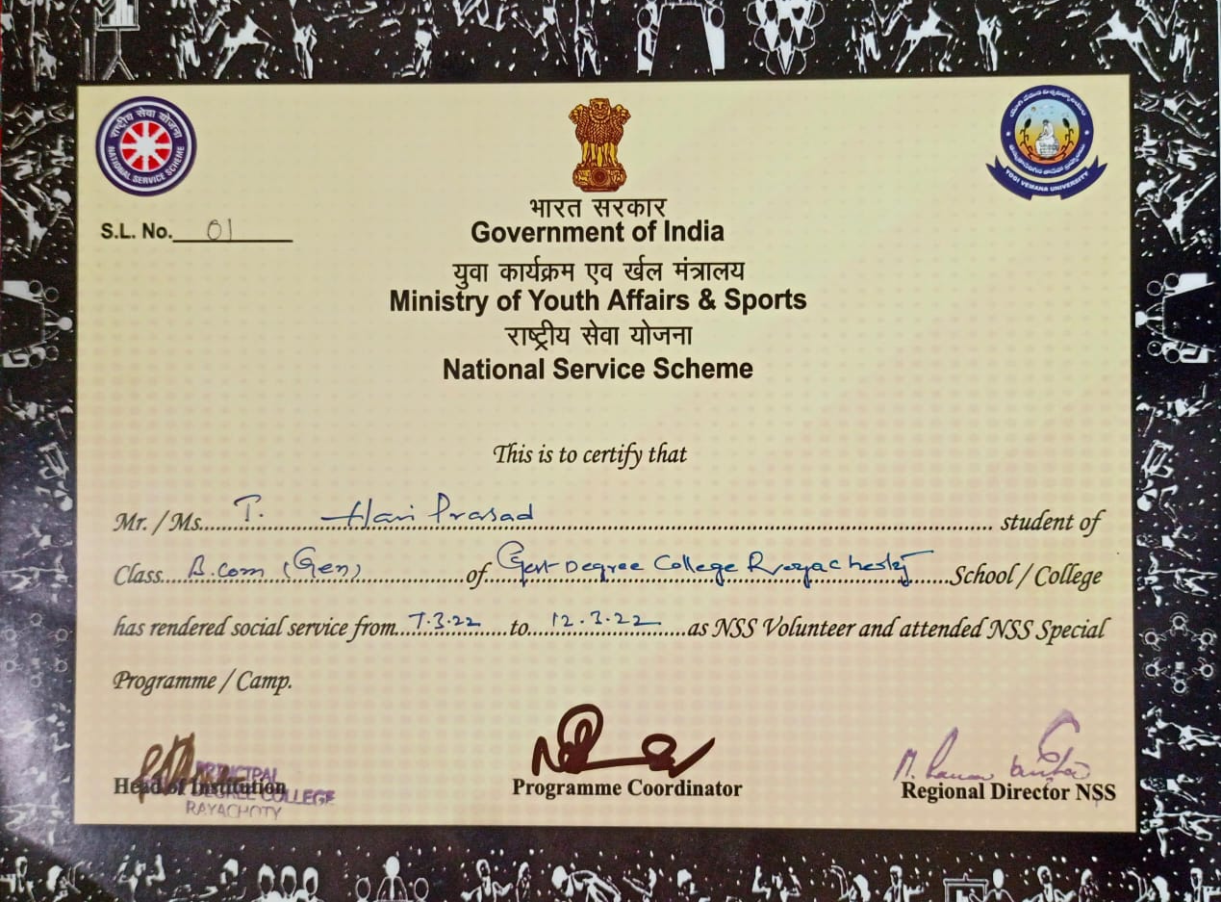

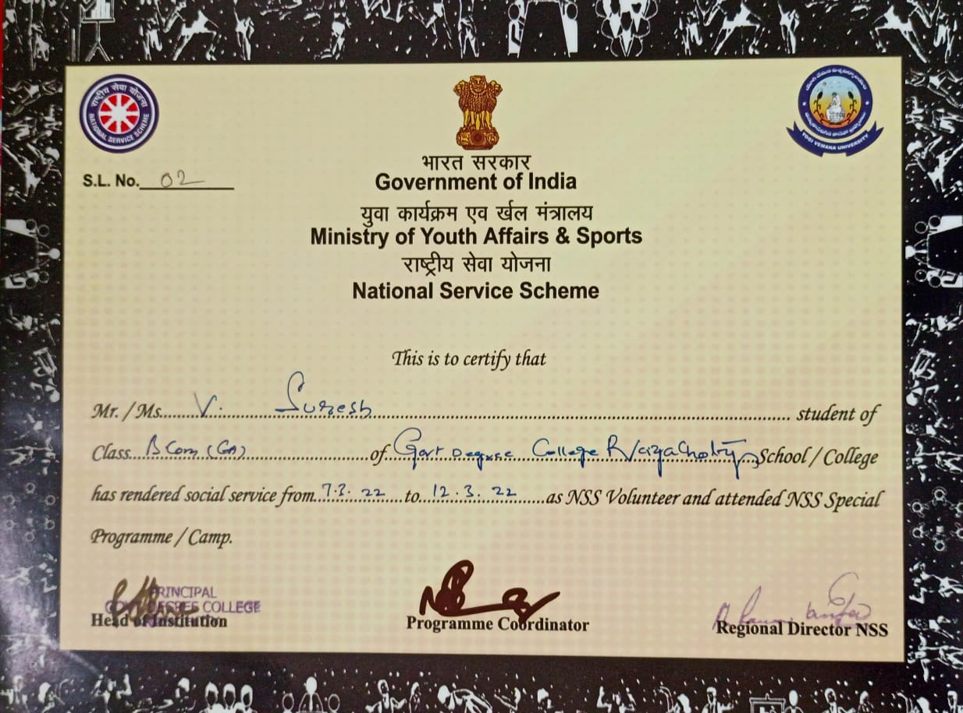

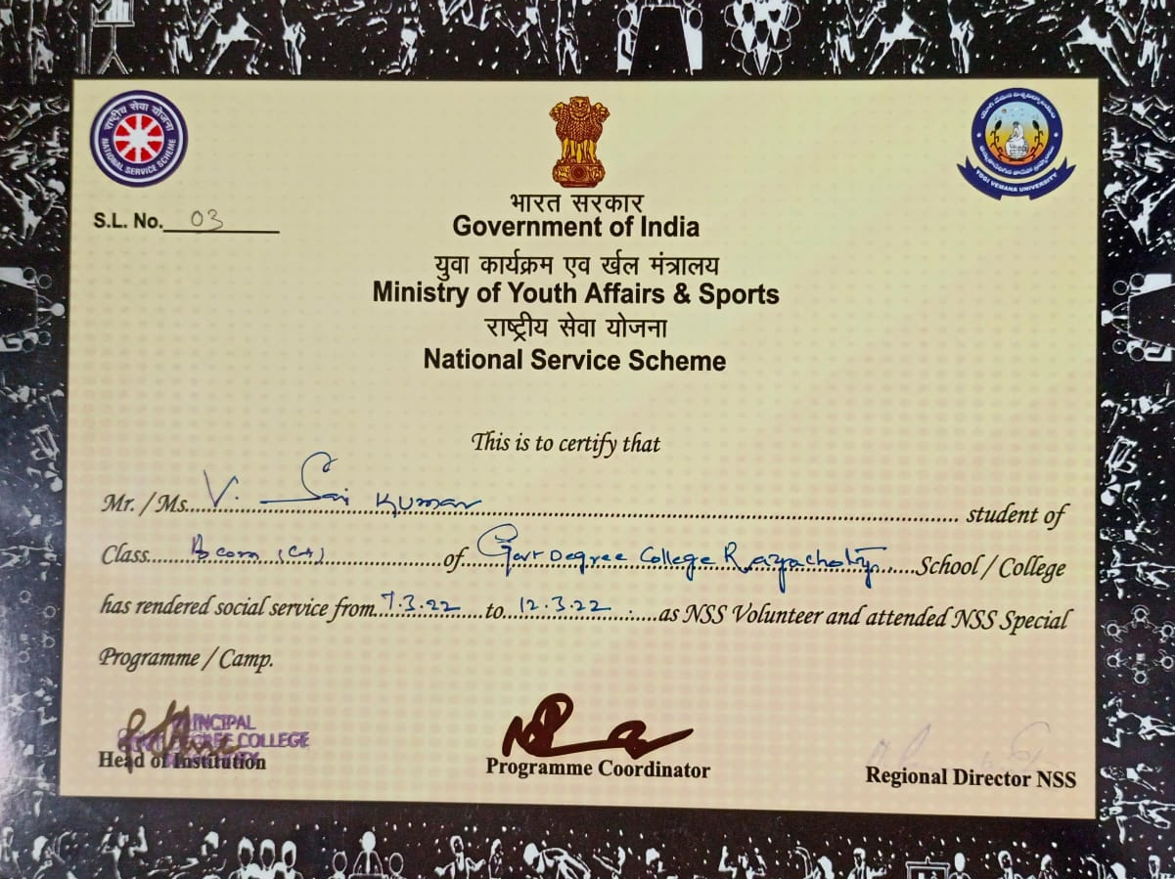

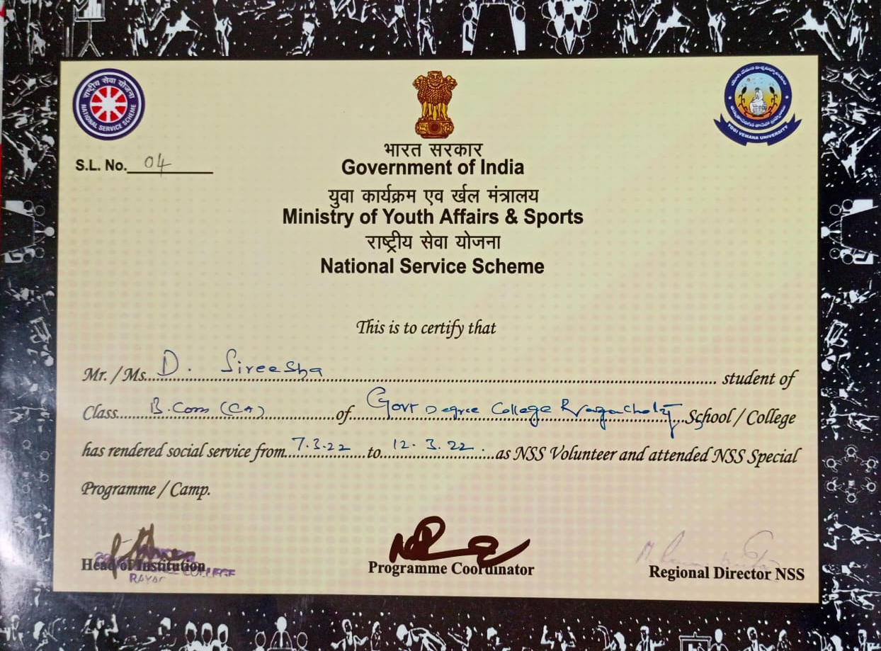

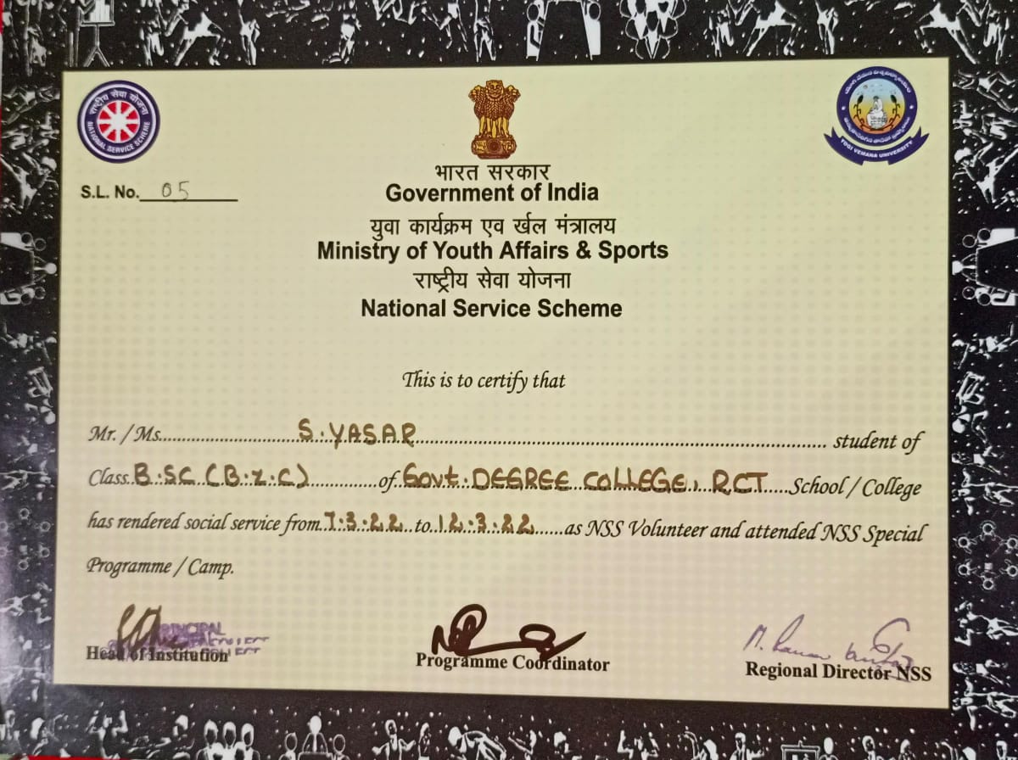

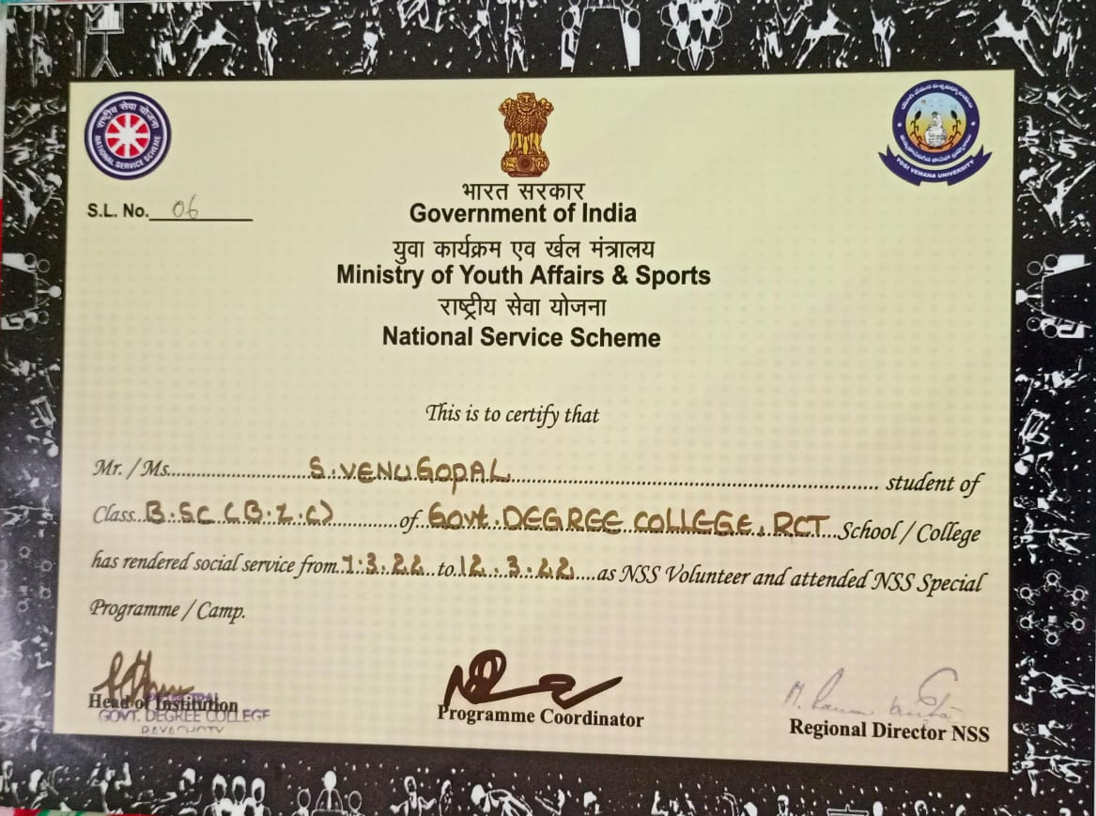

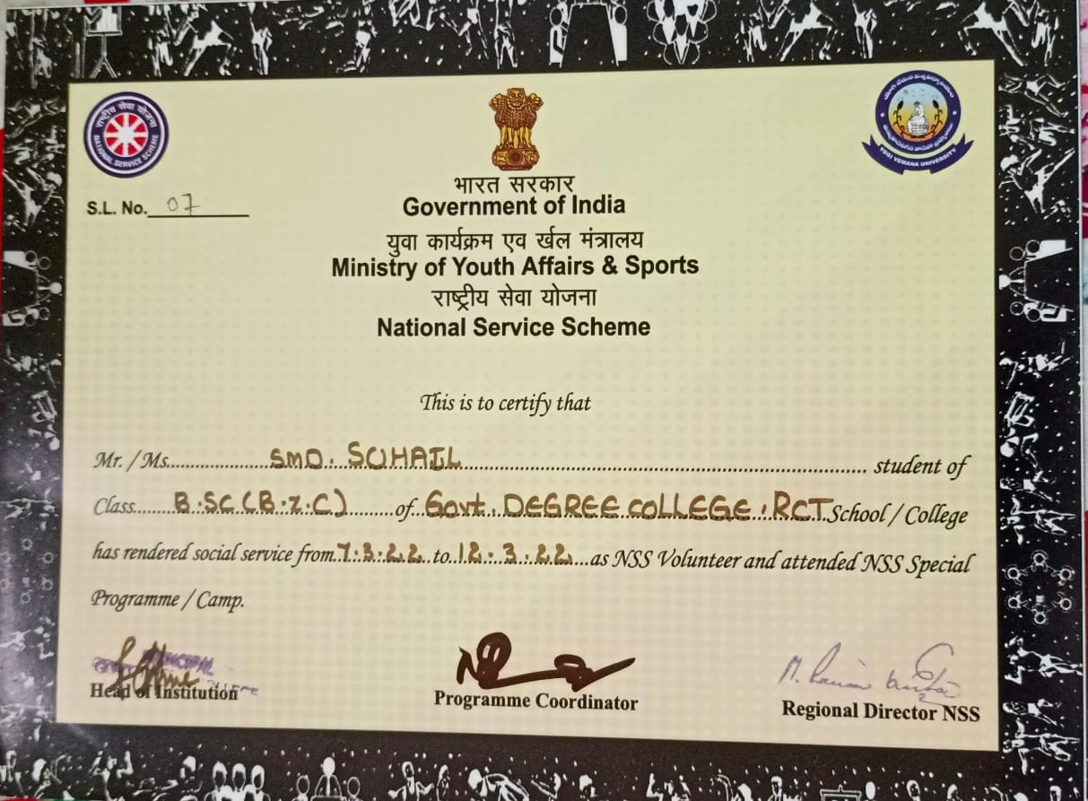

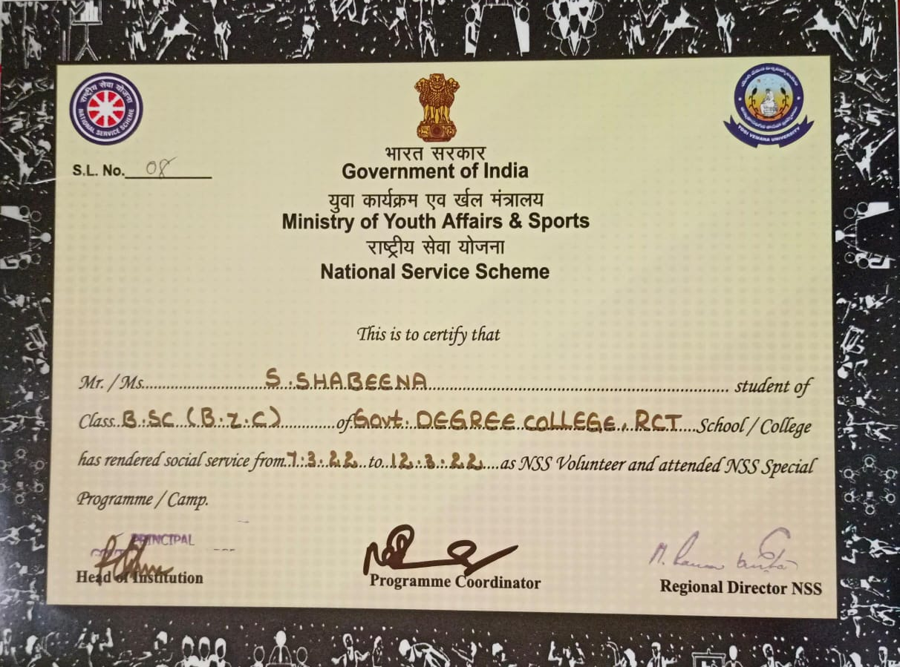

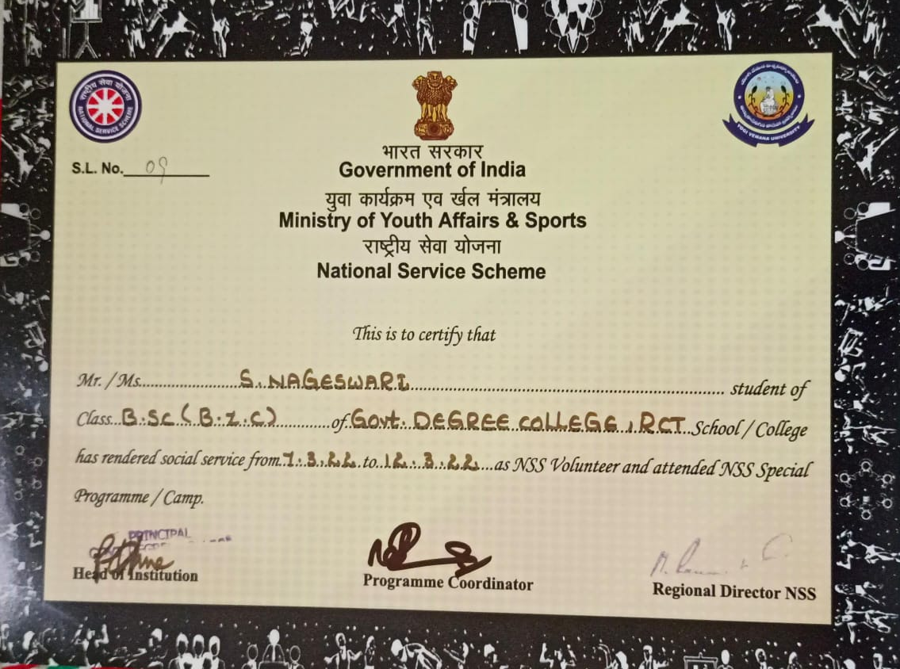

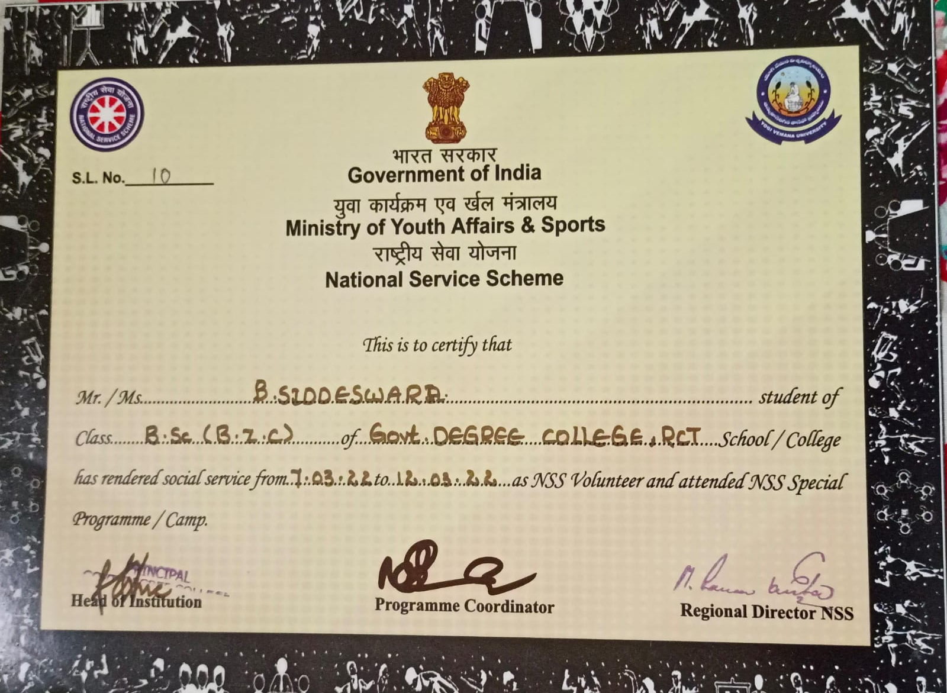

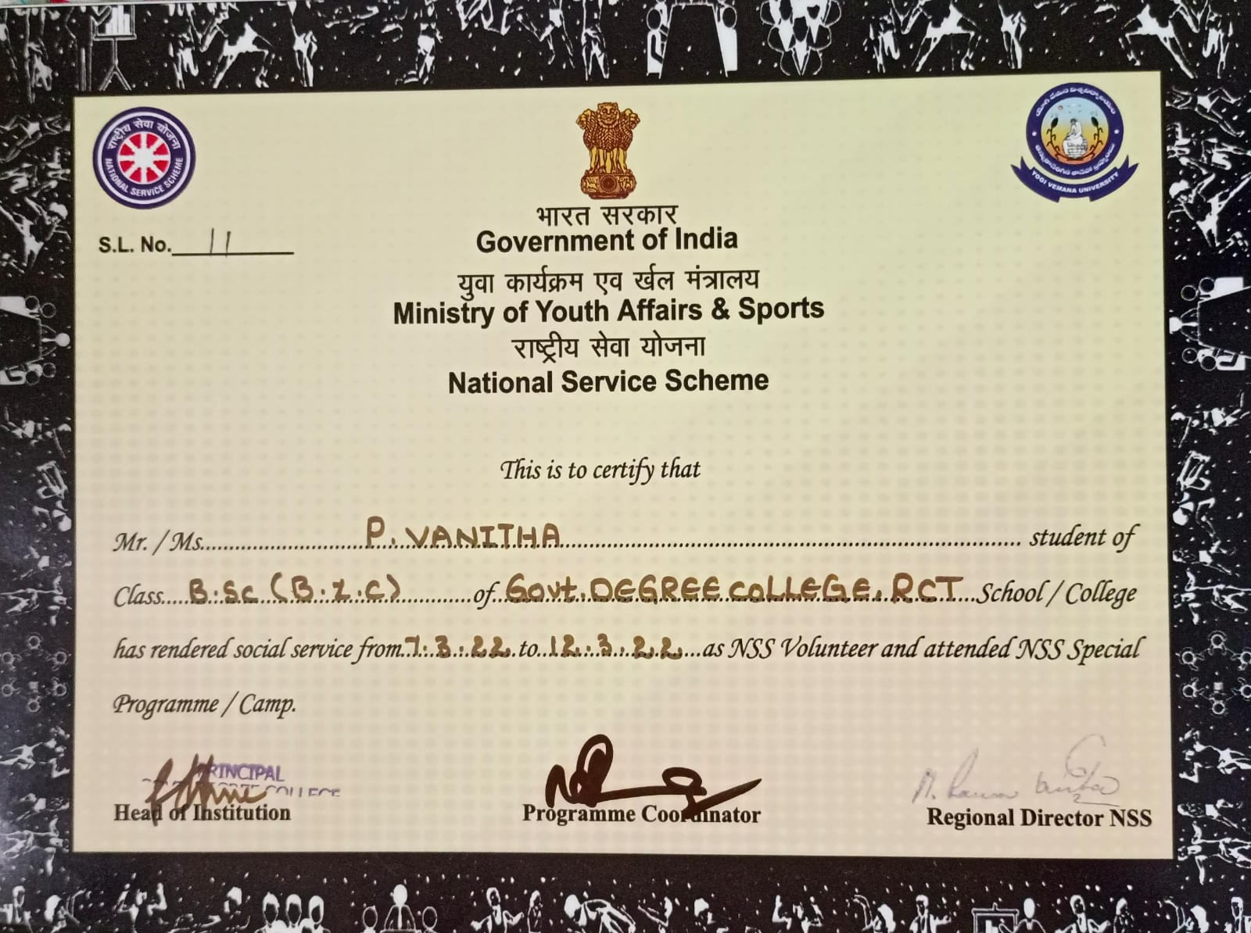

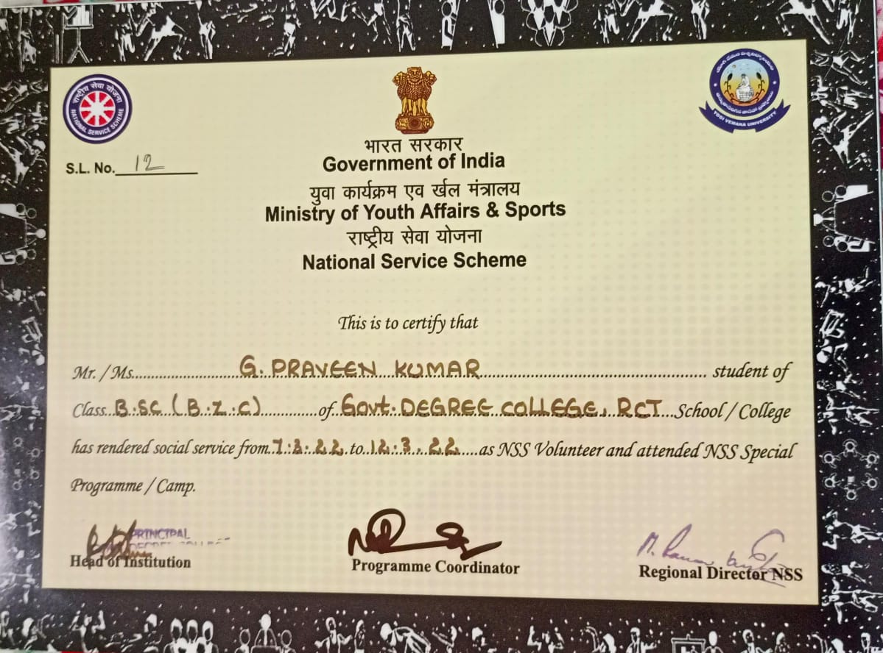

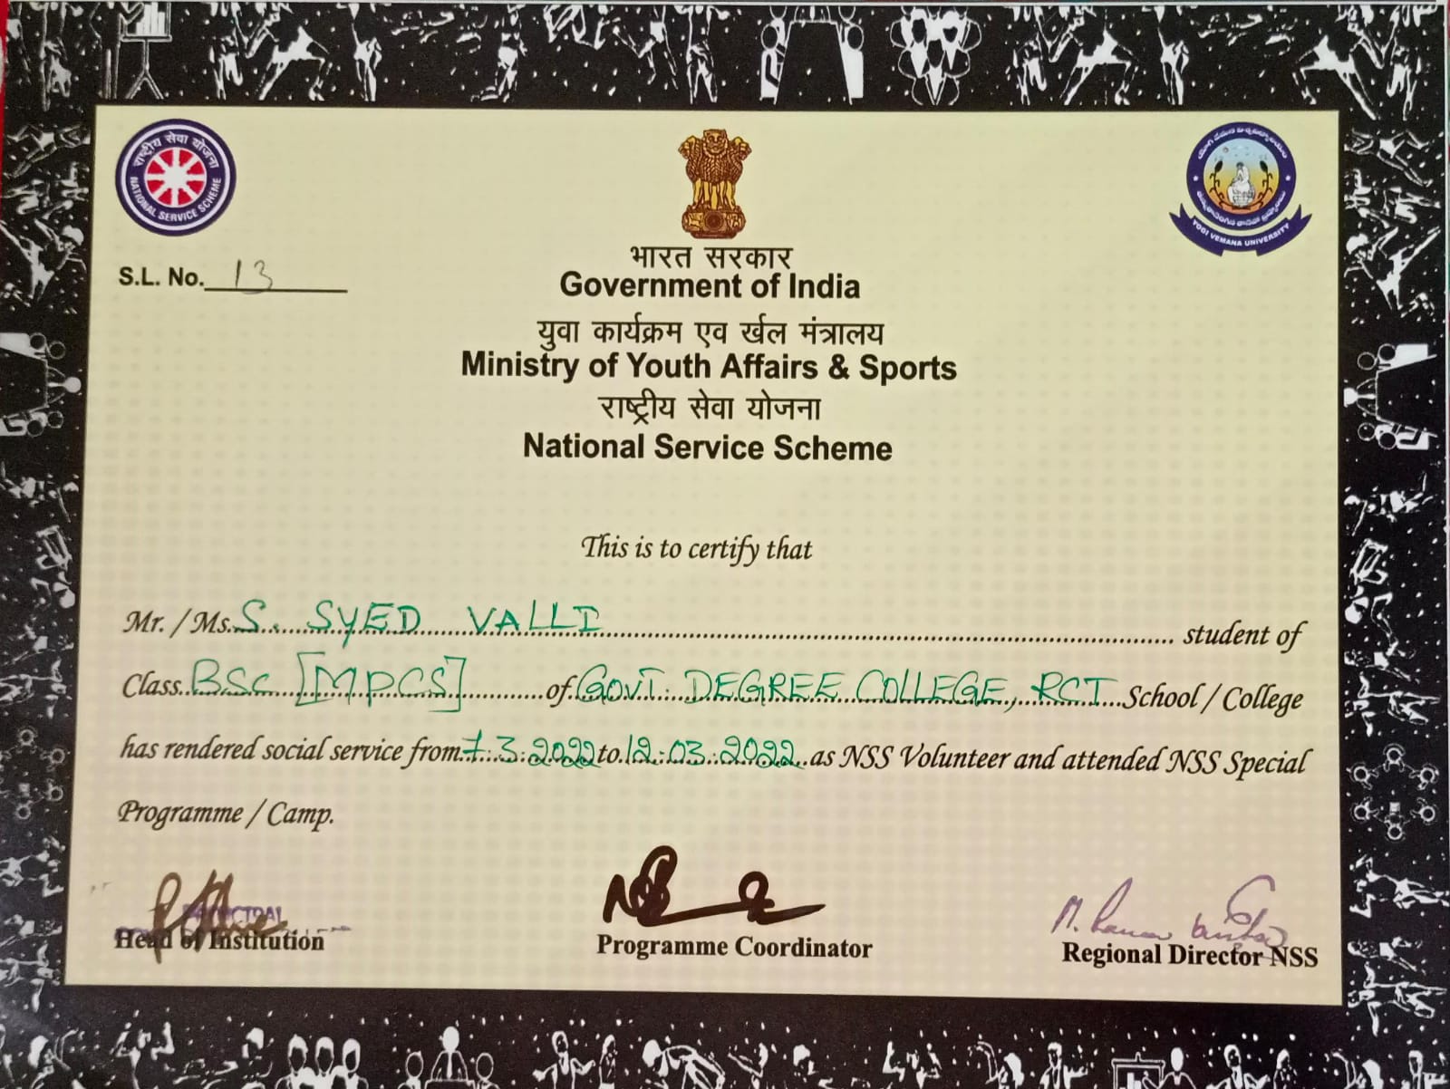

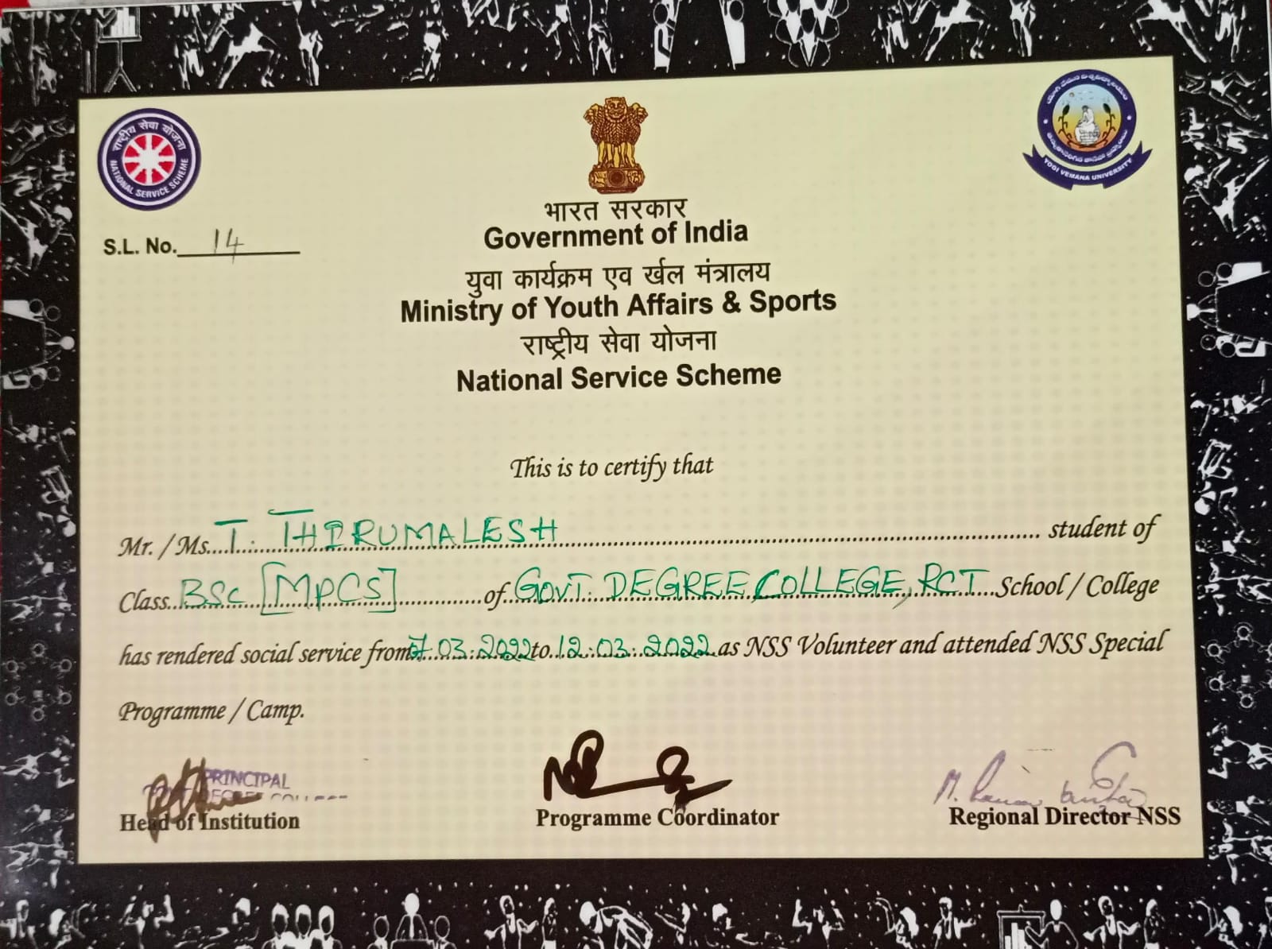

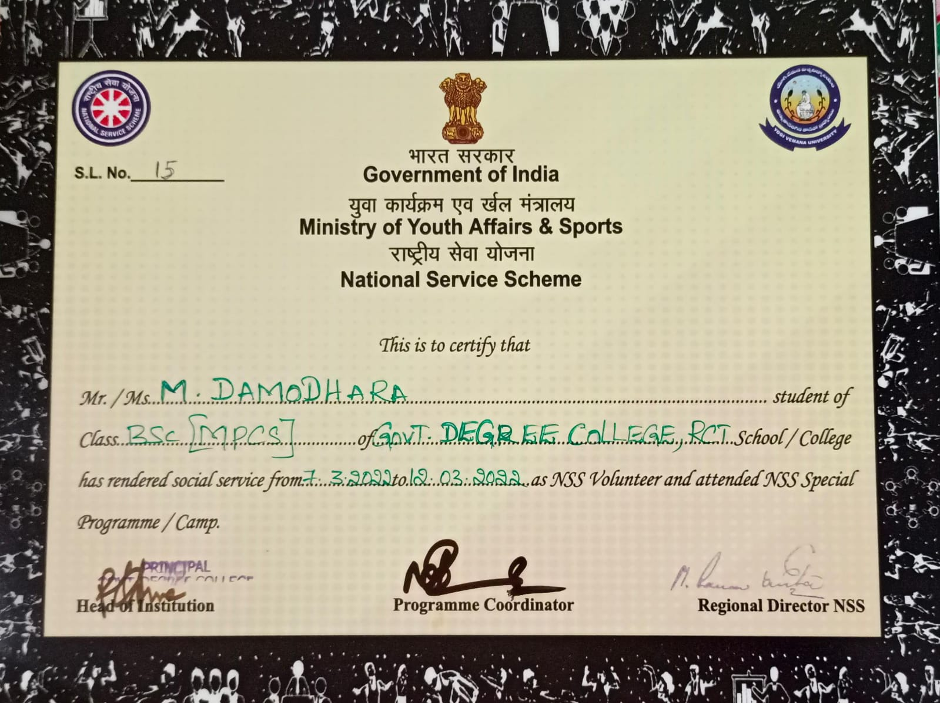

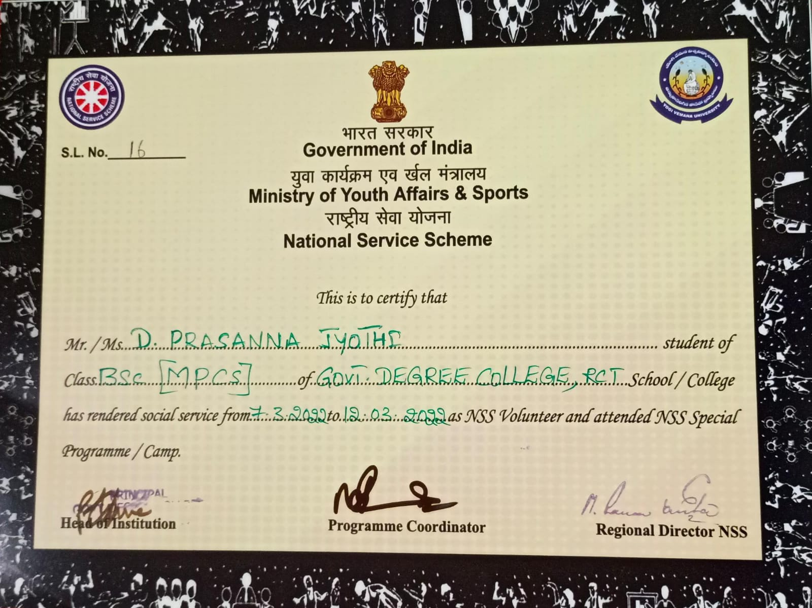

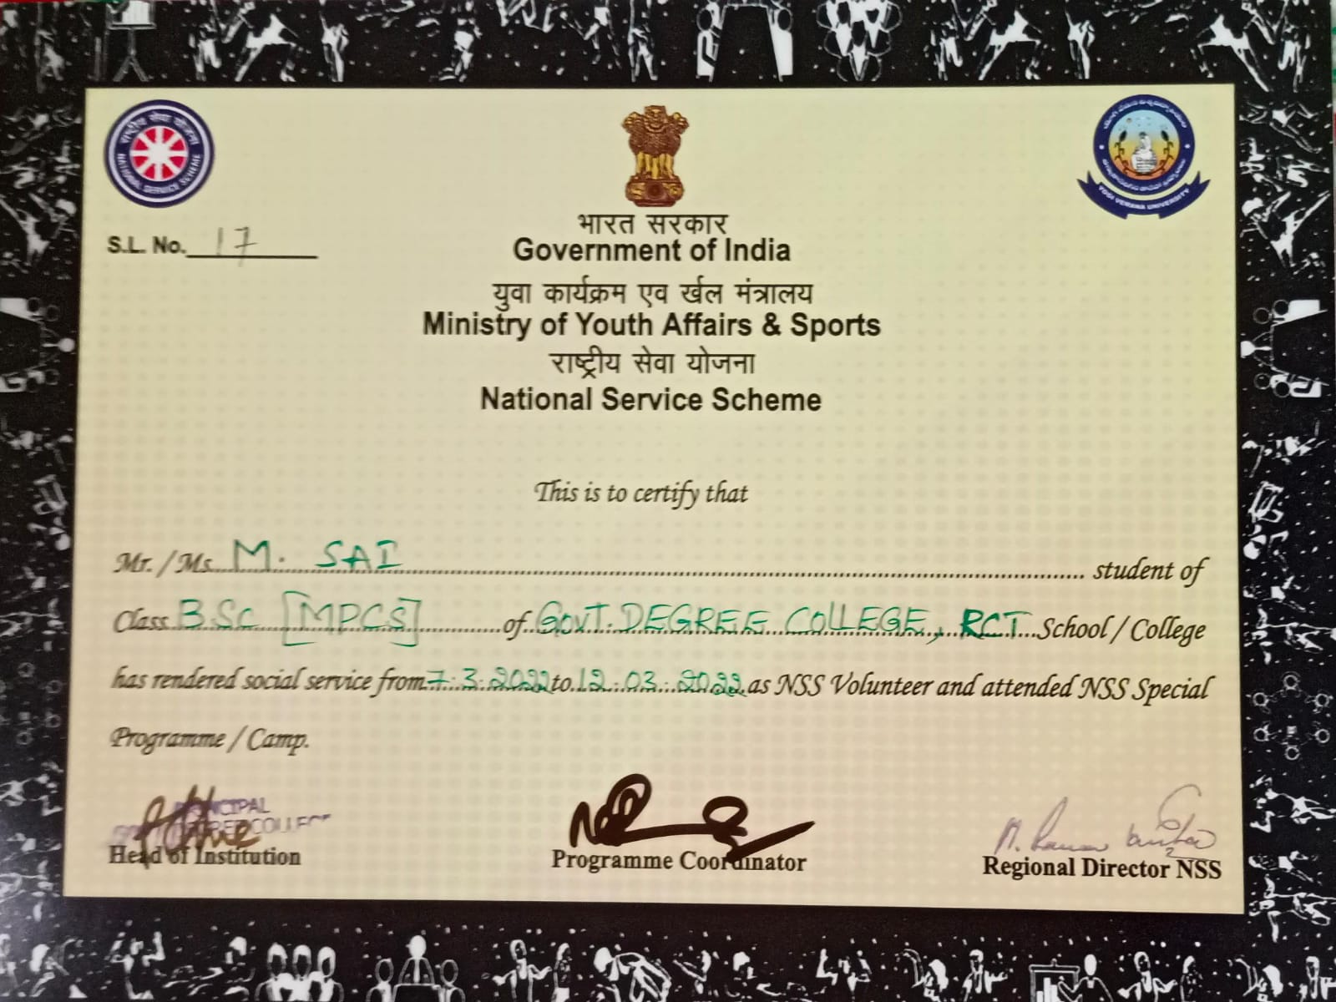

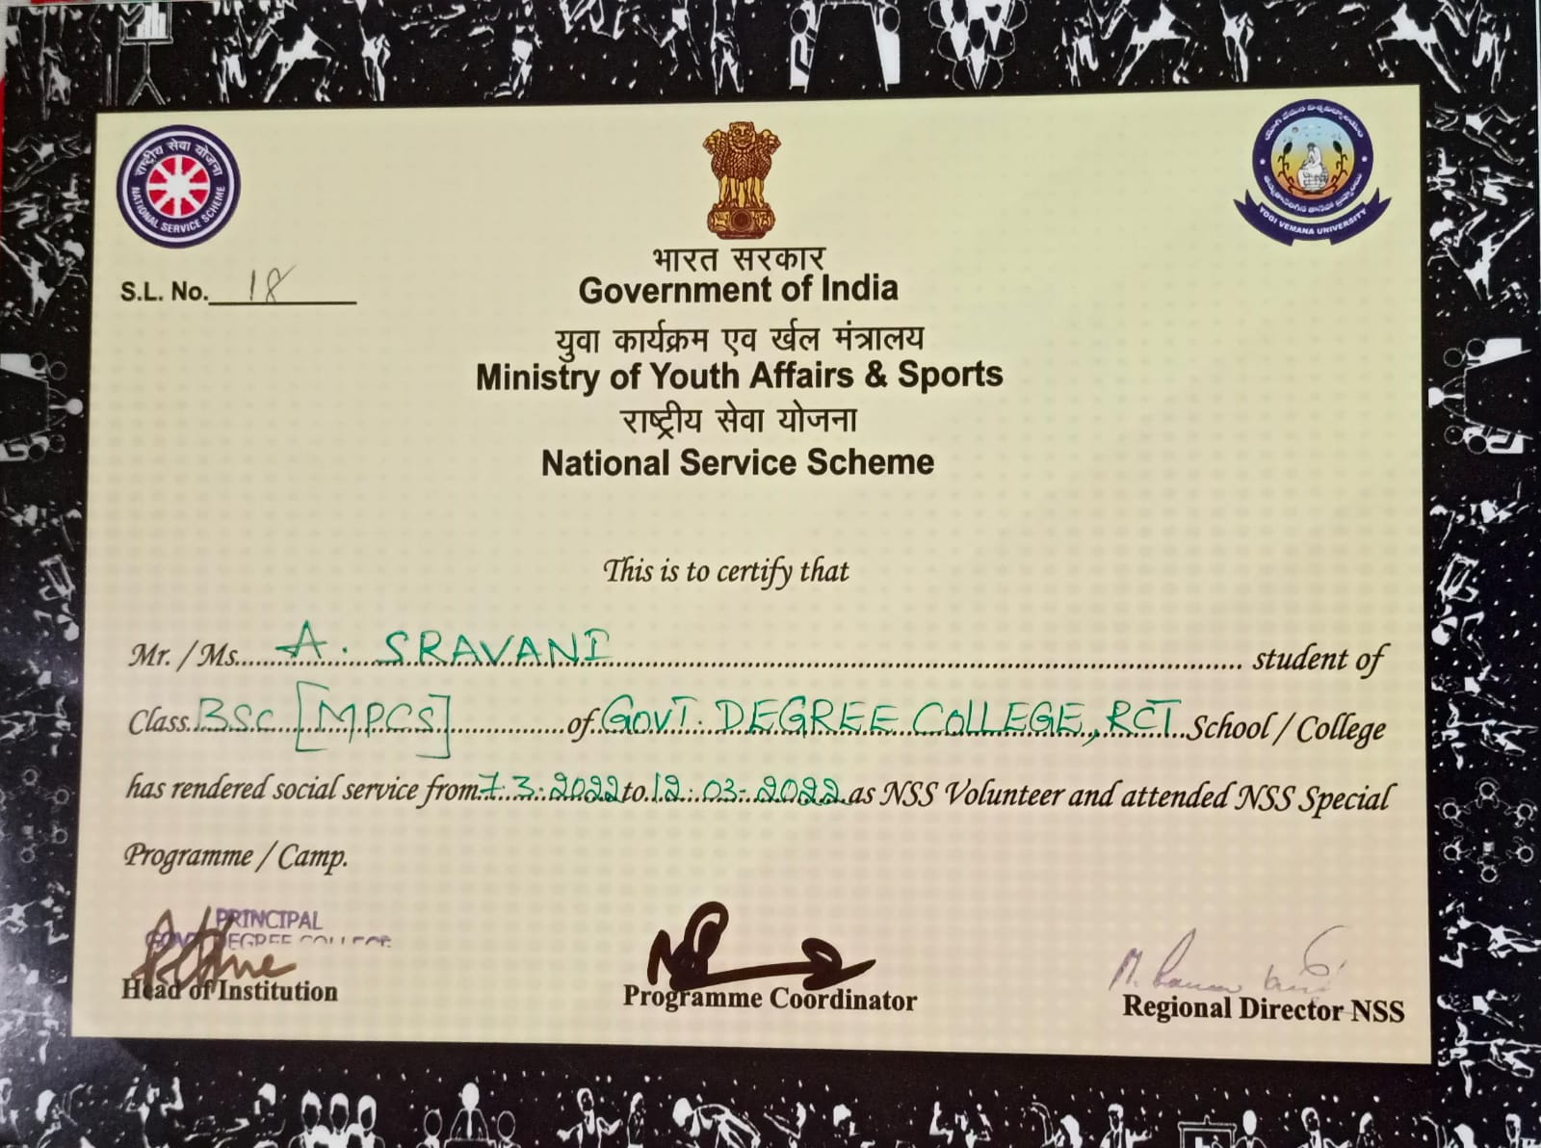

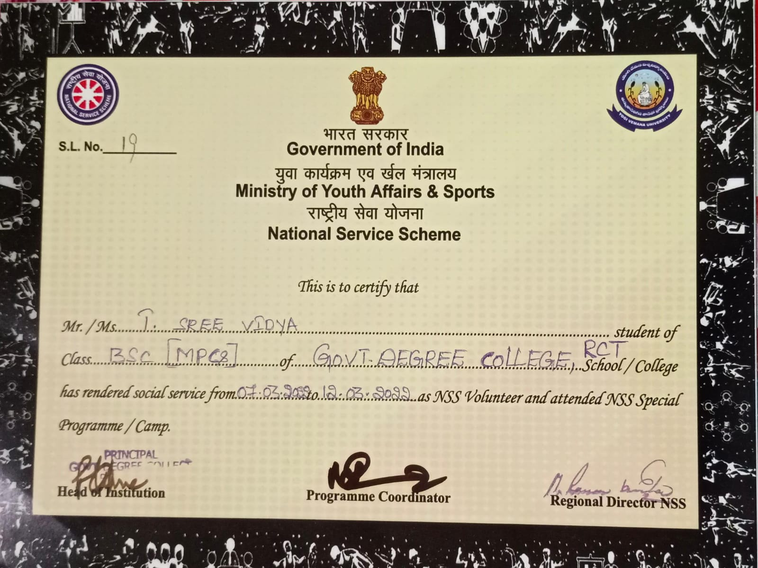

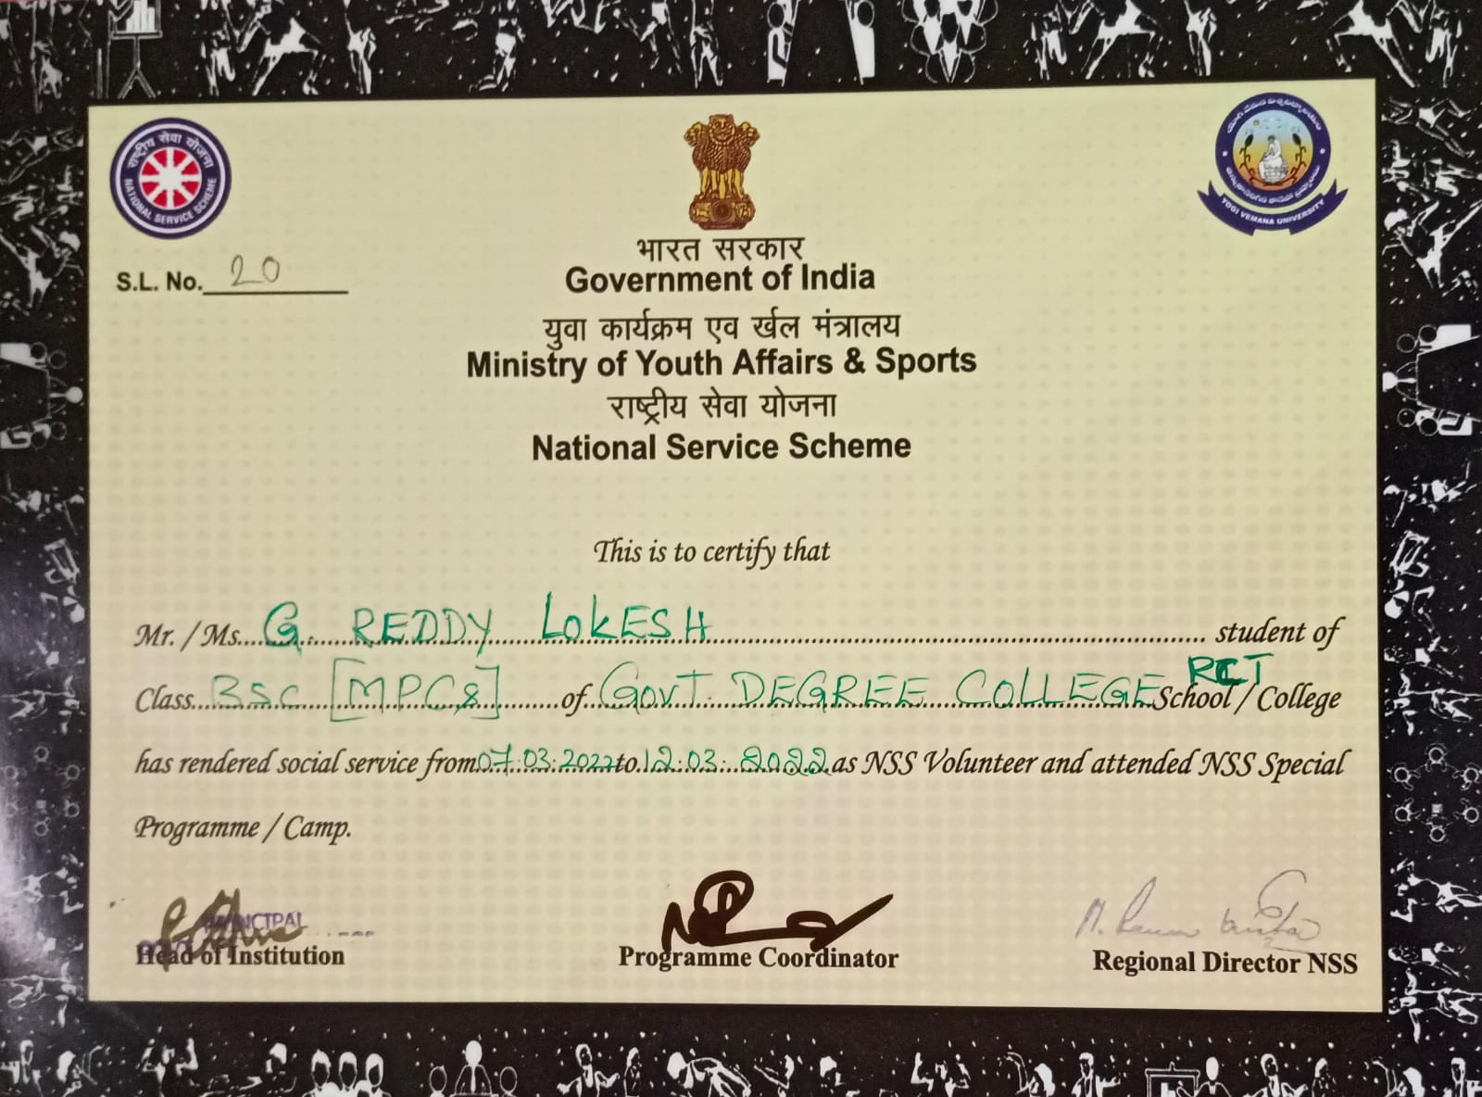

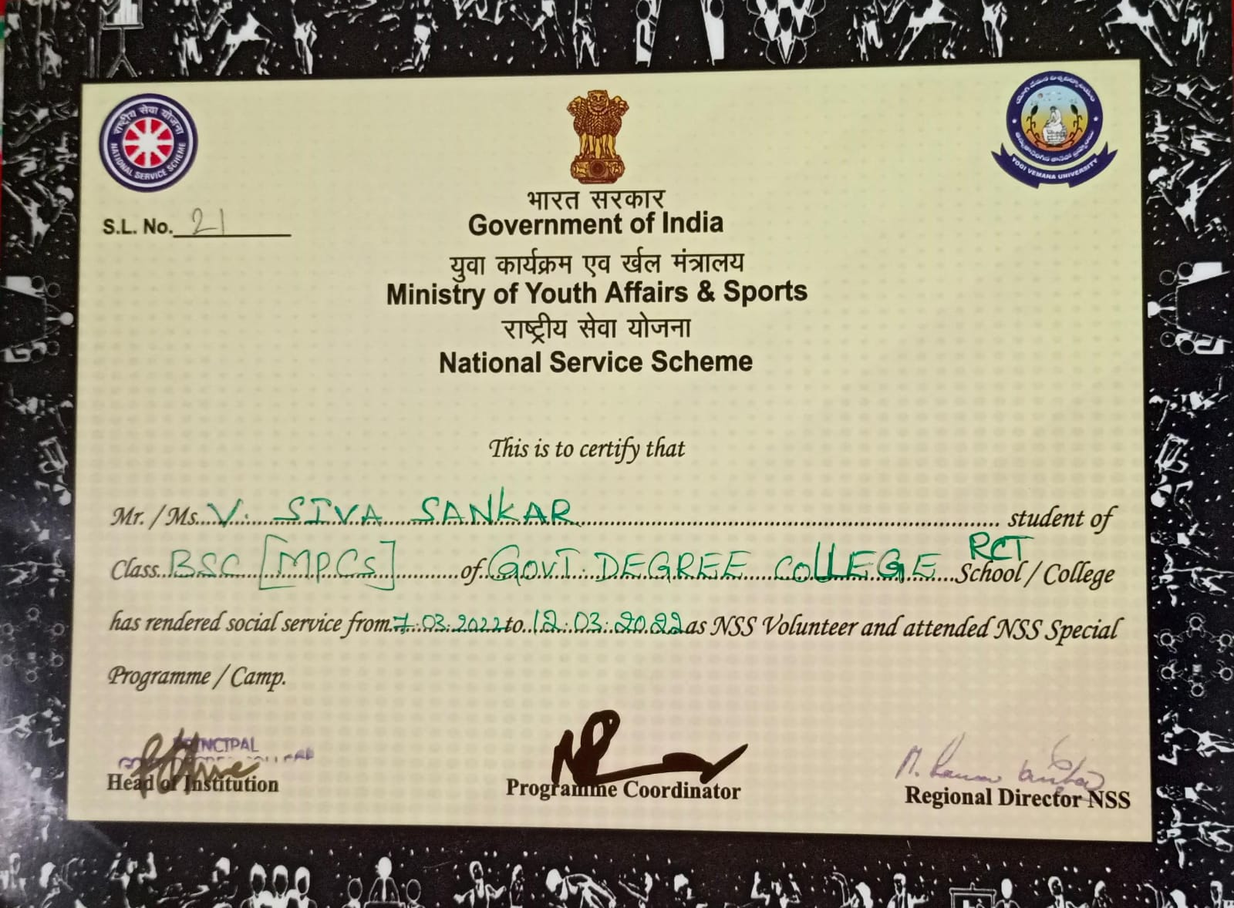

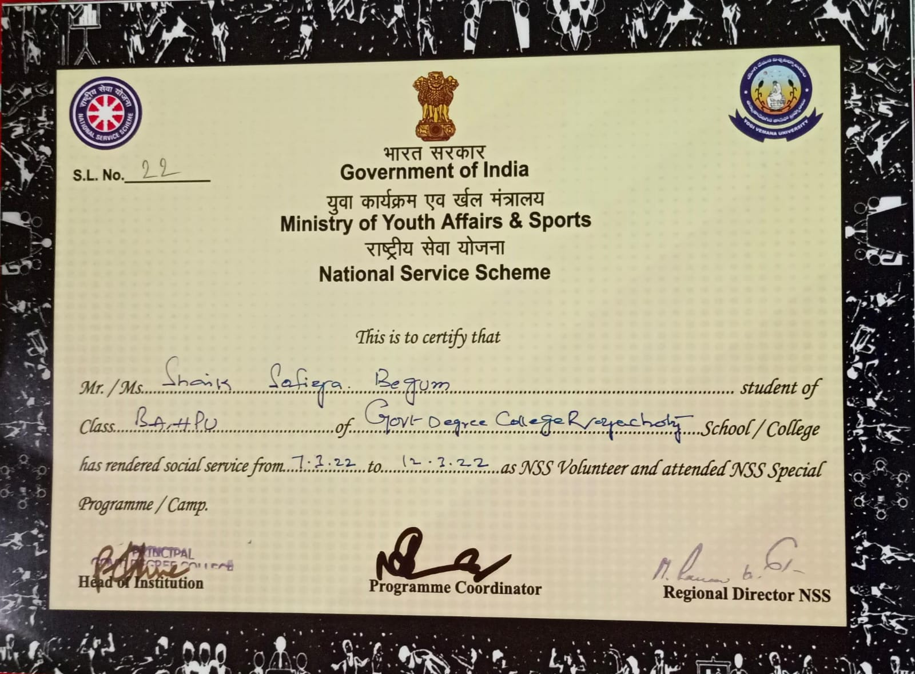

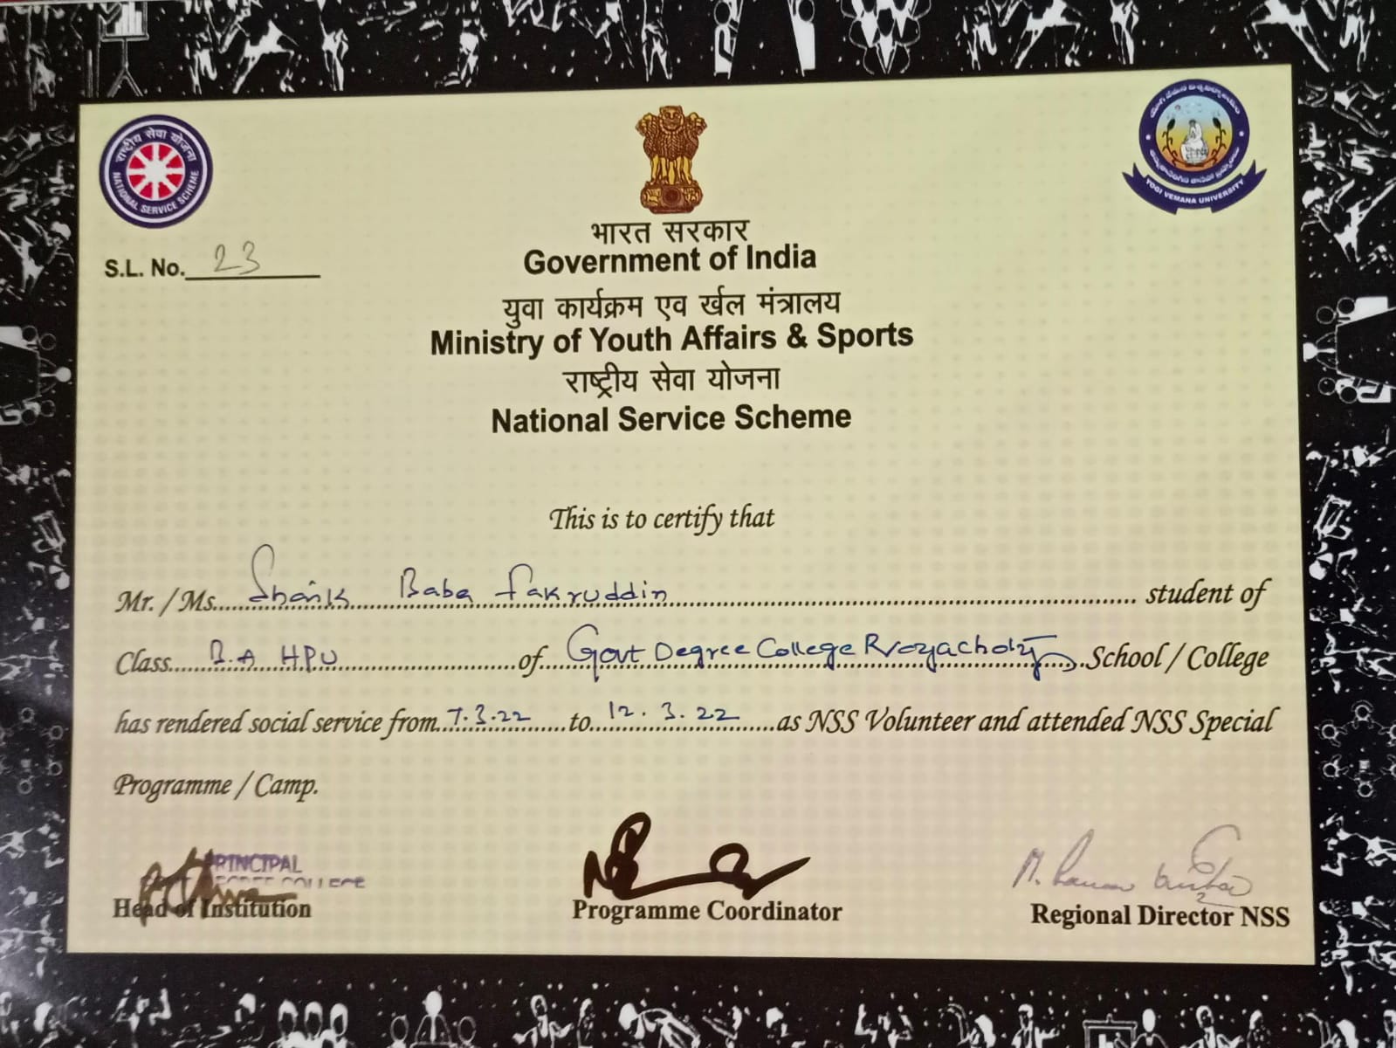

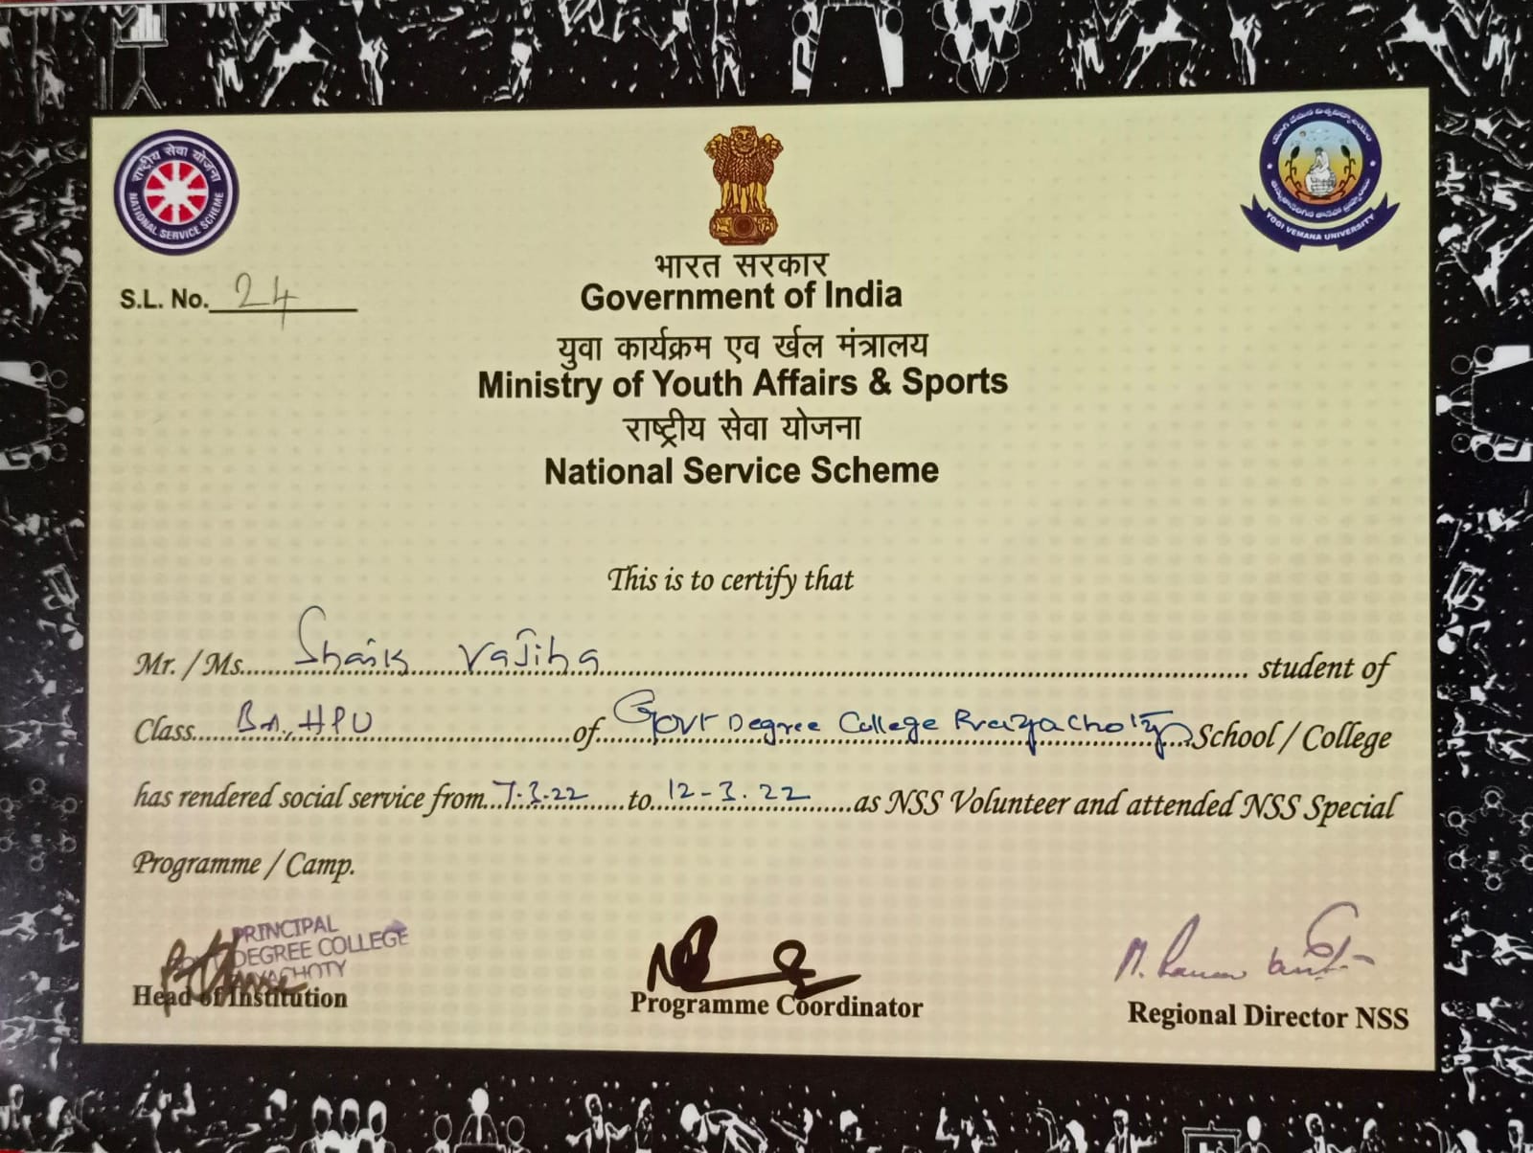

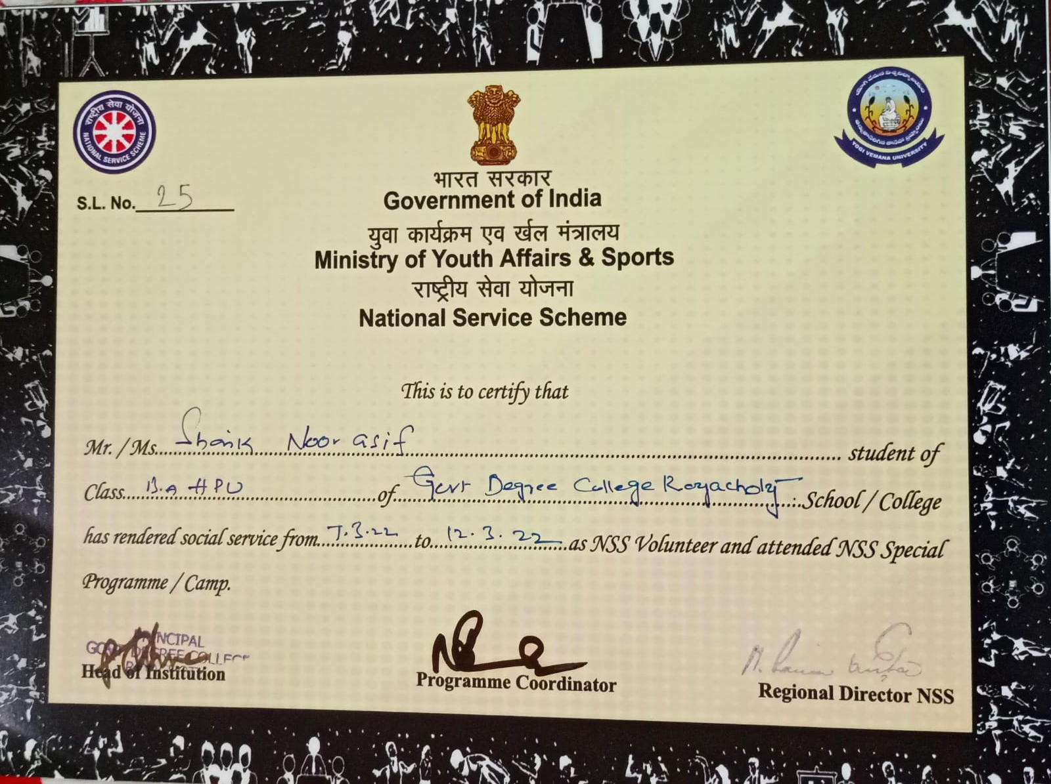

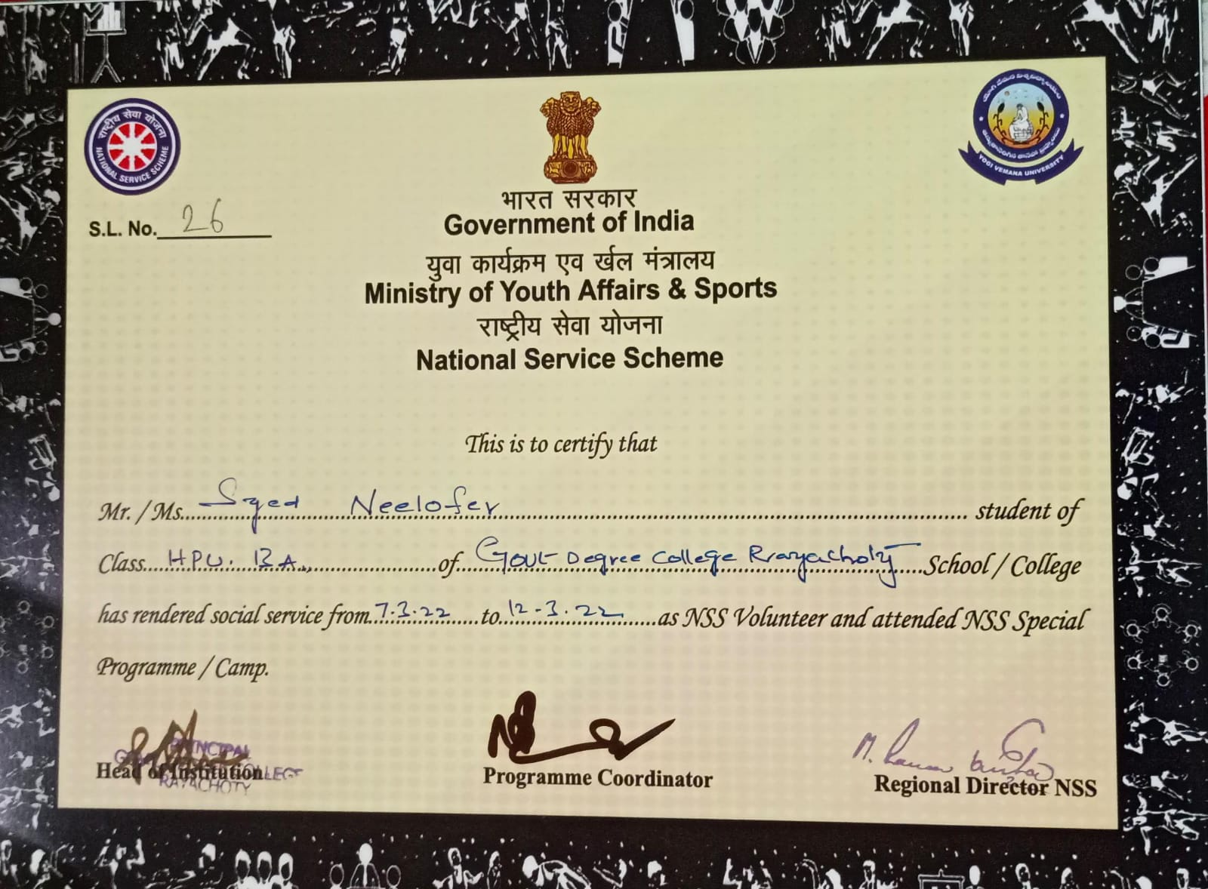

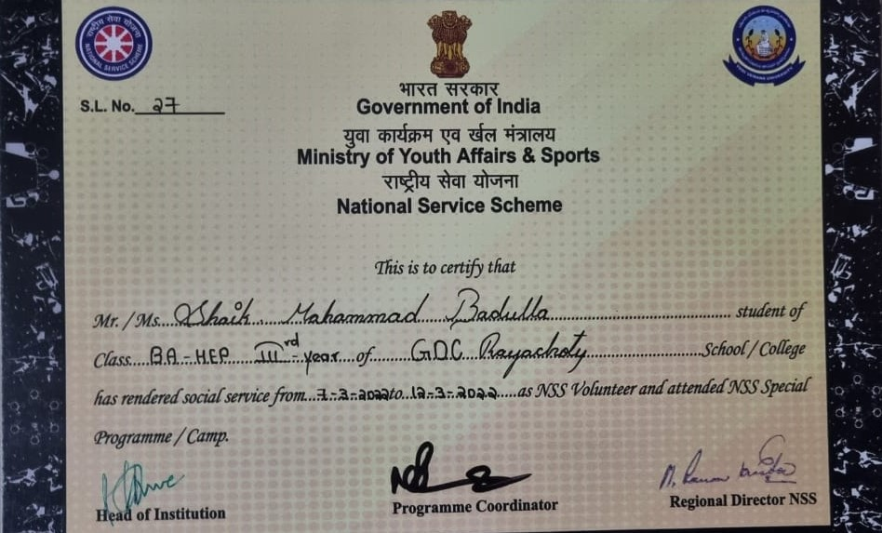

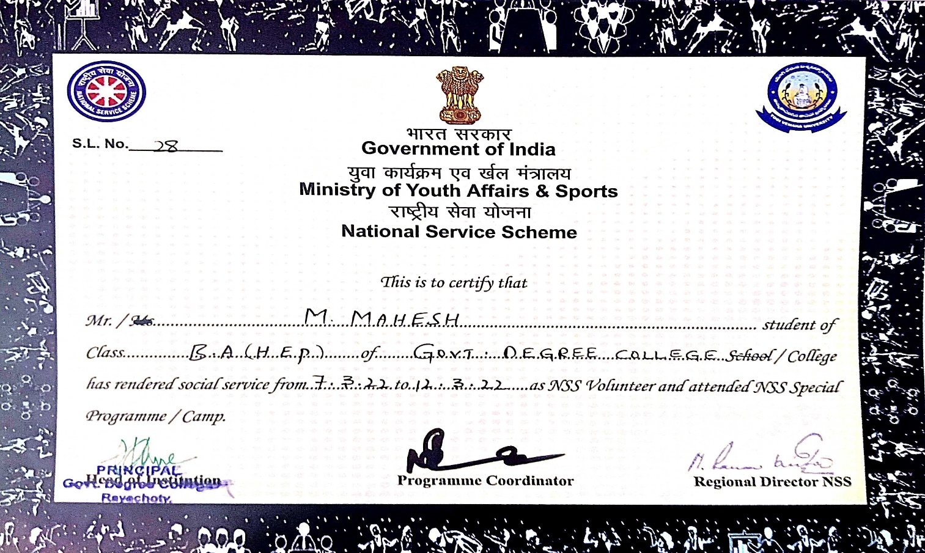

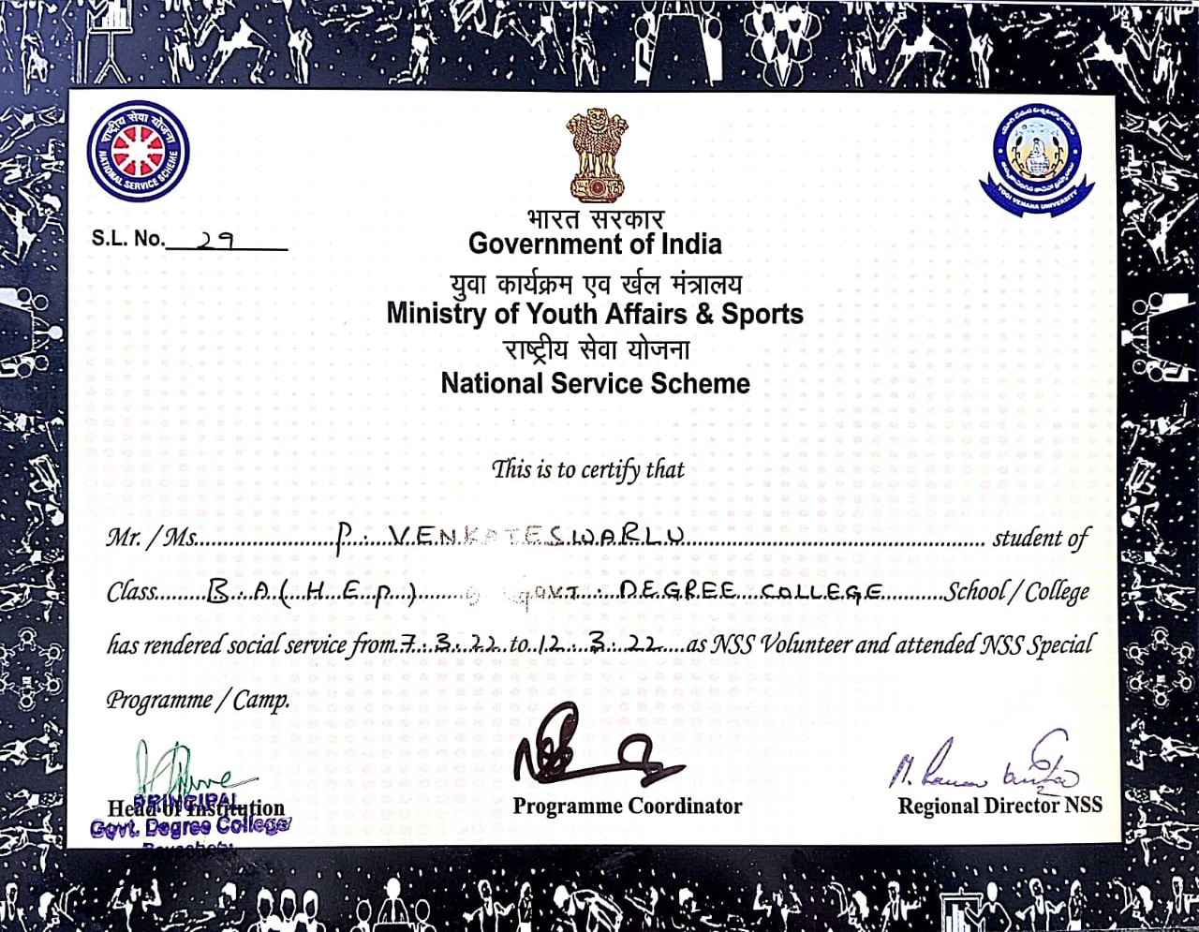

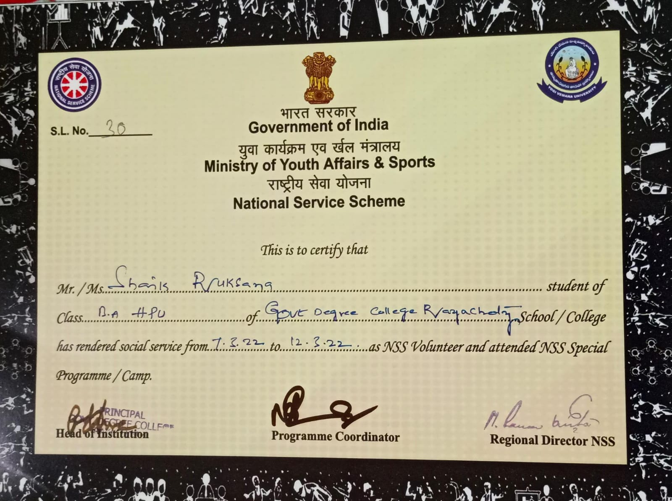

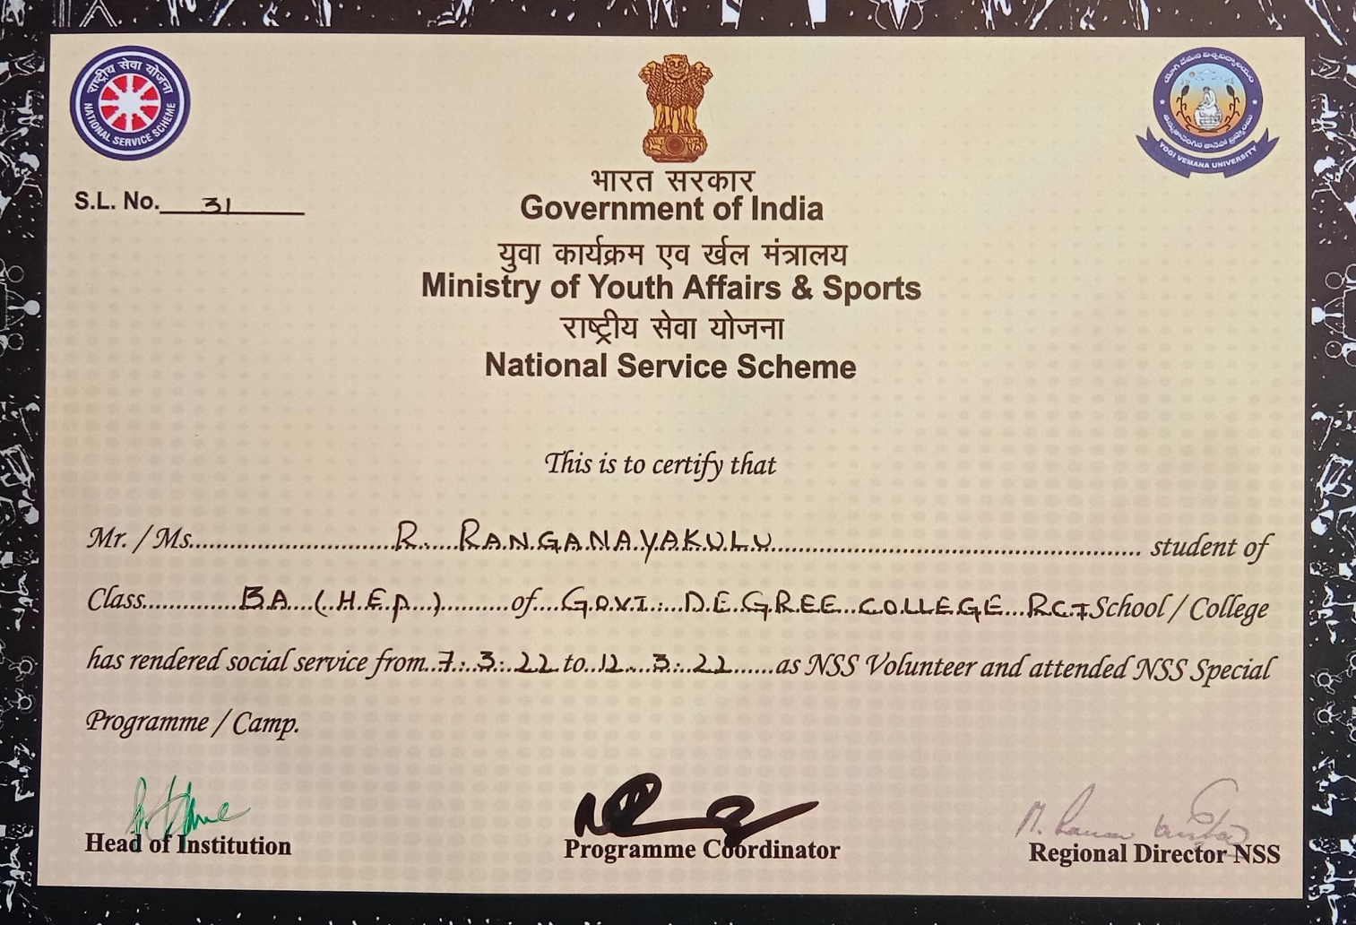

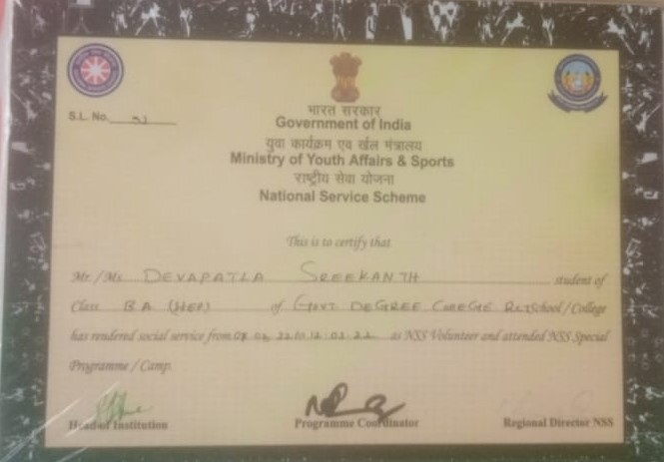

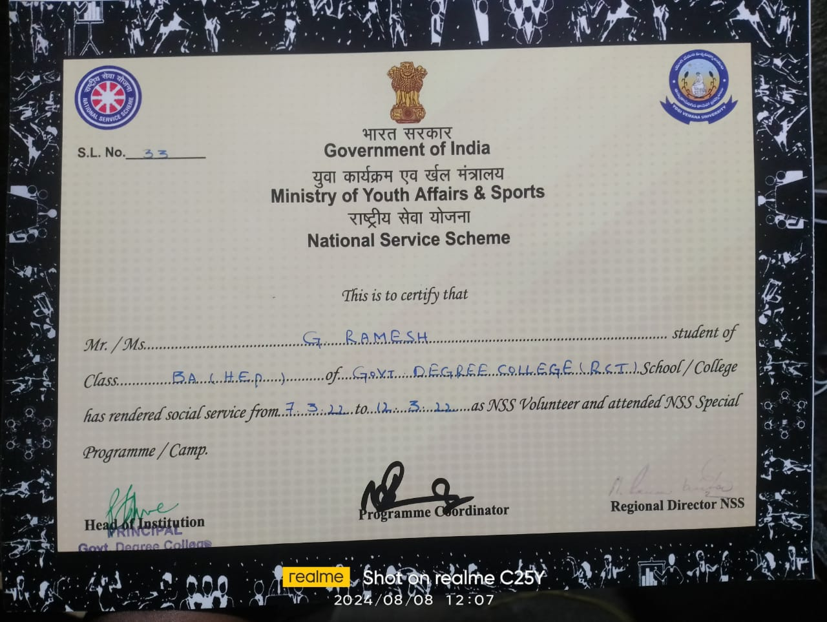

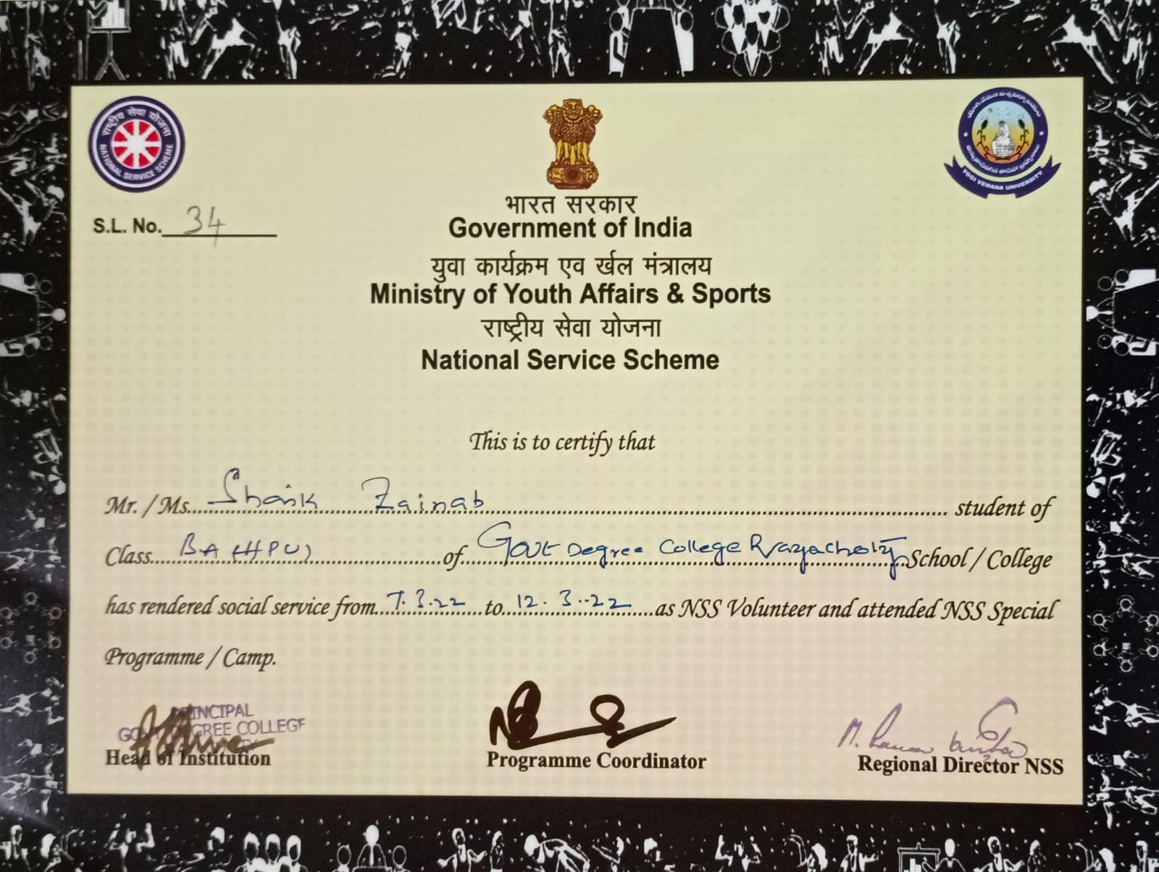

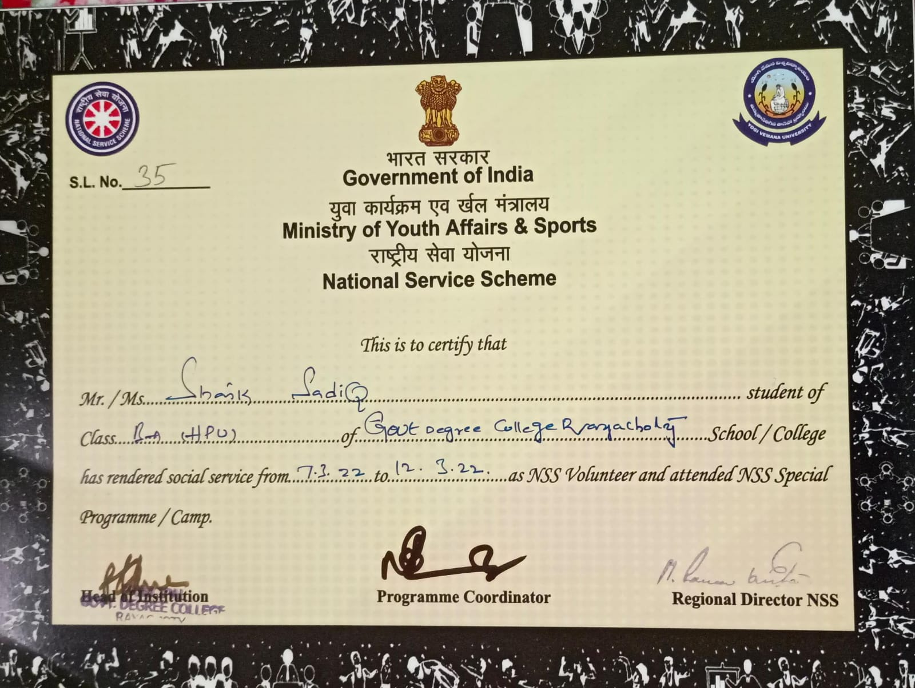

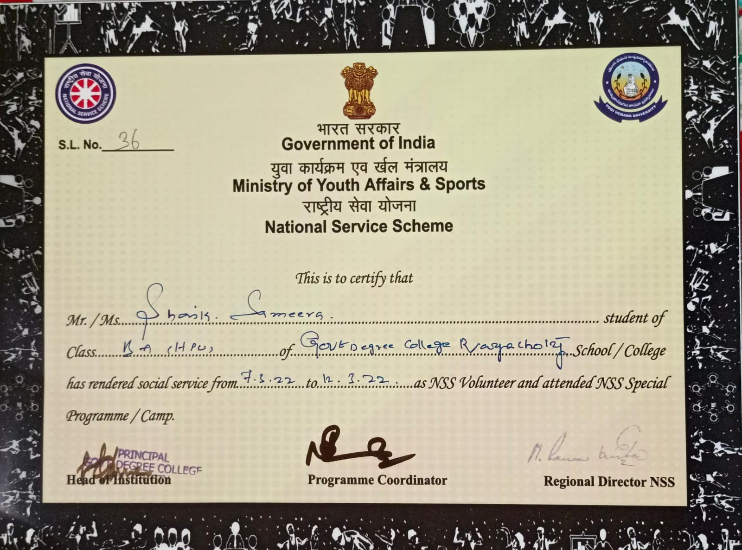

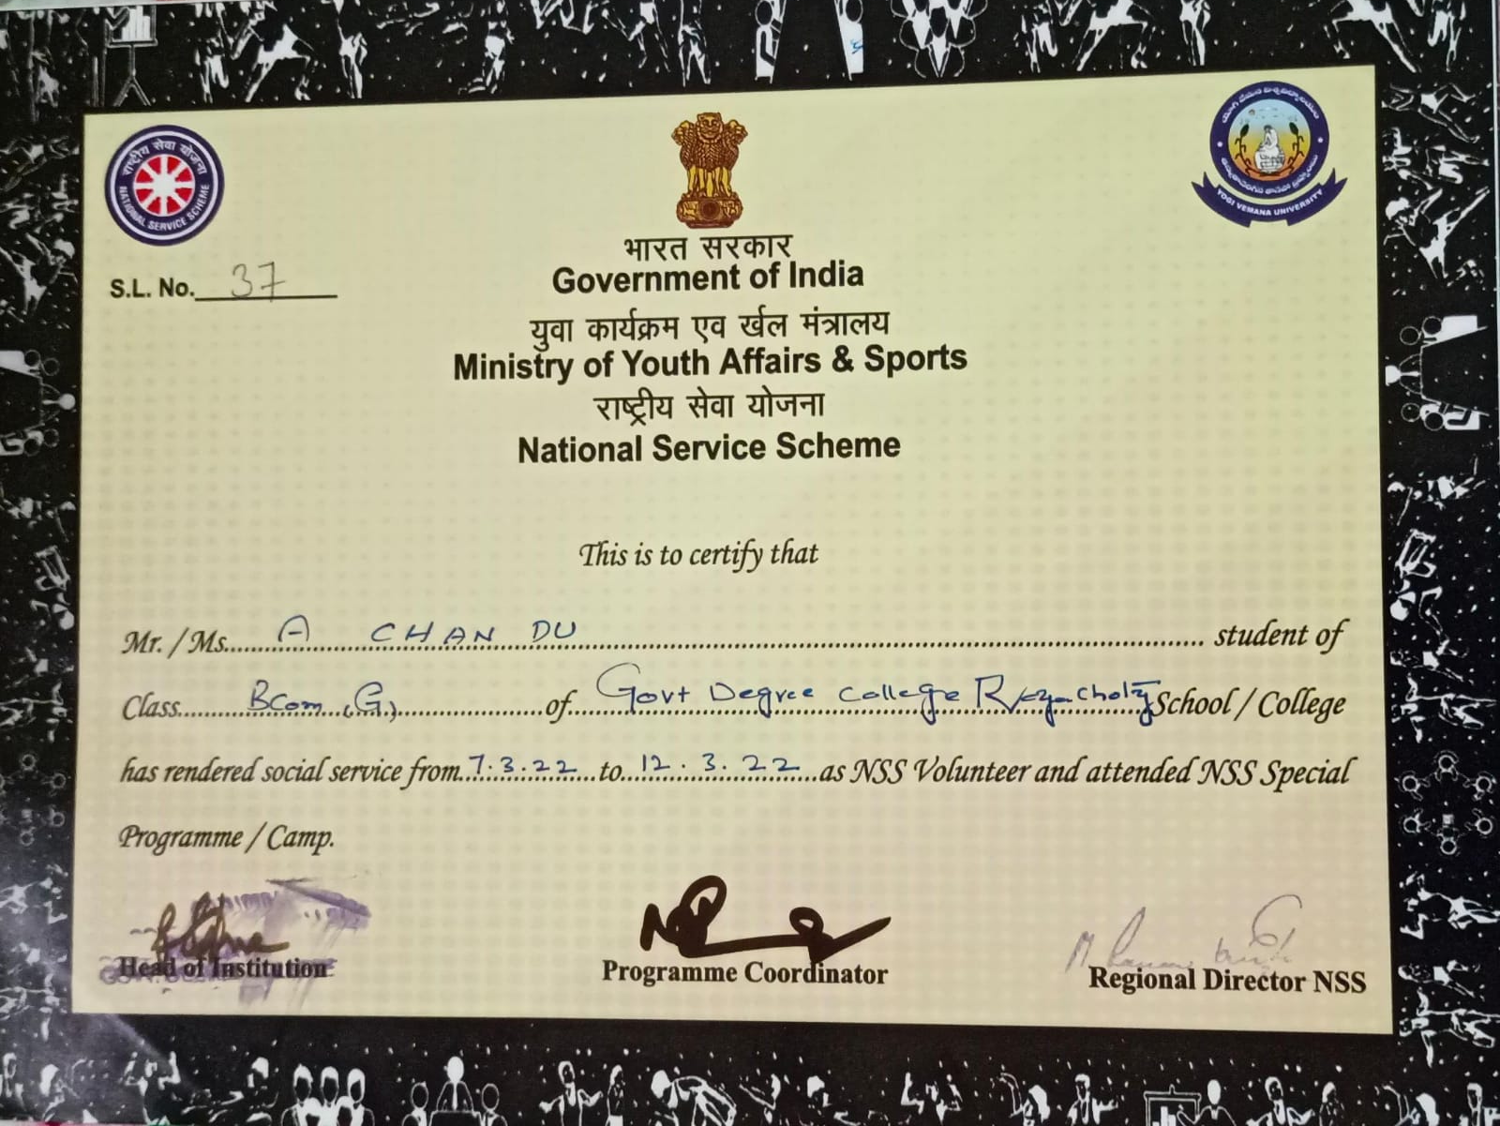

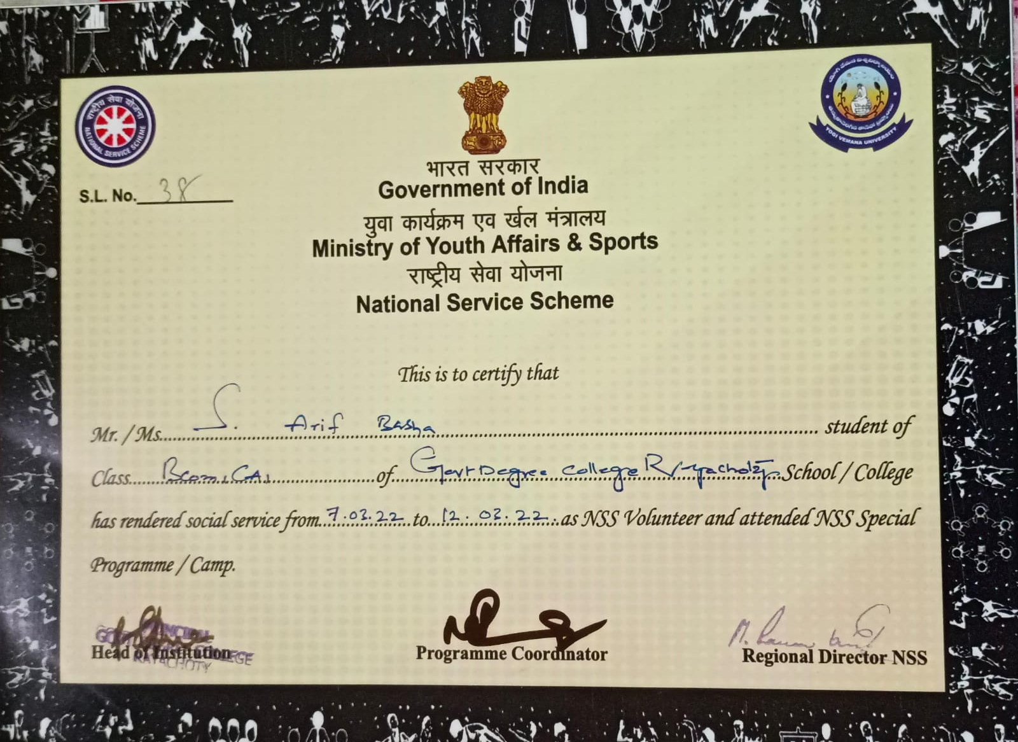

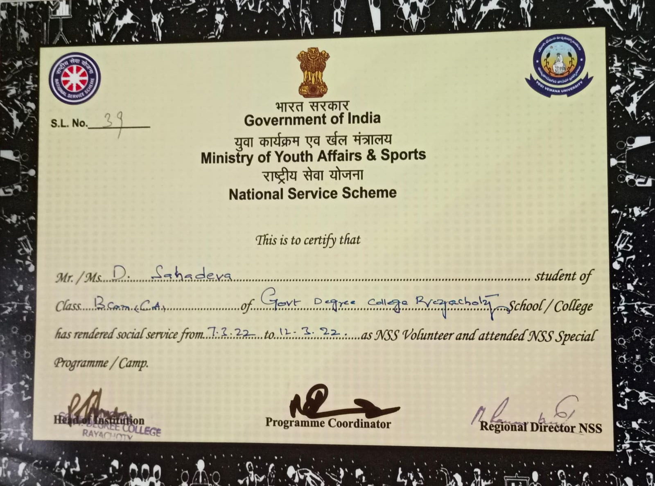

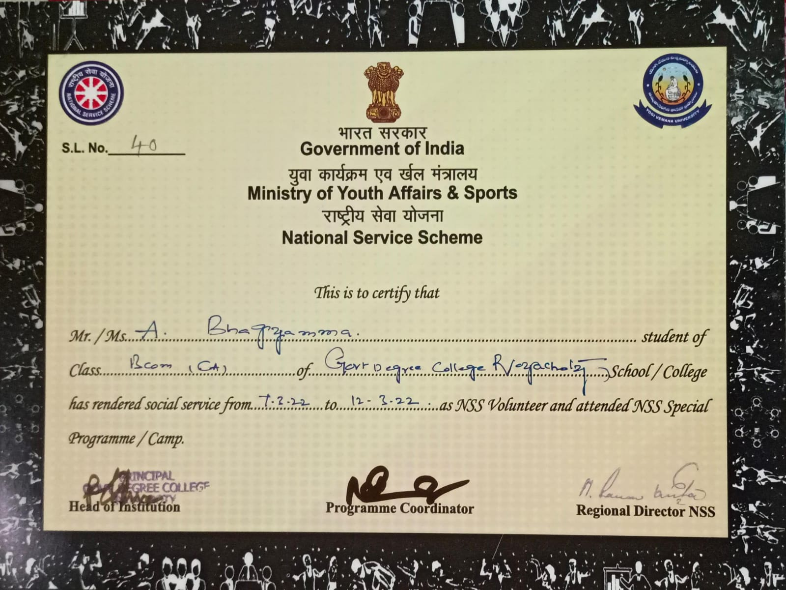

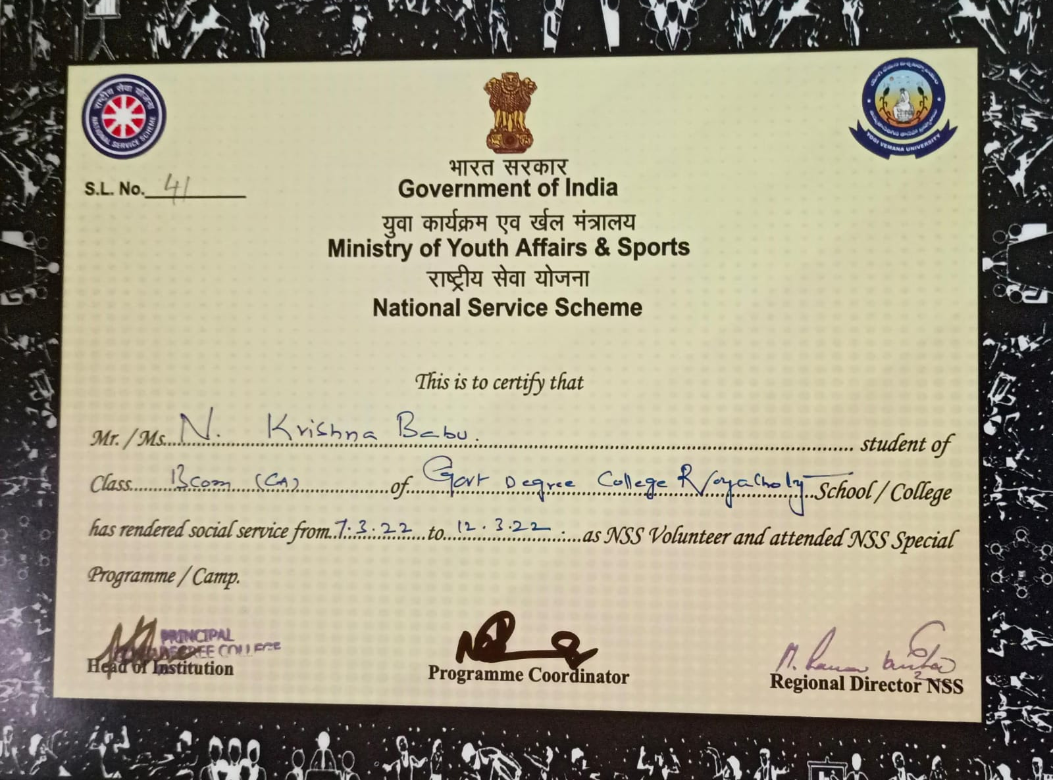

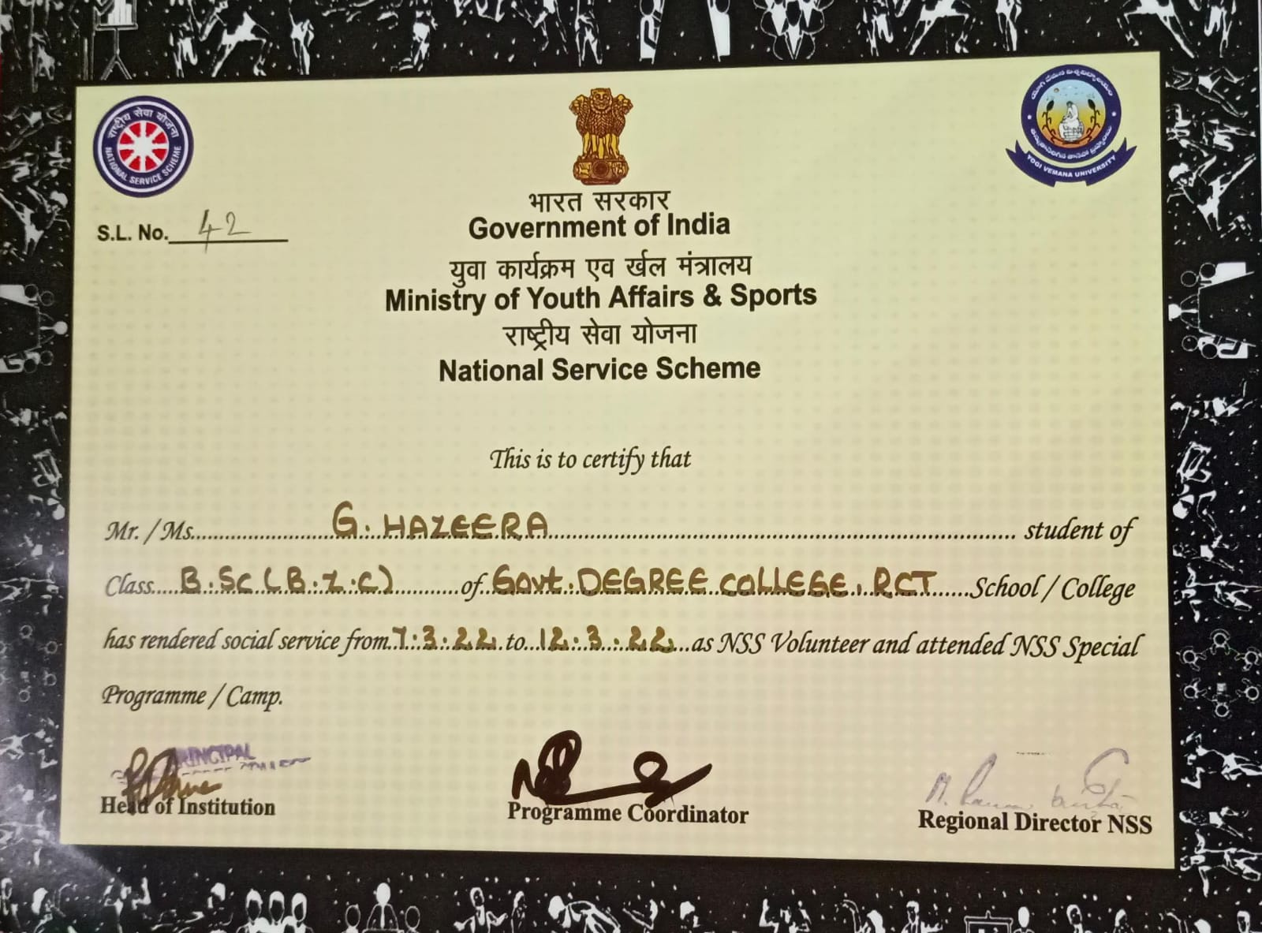

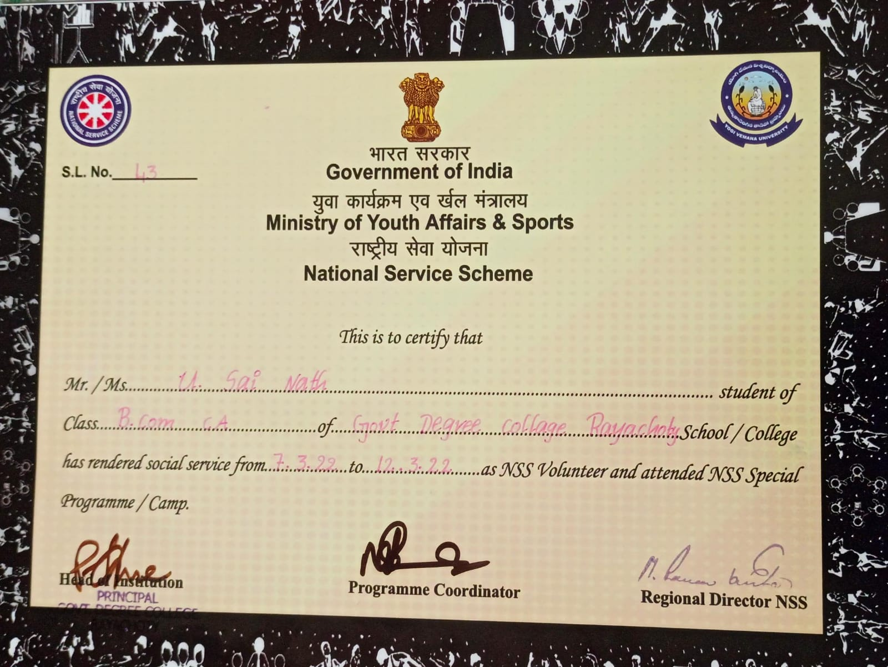

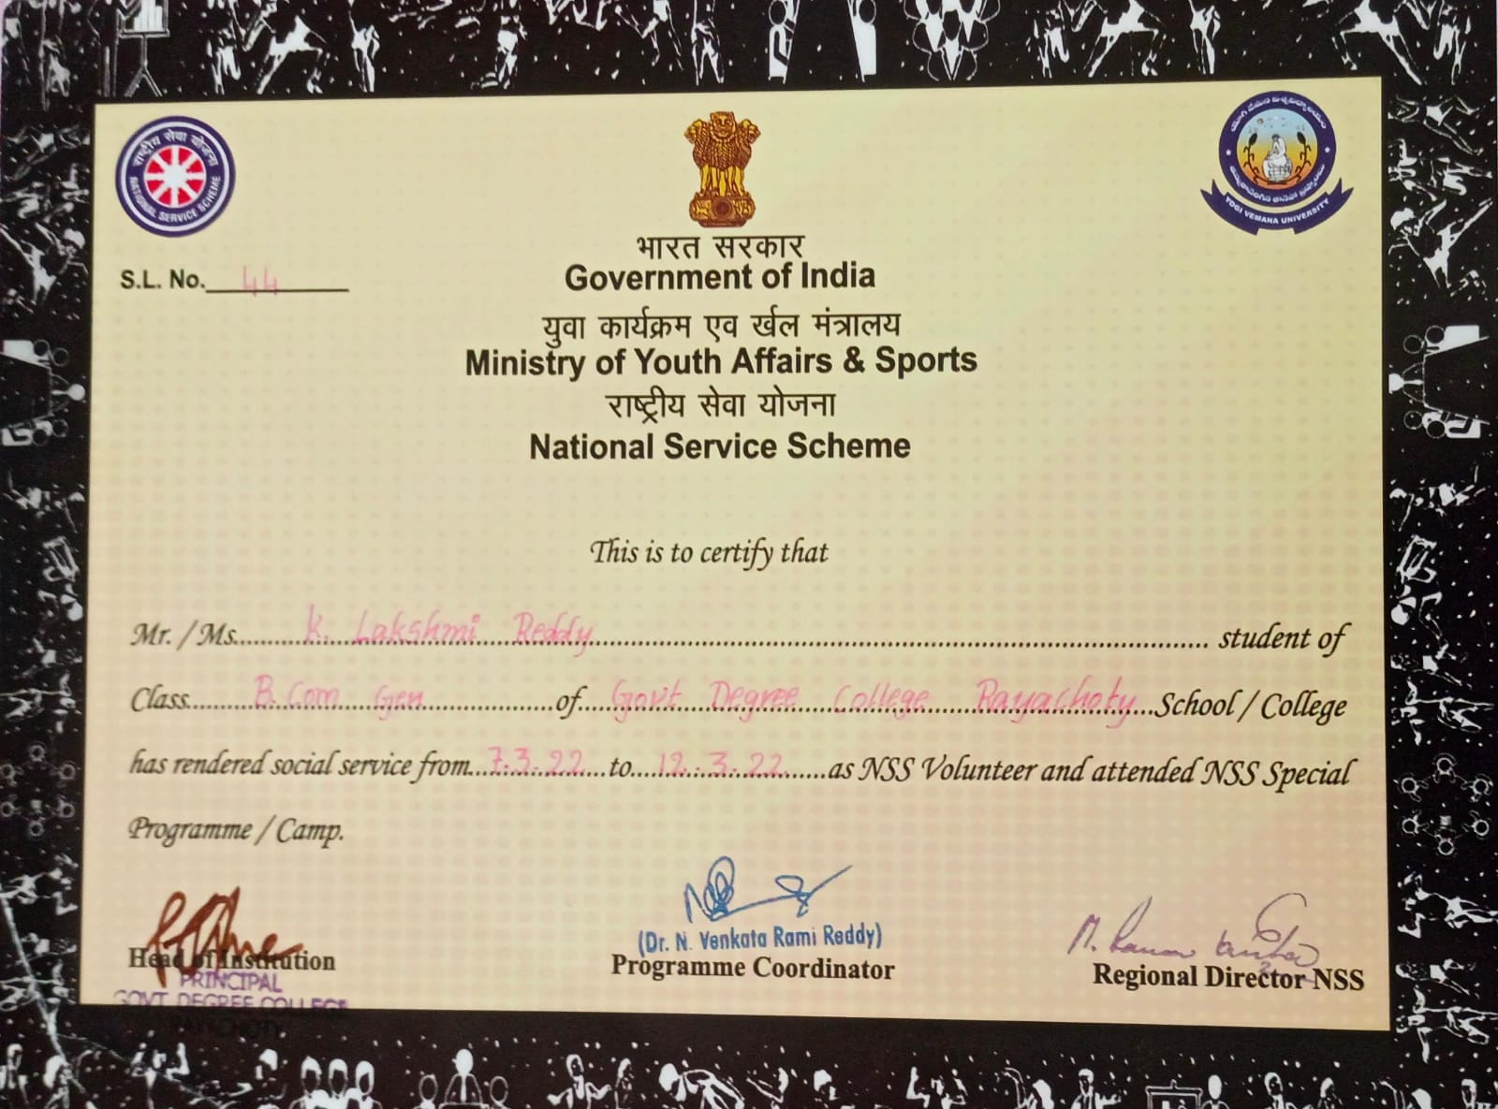

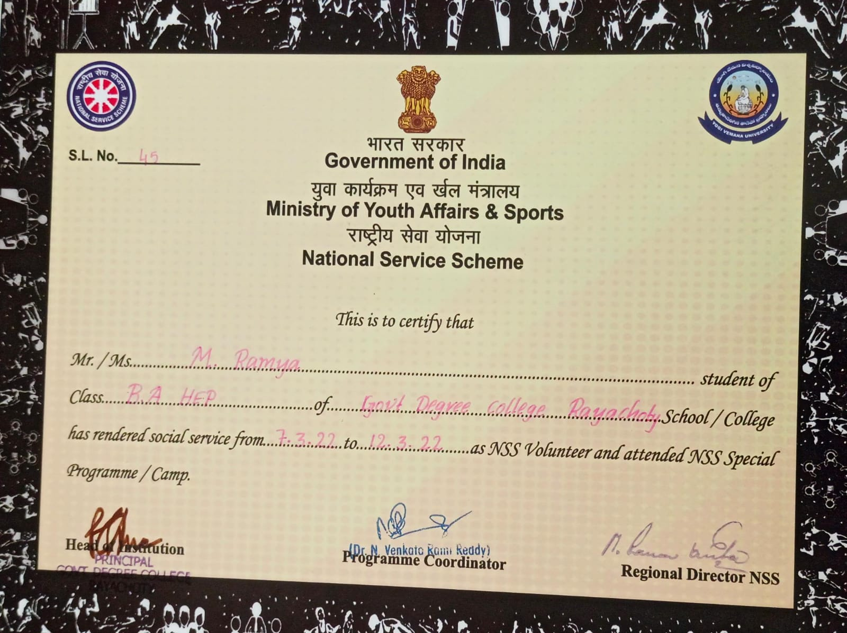

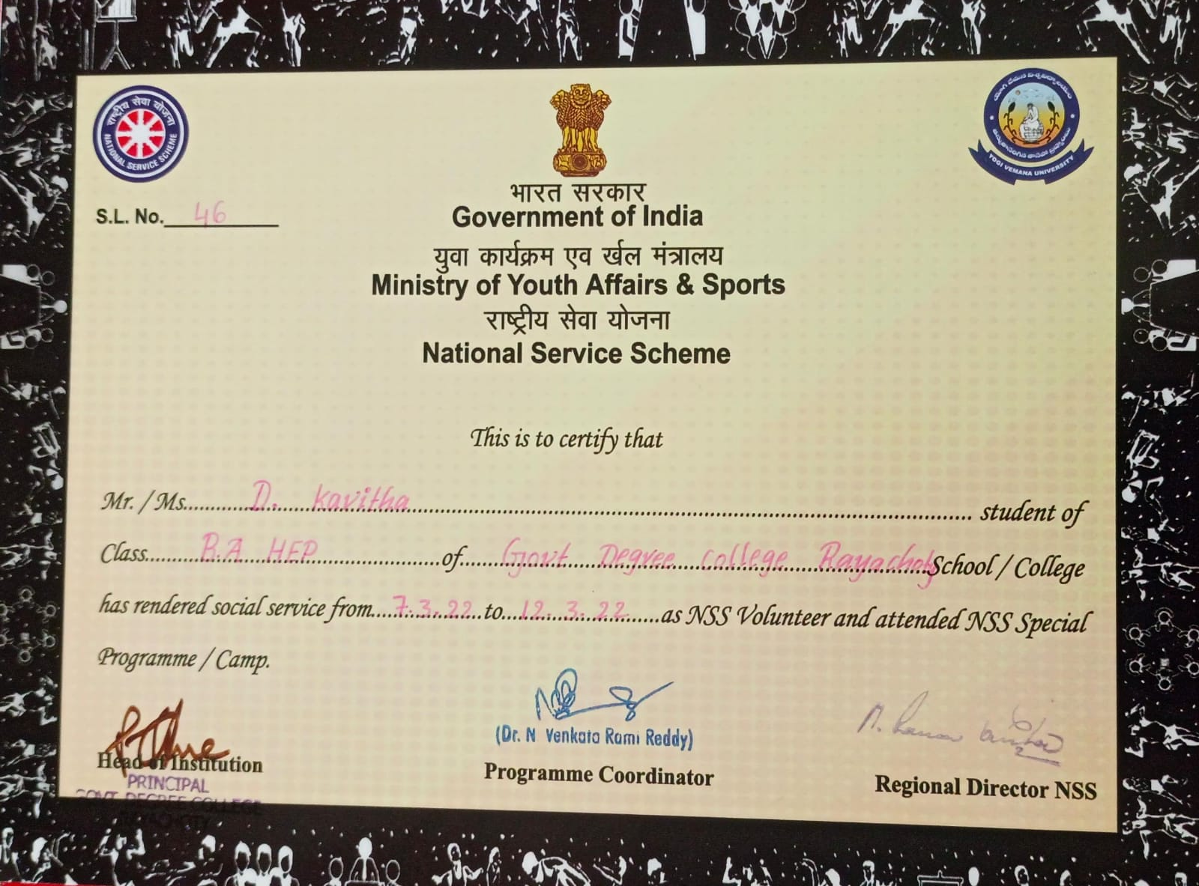

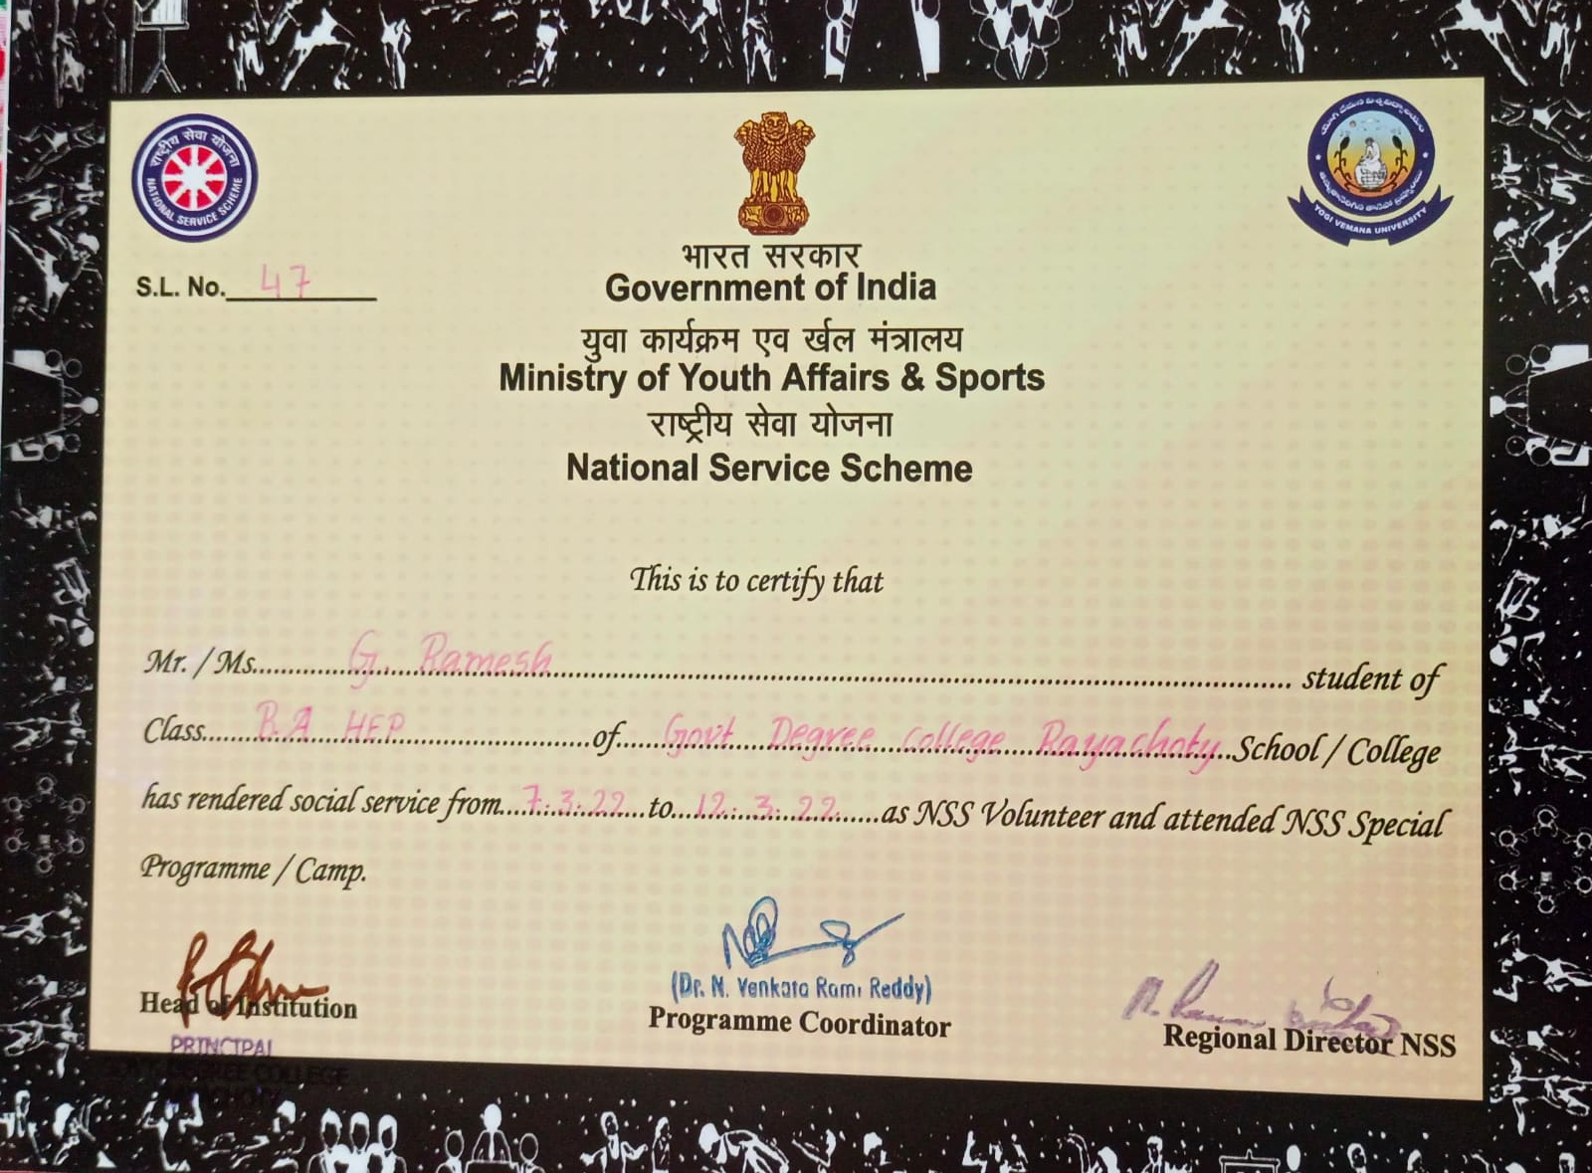

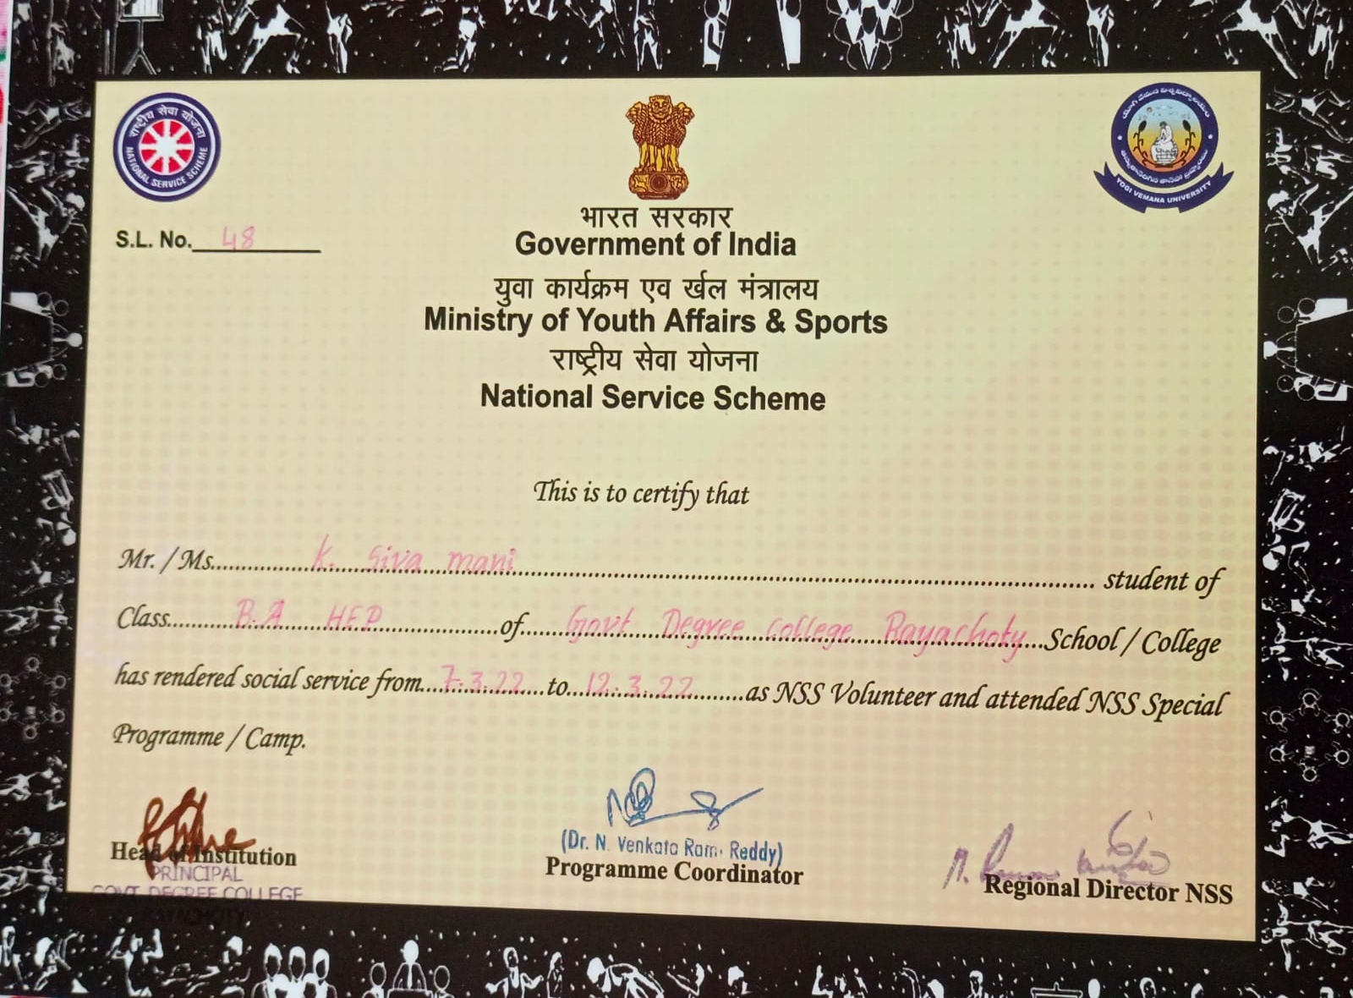

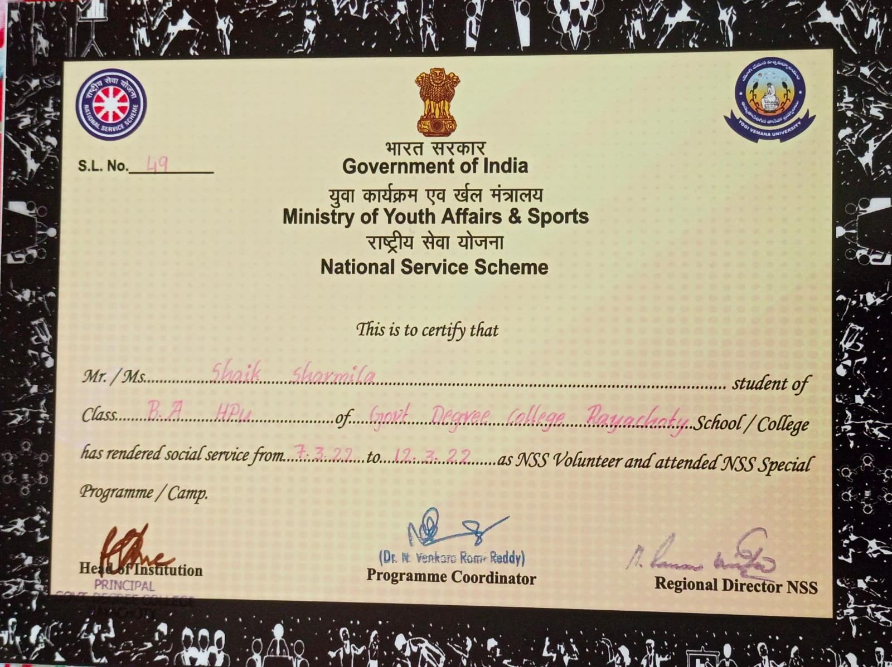

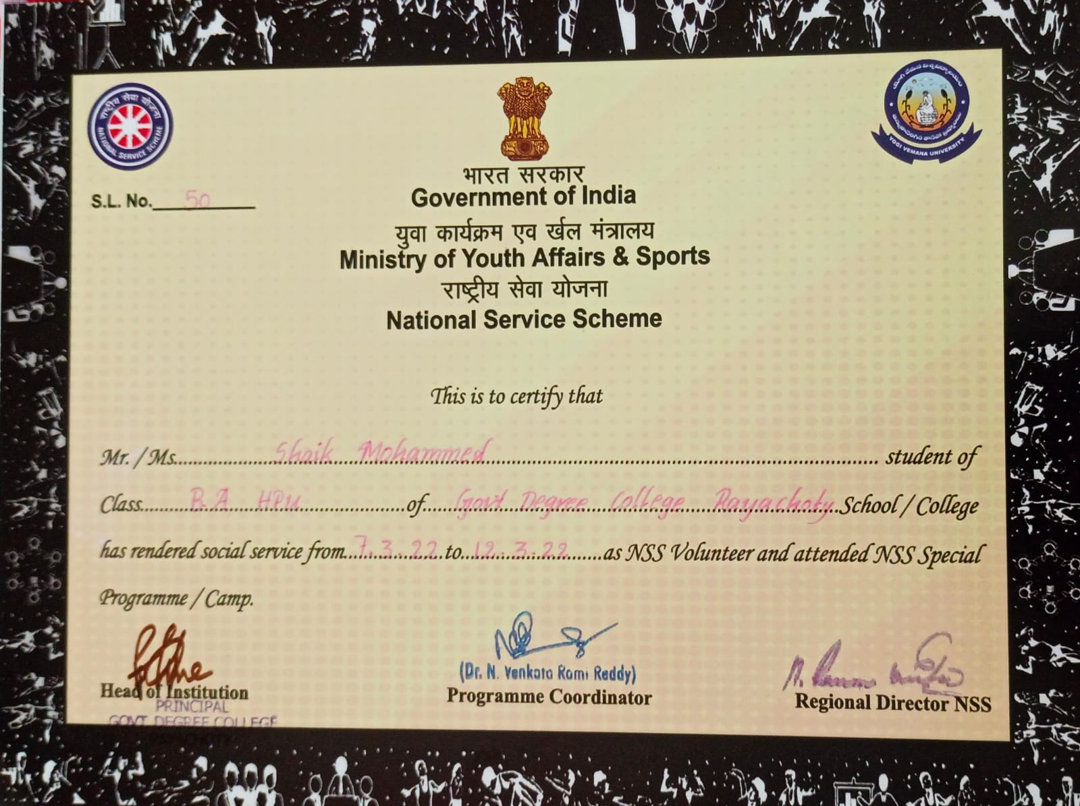

INDIAN RED CROSS BLOOD BANK
The Indian Red Cross Blood Bank is part of the larger Indian Red Cross Society, which is a humanitarian organization dedicated to providing emergency assistance, disaster relief, and education in communities affected by crises. The Blood Bank specifically focuses on the collection, processing, and distribution of blood and blood products to meet the medical needs of patients in hospitals and healthcare facilities.
- Blood Donation Drives: They organize regular blood donation camps and drives to encourage voluntary blood donation. These drives are often conducted in collaboration with schools, colleges, corporate organizations, and community groups.
- Blood Collection and Testing: Once blood is donated, it is collected in sterile conditions and undergoes rigorous testing for various infections and diseases to ensure it is safe for transfusion.
- Blood Processing: The collected blood is separated into its components, such as red blood cells, plasma, and platelets, allowing for multiple patients to benefit from a single donation.
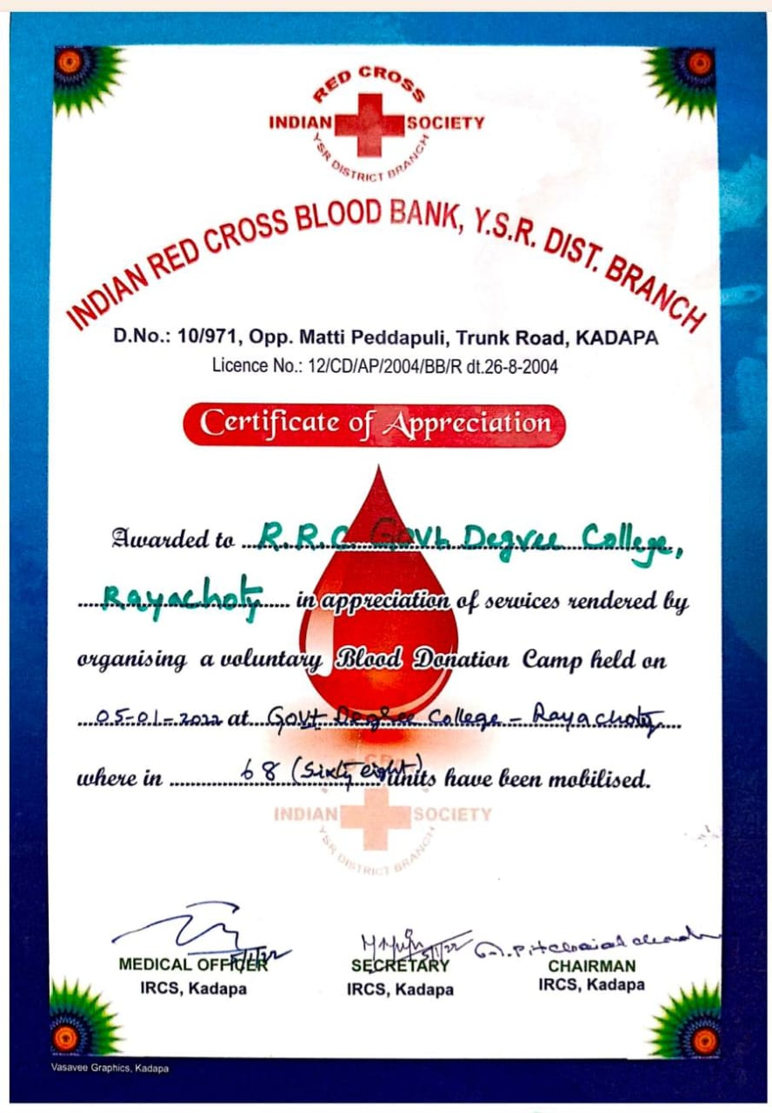

RAYACHOTY—516269
(Accredited by NAAC with C Grade Affiliated to YV University, Kadapa

2022-23

DEPARTMENT OF ZOOLOGY

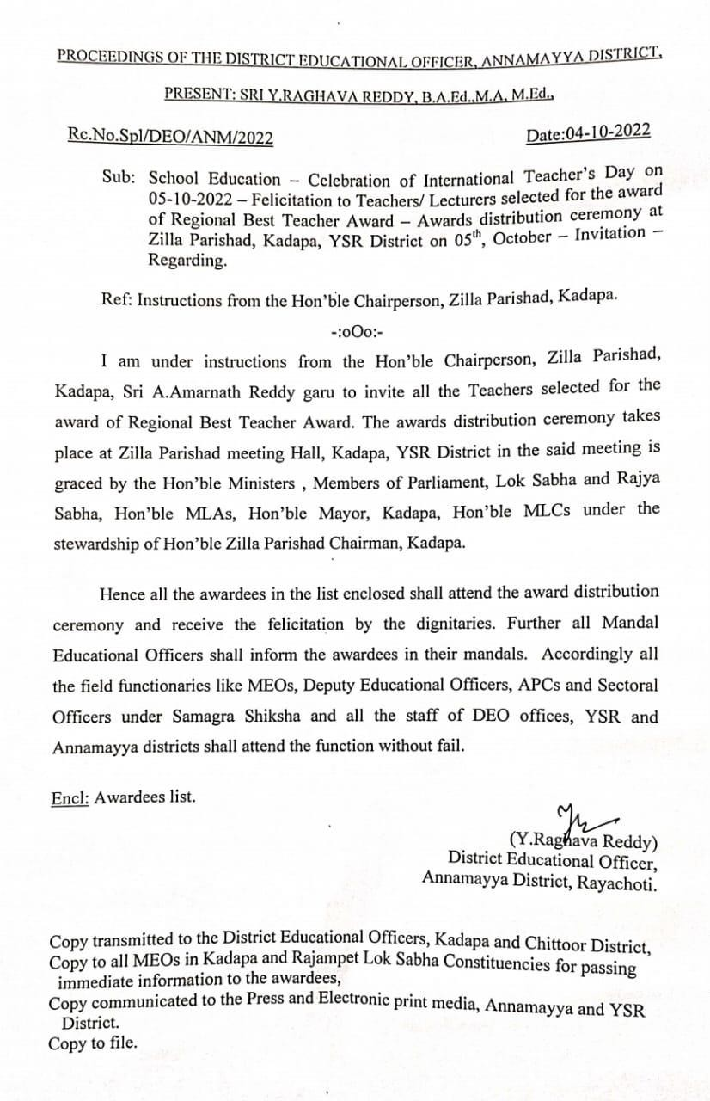
Dr.M. Muniya Naik, Lecturer in Zoology, Department of zoology, Govt. Degree college, Rayachoti, received award of “Regional Best Teacher” on the occasion of international teachers’ day from Hon’ble chairperson, zilla perished, Kadapa, YSR district. On 05.10.2022.
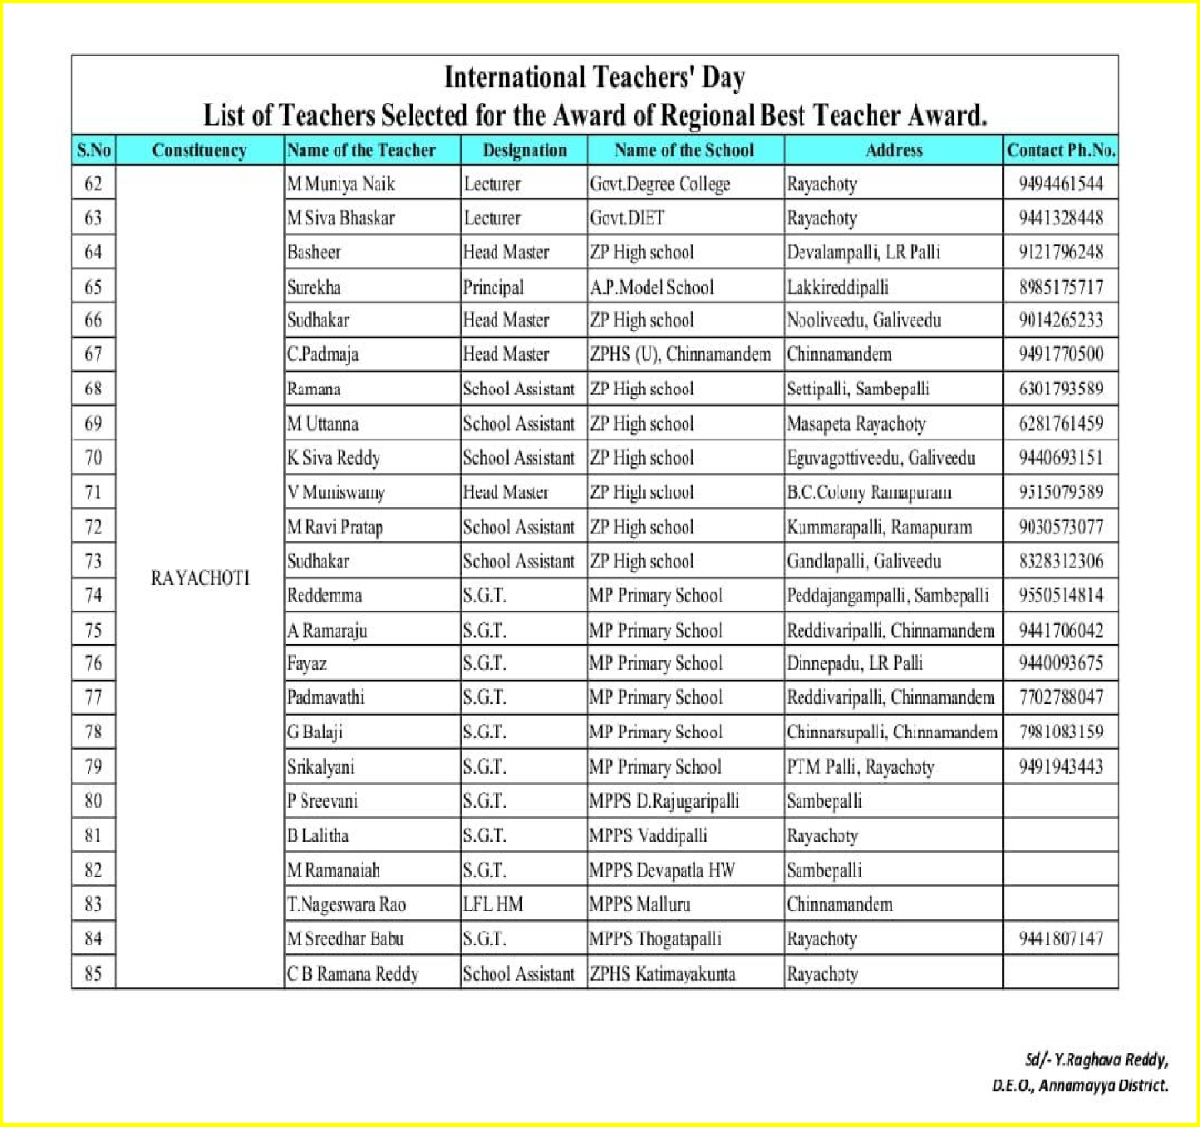

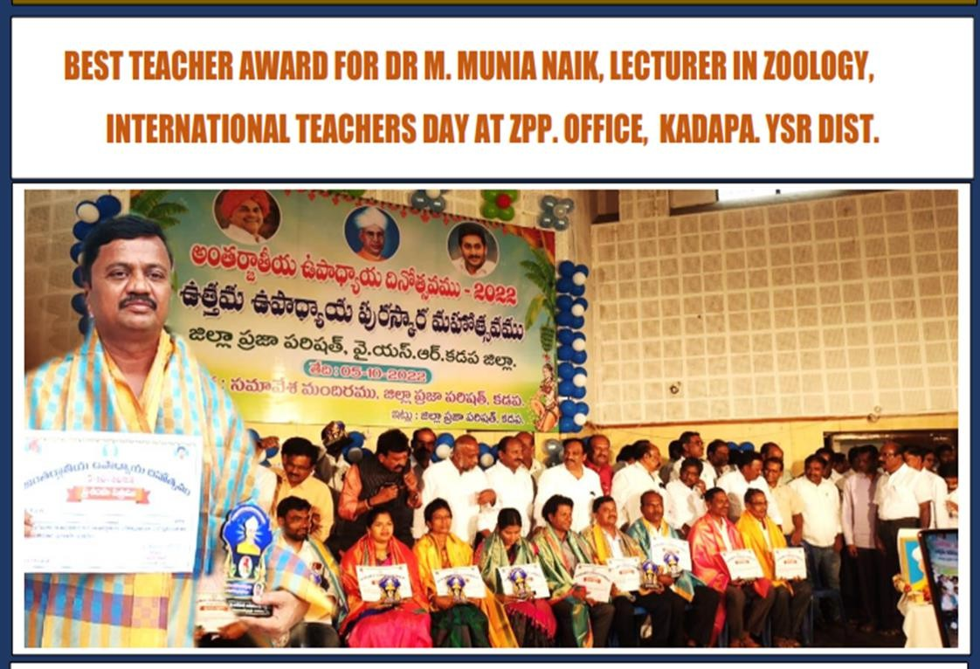

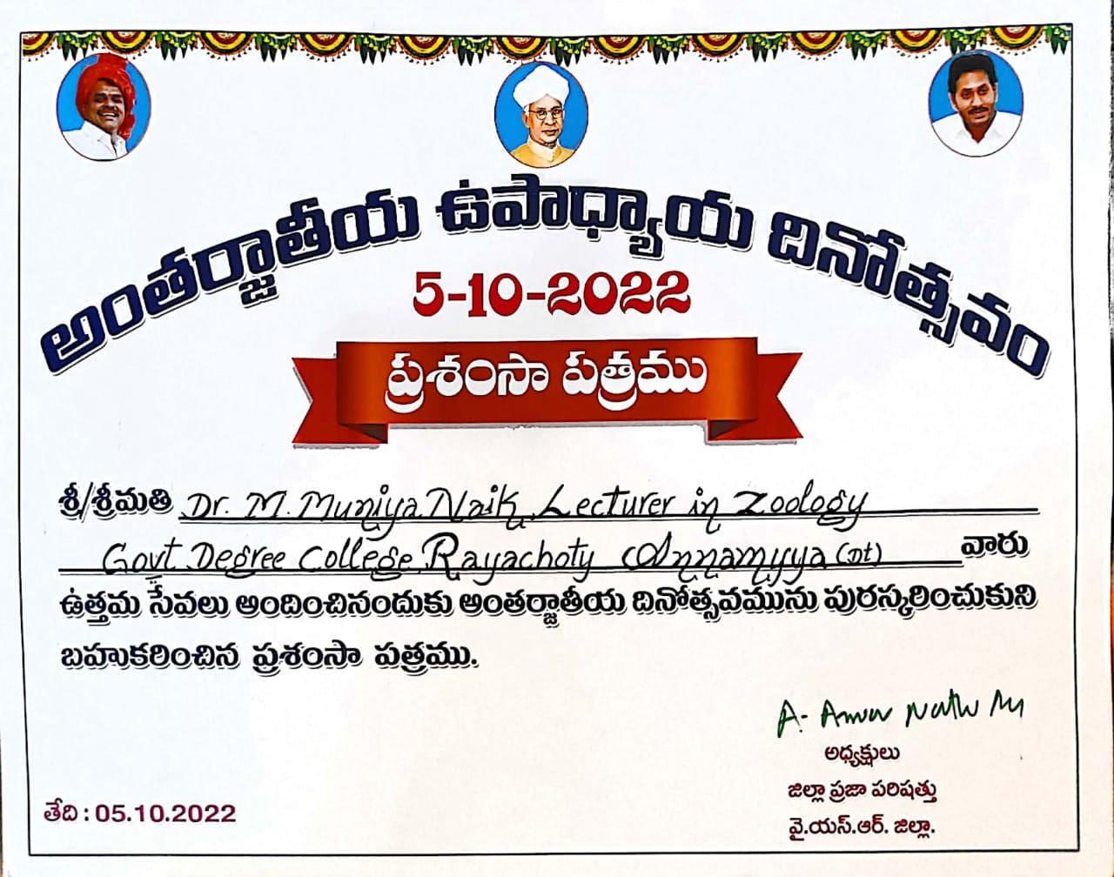

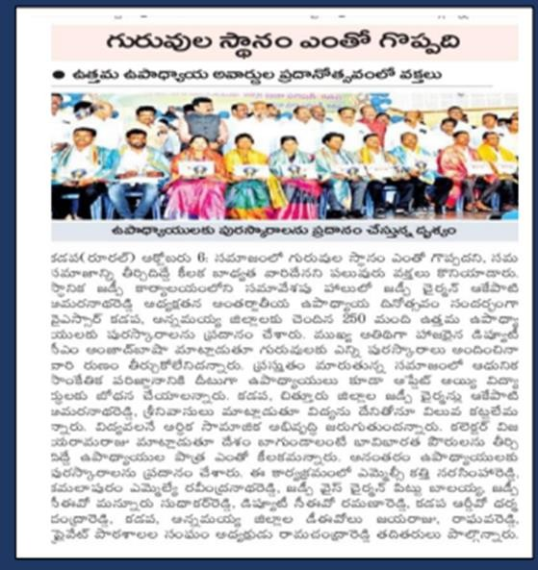
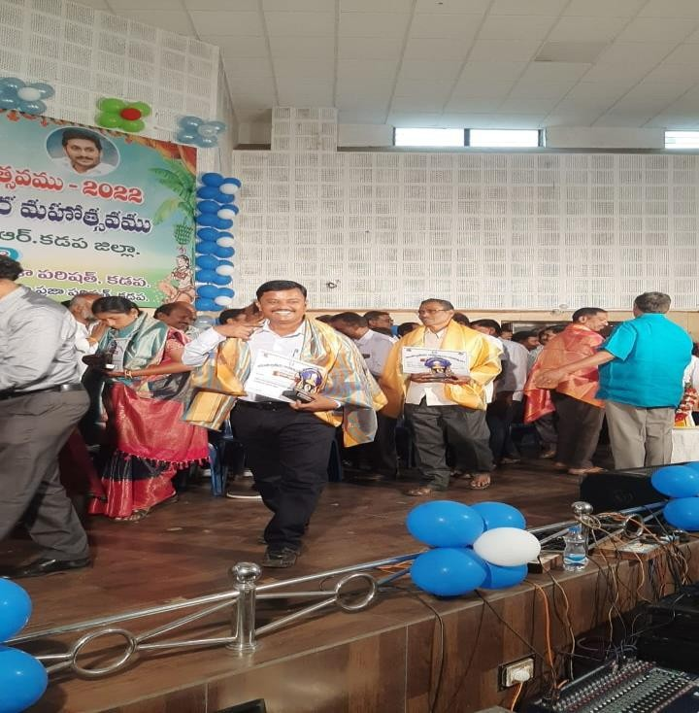

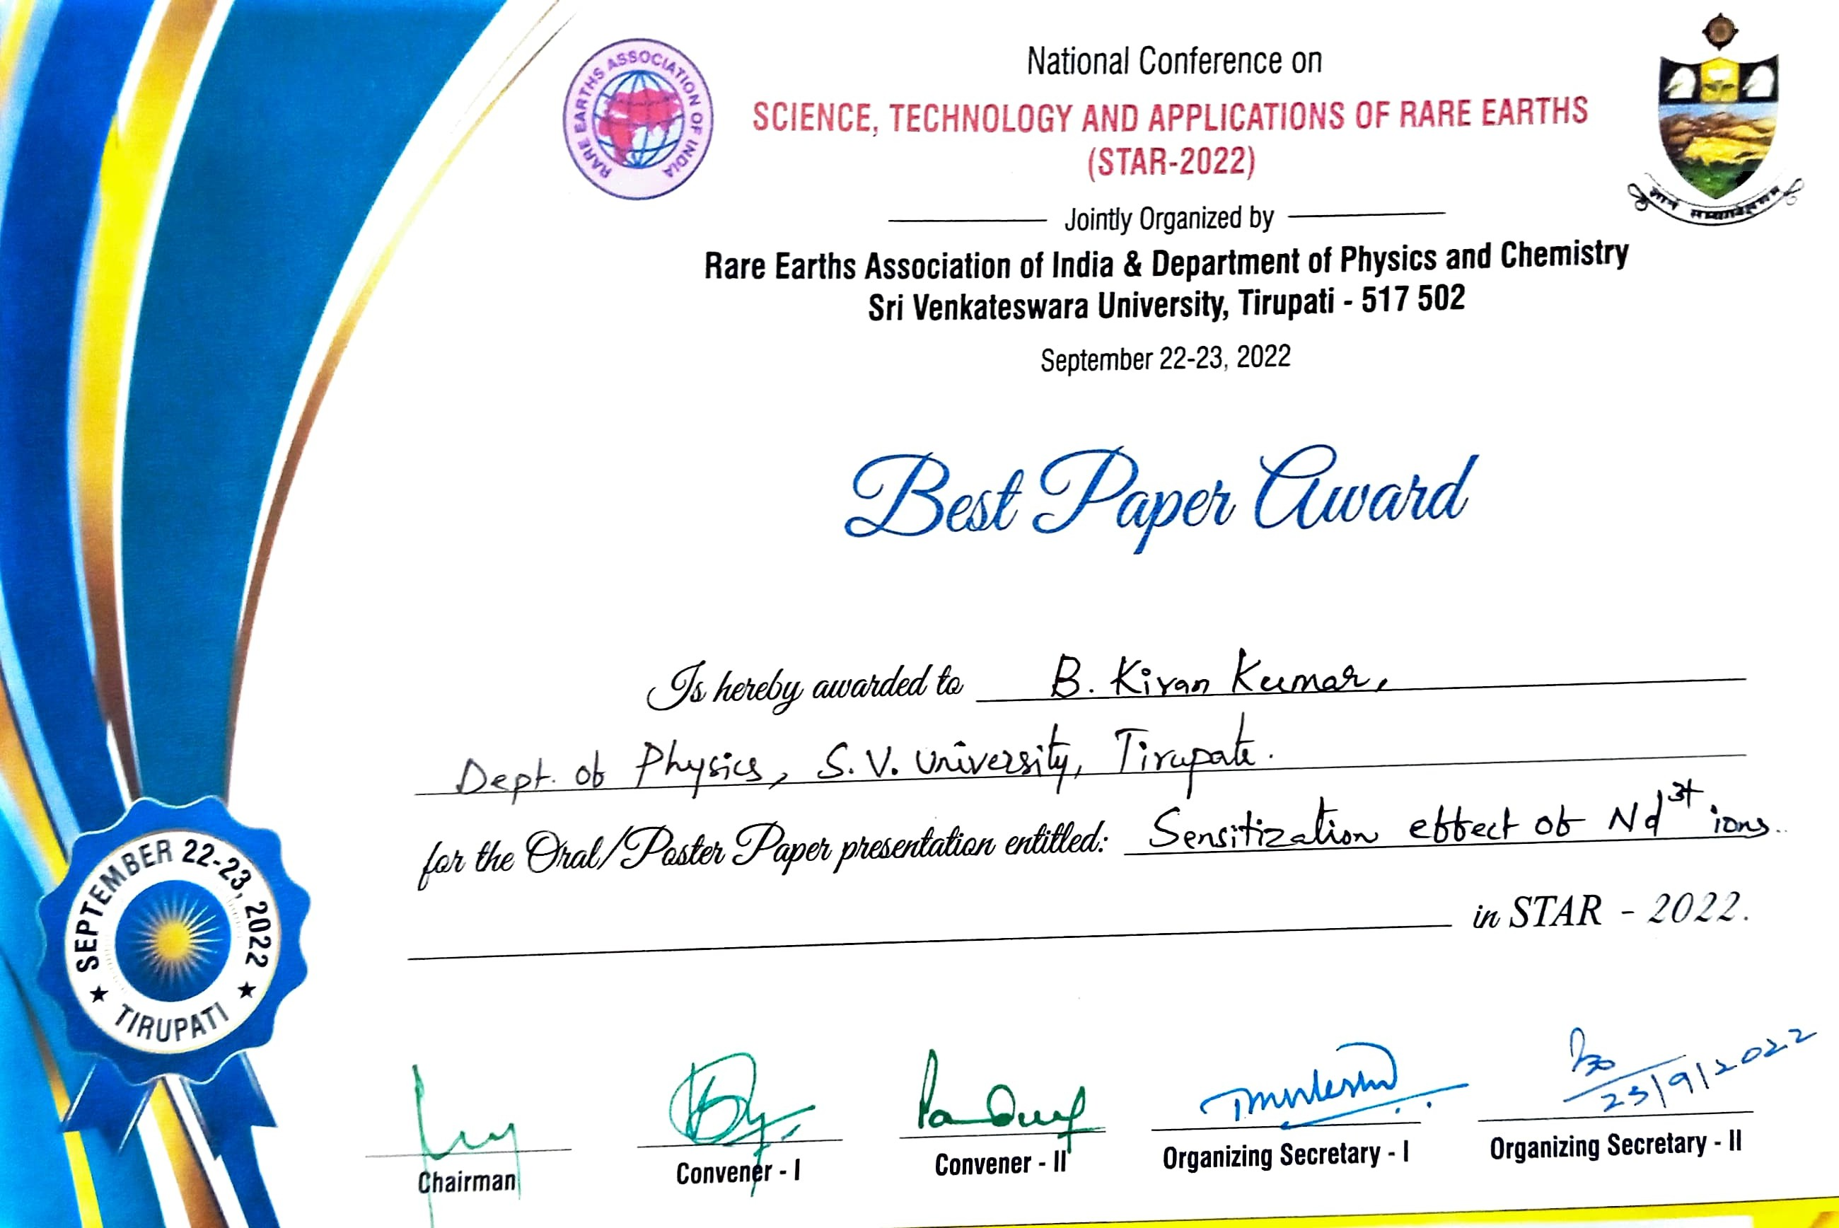

The "National Conference Best Paper Award" is a prestigious recognition given to individuals who present outstanding research papers at a national conference on Science Technology and Applications of Rare Earths (STAR-2022). If someone named B. Kiran Kumar Lecturer in Physics Government Degree College Rayachoti received this award, it means their paper was considered the best among all submissions in that conference, reflecting excellence in research, presentation, and relevance to the field.
Such awards are usually given in various academic and professional fields, and they are a significant achievement for scholars, researchers, and professionals. They recognize the quality and impact of the research presented, and receiving such an award can significantly enhance one’s academic and professional profile.

B. Kiran Kumar
Lecturer in Physics
Govt Degree College Rayachoti.
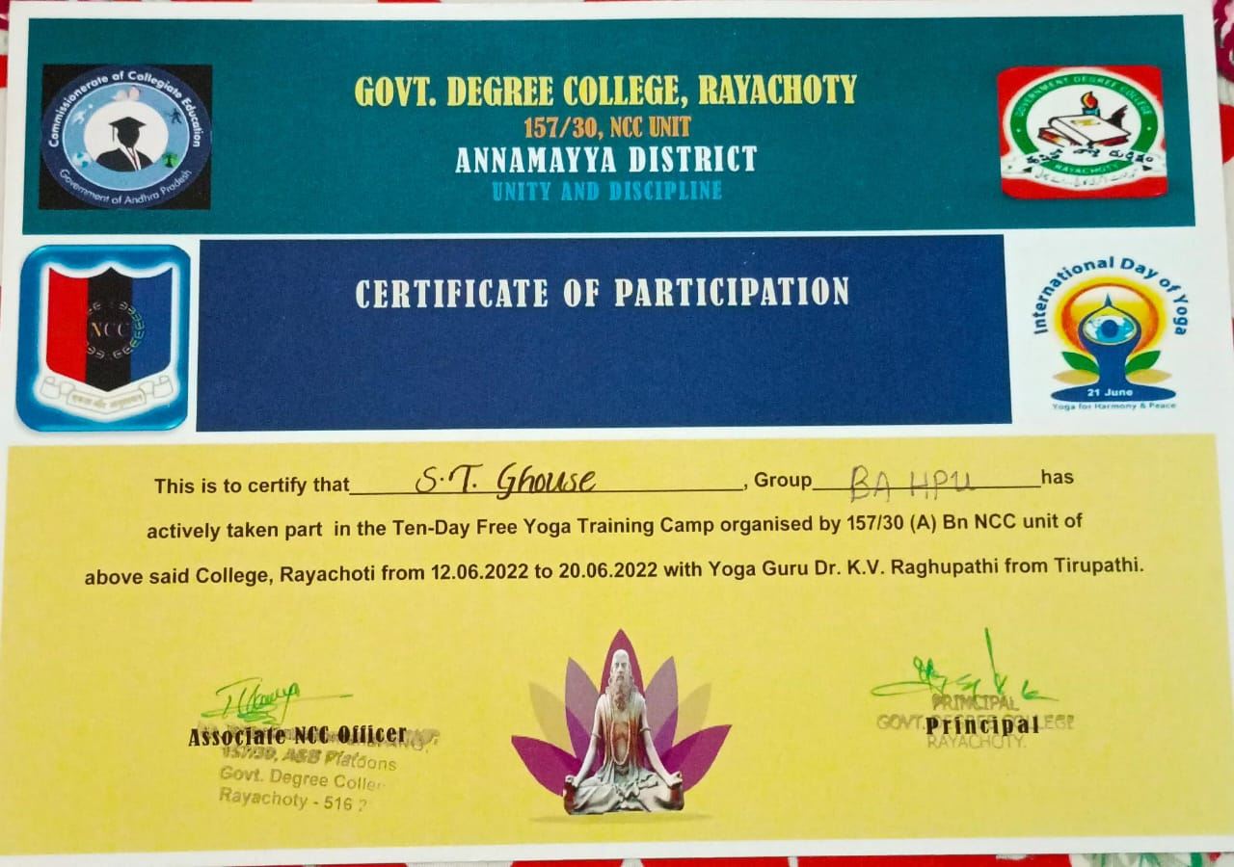

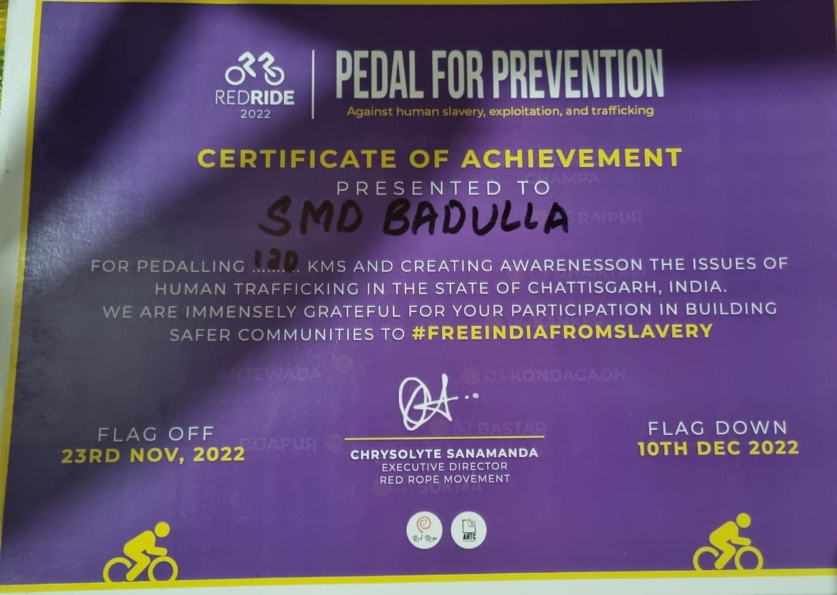

Government of Andhra Pradesh Prevention of AIDS
The Government of Andhra Pradesh (AP) has been actively involved in the prevention and control of HIV/AIDS through various initiatives and programs. These efforts typically include awareness campaigns, educational programs, and health services aimed at reducing the spread of HIV/AIDS and supporting those affected by the virus.
Some key aspects of the Government of Andhra Pradesh's approach to HIV/AIDS prevention might include:
- Awareness and Education: Programs designed to educate the public about HIV/AIDS, modes of transmission, and prevention methods. These might include workshops, seminars, and media campaigns.
- Testing and Counselling: Providing access to HIV testing and counselling services to encourage early detection and support for individuals living with HIV.
- Healthcare Services: Ensuring access to antiretroviral therapy (ART) and other medical services for people living with HIV/AIDS to manage their condition effectively.
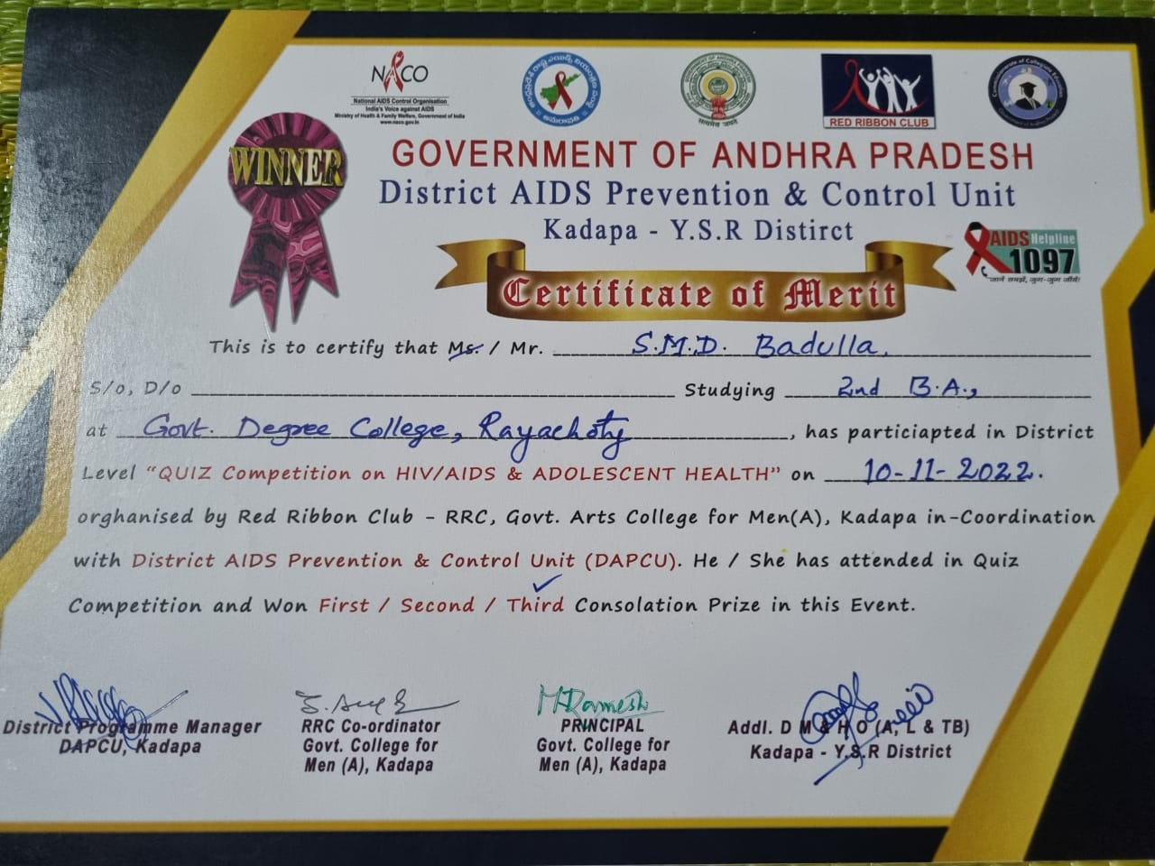
- Support for High-Risk Groups: Targeted interventions for populations at higher risk of HIV infection, such as sex workers, injecting drug users, and men who have sex with men (MSM).
- Community Involvement: Engaging local communities and organizations in the fight against HIV/AIDS to promote a supportive environment and reduce stigma.
- Partnerships: Collaborating with national and international organizations, NGOs, and healthcare providers to enhance the effectiveness of HIV/AIDS prevention and care efforts.

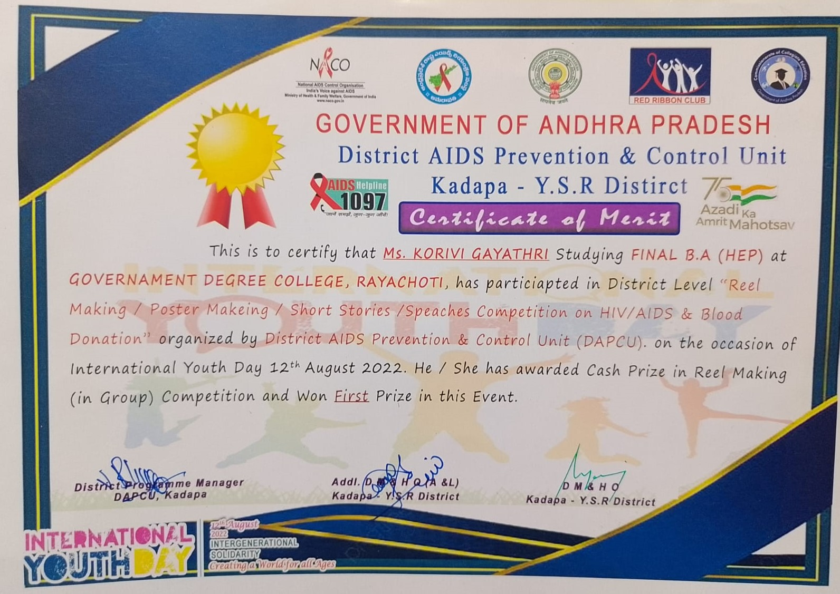

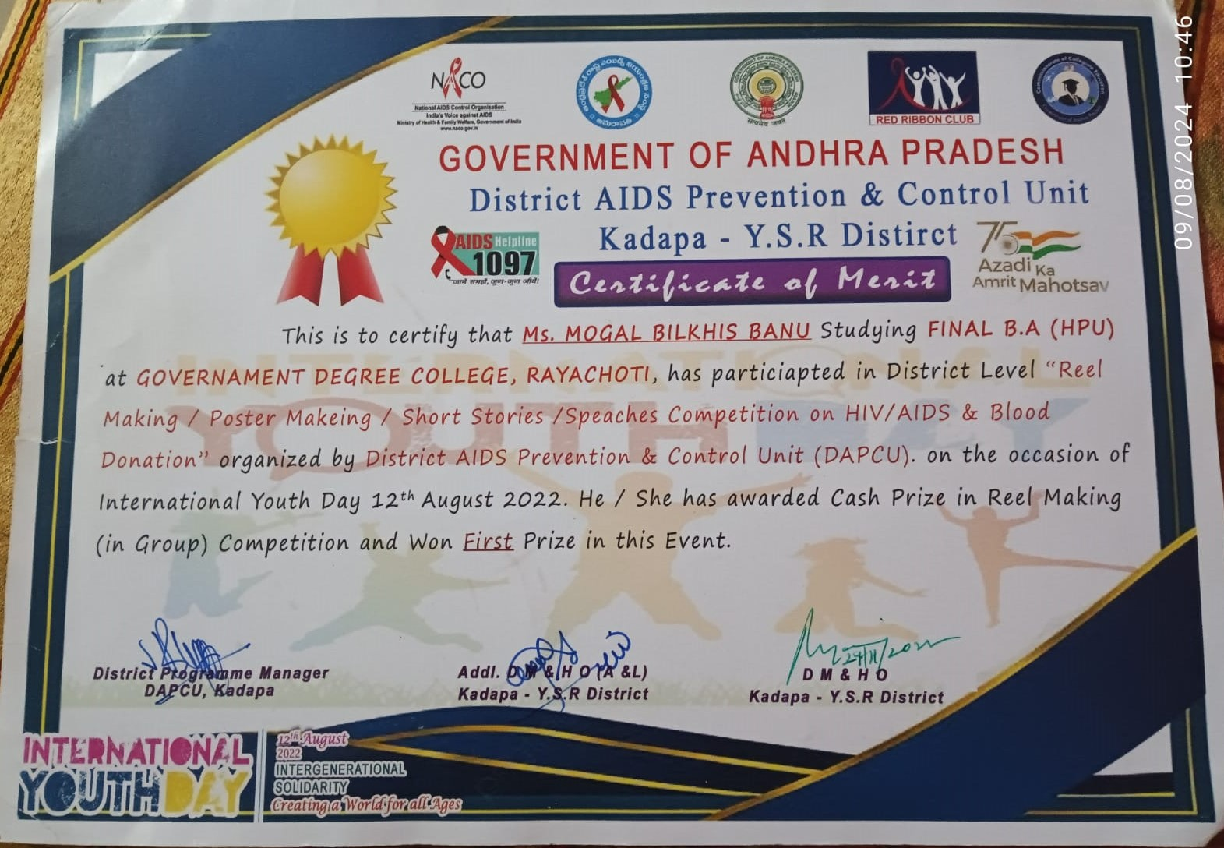

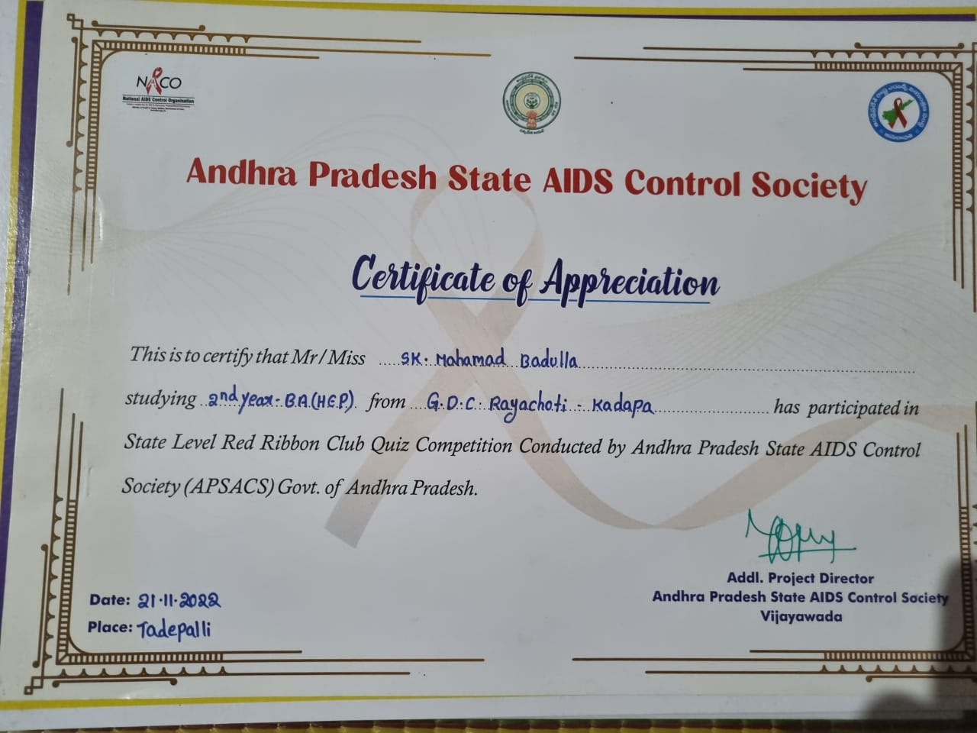

The Andhra Pradesh State AIDS Control Society (APSACS) is a key agency responsible for implementing the state's strategies and programs to prevent and control HIV/AIDS. APSACS operates under the National AIDS Control Organization (NACO) and plays a crucial role in coordinating and executing various initiatives related to HIV/AIDS in Andhra Pradesh.
Key functions and activities of APSACS typically include:
- Awareness and Education: Organizing campaigns and educational programs to raise awareness about HIV/AIDS, its prevention, and the importance of testing and safe practices.
- Testing and Counselling: Providing facilities for voluntary testing and counselling services to help individuals understand their HIV status and receive support.
- Antiretroviral Therapy (ART): Ensuring the availability and accessibility of ART for people living with HIV/AIDS, which helps in managing the disease and improving quality of life.
- Prevention Programs: Implementing programs aimed at reducing the transmission of HIV, such as needle exchange programs, condom distribution, and outreach to high-risk groups.
- Support Services: Offering support for people living with HIV/AIDS, including social support, treatment adherence, and linkage to care services.
- Monitoring and Evaluation: Tracking the progress of HIV/AIDS programs and evaluating their effectiveness to ensure that resources are used efficiently and goals are met.
- Partnerships: Collaborating with various stakeholders, including NGOs, community-based organizations, and international agencies, to enhance the reach and impact of HIV/AIDS interventions.
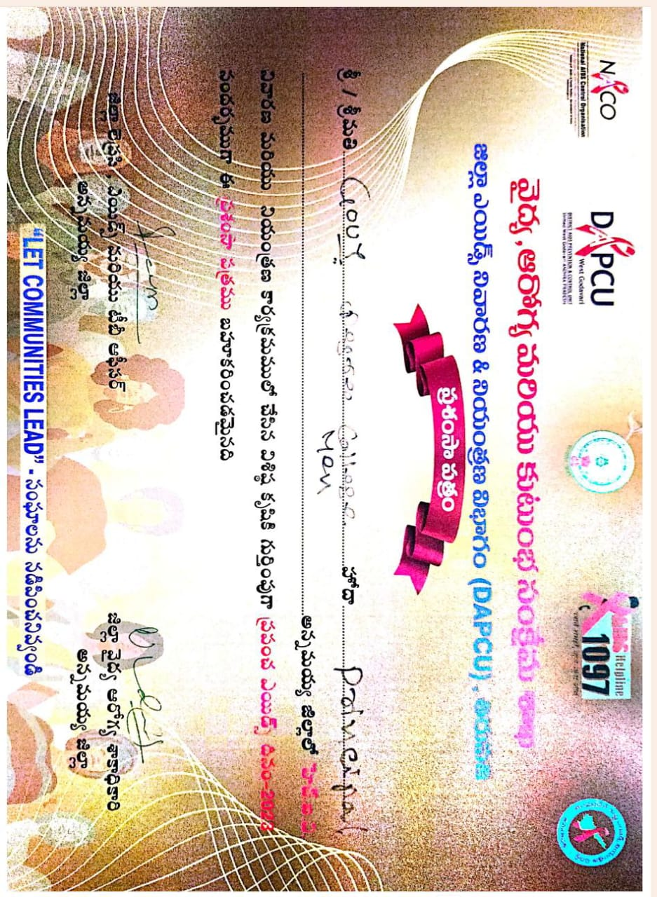

AP Police Republic Day Parade
The 74th Republic Day of India, celebrated on January 26, 2023, was marked by a grand parade and various events showcasing the nation's diversity, military strength, and cultural heritage. Republic Day commemorates the adoption of the Indian Constitution on January 26, 1950, and is a major national holiday in India.
Highlights of the Republic Day Parade typically include:
- Location: The main Republic Day Parade takes place at Rajpath in New Delhi, where the President of India presides over the event.
- Military Display: The parade features impressive displays by the Indian Armed Forces, including the Army, Navy, and Air Force. This includes marching contingents, tanks, missiles, and other military hardware.
- Cultural Performances: Various states of India present colourful and vibrant tableaux representing their cultural heritage, festivals, and significant achievements.
- Flag Hoisting: The President of India leads the flag hoisting ceremony and delivers a speech reflecting on the country’s achievements and aspirations.
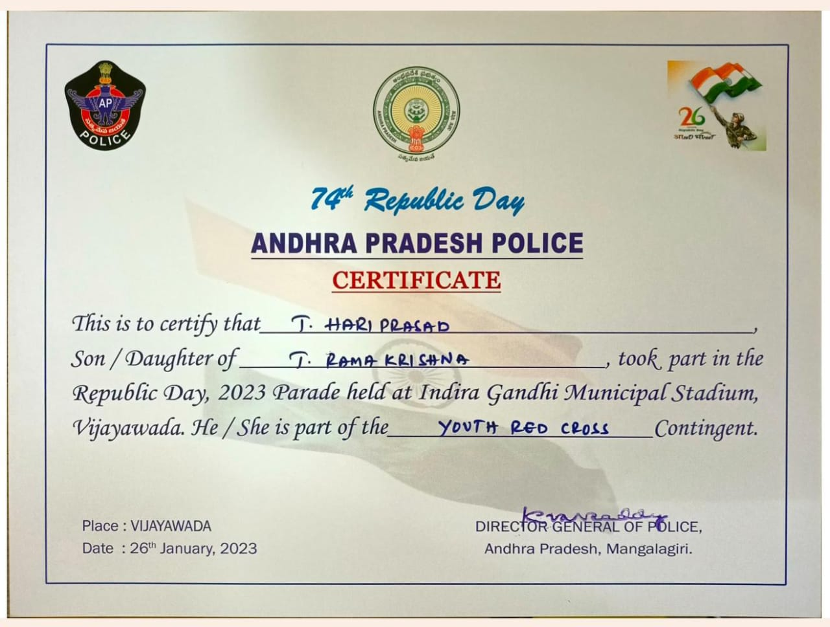
- Awards and Honours: The ceremony includes the presentation of various awards, including bravery awards like the Ashoka Chakra and the Kirti Chakra, to military personnel and civilians.
- March Past: Contingents from different regiments of the Indian Armed Forces, paramilitary forces, and school children participate in a march past, showcasing discipline and unity.
- Parade Participants: In addition to military units, there are performances by school children, police forces, and other groups, demonstrating the diversity and unity of the country.

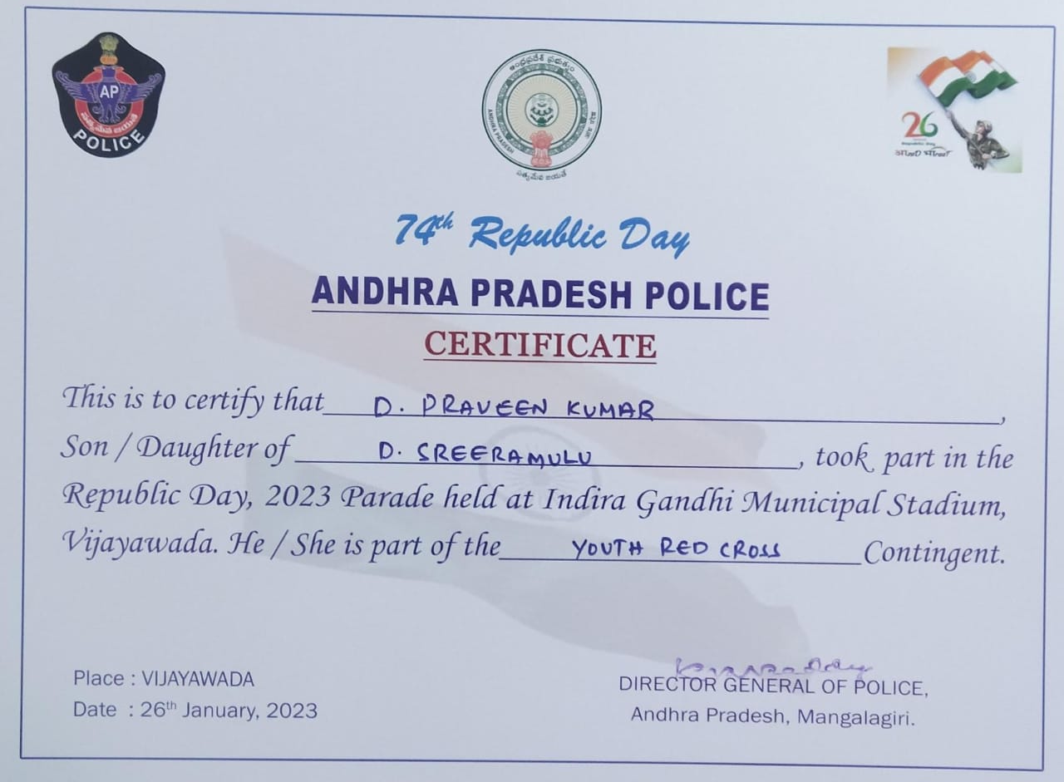

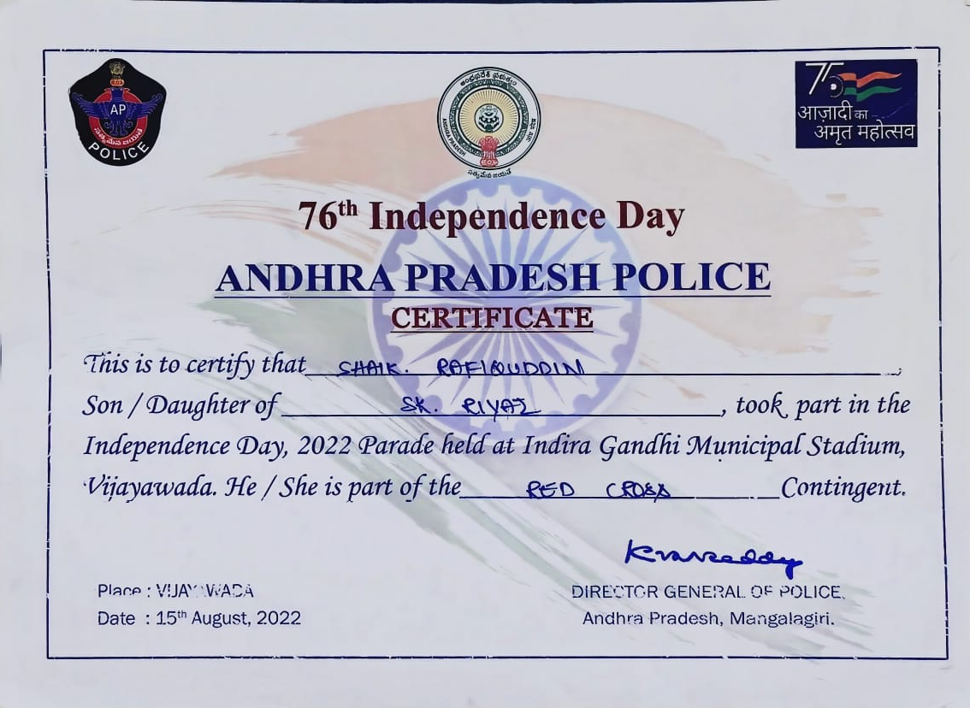

INDIAN RED CROSS BLOOD BANK
INDIAN RED CROSS SOCIEY
The Indian Red Cross Blood Bank is part of the larger Indian Red Cross Society, which is a humanitarian organization dedicated to providing emergency assistance, disaster relief, and education in communities affected by crises. The Blood Bank specifically focuses on the collection, processing, and distribution of blood and blood products to meet the medical needs of patients in hospitals and healthcare facilities.
- Blood Donation Drives: They organize regular blood donation camps and drives to encourage voluntary blood donation. These drives are often conducted in collaboration with schools, colleges, corporate organizations, and community groups.
- Blood Collection and Testing: Once blood is donated, it is collected in sterile conditions and undergoes rigorous testing for various infections and diseases to ensure it is safe for transfusion.
- Blood Processing: The collected blood is separated into its components, such as red blood cells, plasma, and platelets, allowing for multiple patients to benefit from a single donation.
